Upton-By-Chester High School Sixth Form
“EXPECT MORE, GET MORE, BE MORE”
VESPA

Introduction
Over the last 15-20 years, much research into the psychology of success has been conducted and the findings are very interesting. Achieving the best grades possible in your A Levels is more than just learning the specification content. A particular set of skills and an advanced mindset is necessary. In other words, your attitude, self-beliefs about abilities and self-awareness of your own goals are essential to being an effective and successful A Level student.
This is good news for you! Your mindset and skill set can be developed and enhanced throughout your studies and life in general. Students who achieve higher than their minimum target grades have developed these required skills and mindset to support their success. This is all about really tapping into the Zettabyte of potential!

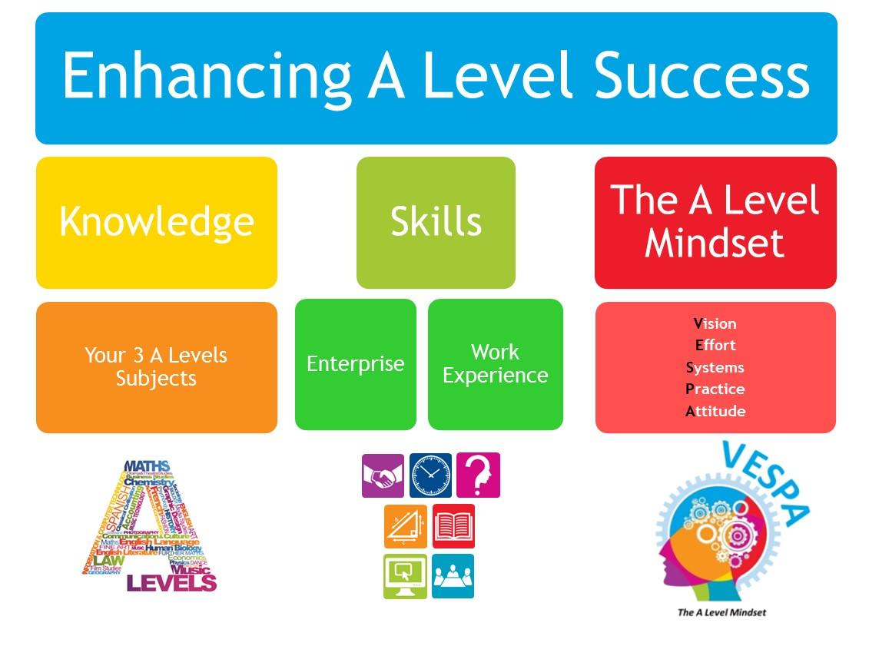

Your mind
The capacity of your mind is enormous and the brain is a phenomenal thing. Recent studies have shown that the brain still changes throughout our lives and is capable of amazing growth/recovery – this is known as brain plasticity. Struggling at a task usually leads to neural changes that will encourage structural growth of new/better connections between the brain cells (neurons). A Levels are challenging but that struggle will literally change/improve your brain.

What is a mindset?

“A fixed mental attitude or disposition that predetermines a person’s

responses to and interpretations of situations” (Oxford English Dictionary)

Unfortunately, it is quite common for people to have a fixed mindset which is one that believes we are born with our levels of intelligence/personality/creativity. Or at best, that these are formed in childhood. This is an inaccurate view of ourselves. A growth mindset recognises that we are all constantly learning. This is the accurate way to view our minds and how our brains work. We are changing, growing as people all time and so is our capacity to learn and improve ourselves.
Research conducted here in England into the mindset of A Level students identified the following as the key ingredients for Being More/being successful at Sixth Form:

Commitment

to the

Effort

needed

Practising

your
learning

&
skills

Developing
a positive

mental
Attitude

Having
suitable
Systems

in place

Having
a
Vision

These 5 elements = success! But the key is that all 5 elements need to be in place as they all feed into each other. All of us can enhance each of these elements to provide us with an effective mindset for A Level/Level 3 learning.

VESPA: The Five Elements of Success

Vision

- Do you know what you want to achieve?
- Why are you studying A Levels?
- What grades do you want to achieve in your A Levels?
- What career are you interested in?

Effort

- How many hours of independent study do you do?
- How do you compare to the most committed students in your year group?

Systems

- How do you organise your learning and your time?
- Do you have any study or time management methods or techniques to draw on?
- Do you have good habit/routine eg. sleep routine/work routine?

Practice
- How do you practice to improve your study skills?
- How do you practice to improve your time management?
- How do you practice to improve exam technique?

Attitude

- How do you respond to setbacks?
- Are you defensive when it comes to feedback or do you like the opportunity to improve?
- How do you respond to constructive criticism?
- How do you overcome setbacks or adapt your plans?

x E x S x P x A = success

(great mind/great habits/great grades/great you!)
This equation needs to have multiplication signs rather than addition signs because it is about ALL 5 elements being present simultaneously. Having all 5 elements as part of your mindset will lead to success. Missing one will greatly reduce or impair your chances of success.

Where are you now?

Rate each statement in line with your own attitude/beliefs:

1 = Strongly Disagree, 2 = Disagree, 3 = Neither Agree nor Disagree, 4 = Agree, 5 = Strongly Agree

*Question 9 only: 1 = Never, 2 = Rarely, 3 = Occasionally, 4 = Frequently,
5 = Very Frequently

1) Your intelligence is something about you that you can change easily?
1 2 3 4  2) I’m committed to finishing school regardless of obstacles | 5
1 2 3 4 5

- I do my best in class
  - 2 3 4 5

- I know that attending university is the best choice for me
  - 2 3 4 5

- I try to do my best at any task
  - 2 3 4 5

- If a problem is very large, I divide it into small parts
  - 2 3 4 5

- I bounce back after disappointment or failure
  - 2 3 4 5

8) I take good notes in class
1 2 | 3 4 5
9) I often write exam answers under timed conditions*

9) I can
1 2 | 3 4 5

- I have a clear idea about the career I want to pursue
1 2 | 3 4 5

- My work is very organised (answers/notes)?
1 2 | 3 4 5

- I compare model answers against my own work
1 2 | 3 4 5

- Others consider me a hard working student
1 2 | 3 4 5

- If I don’t understand class work, I talk to my teacher
1 2 | 3 4 5

- I have a positive view of myself
1 2 | 3 4 5

The mark scheme:  Add up your ratings in the following groups:  Vision = Questions 2, 4 & 10 _____  Effort = Questions 3, 5 & 13 _____  Systems = Questions 6, 8 & 11 _____  Practice = Questions 9, 12 & 14 _____  Attitude = Questions 1, 7 & 15 _____ | A high score out of 15 = strong element  A low score out of 15 = area to develop

Vision
It is very difficult to answer the question ‘what is your long term goal in life?’ This is very general and abstract. However, it is a vital element to succeeding in life. To make this more meaningful you need to break it down into short term goals that will keep you on
track and give you a sense of achievement.
Have you considered what sort of person you want to be when you’re 21...or when you’re
30? What experiences, training or qualifications will enable you to become this person? Here are some tips to help you realise your own vision:

Dream vs
.

Goal
s

Place a picture of the university you
want to attend on the inside of one
of your folders so you see it every
time you open that folder.

This will
remind you of your goal and give you
a focus every day!

Have positive /inspirational quotes
posted
in key locations that will
catch your eye and give you a
motivation boost to stay on track
with your homework, etc.

Put a photo of your chosen career or
a person you admire and would like
to emulate in your own life where it
will be a frequent reminder of your
goals.

Can you think of other ways you can
create visual reminders and prompts
that would work for you? Examples
might be a “mood board” or your
choice of music to play at the start
of
the day or after a hard day at
school?

Do you have dreams that you’ve talked about, but never
followed up with action?

Dreams that deep down you

would
really like to turn into goals
?
Are your goals push
or pull?

The following pages have specific activities that
will support you in identifying
ng and/or clarifying your
academic or personal goals and how to achieve them.

Vision Activity 1: Twenty Questions

Please write your own answers under each question:

- If you could only take one subject – what would it be and why?

- What lessons or elements of study do you find easy?

- What do you do with your spare time?

- Describe an interesting lesson you had recently. Why was it interesting?

- What jobs do you avoid doing – and why?

- When does time fly? What are you doing?

- When does time seem to drag or stop? What are you doing?

- What job would you do for free?

- Who do you look up to?

- What would you try if you knew you couldn’t fail?

- What puts a smile on your face?

- If you had the afternoon off to work at home, which piece of work would you choose to do?

- When you have a lot of homework which subject do you do first?

- Describe a homework task you have recently left until the last minute – or not done at all. Why?

- What do you get obsessed about?

- When you are with your friends, what do you want to talk about?

- What stresses you out?

- If you had an hour off A level work and a laptop, what would you type into a search engine?

- If you were given a small amount of money to start a company, what would it be?

- List five words you associate with ‘happiness’.

Vision Activity 2: Getting Dreams Done

Distance travelled
In the box, list one goal you have achieved to date and one goal which you gave up on. Why were you successful, and why did you give up?

I achieved this goal

because…

I abandoned this goal

because…

Work in progress
Here, list the thing you would like to achieve that you have also started to take some positive steps towards. Try and think of at least three. Coming to school and starting your A Levels might be one example, having a post-Year 13 application in the works is another.

1.

2.

3.

Vision Activity 3: Your 21st Birthday
Imagine it’s your 21st birthday party. At this party, your family and friends stand up and describe the type of person that you are to them.
What do you want your family and friends to say about you? What qualities do you want them to admire in you?

- How would you like to be described by your family?

- When they list your achievements so far, what do you want them to be?

- When they describe all the things you are still going to do and the hopes they have for your future, what will they say?

- Write down what you would like each person to say about the different areas of your life.

Now, do the same: except it is your 30th birthday. Looking further ahead, what would you like to have achieved by then?

  - What do you want your friends to say about you at your 30th party? What qualities do you want them to admire in you?

  - How would you like to be described by your family?

  - When they list your achievements so far, what do you want them to be?

  - When they describe all the things you are still going to do and the hopes they have for your future, what will they say?

  - Write down what you would like each person to say about the different areas of your life.

Vision Activity 4: SMART Goals

This is a reflective planning activity designed to help you work towards your end goal by achieving sub-goals along the way. You will now develop SMART goals – something concrete and doable which will help you reach your end goal.
Pick one goal related to your education. Try and identify how you can make it SMART.
Specific: Be as precise as you can rather than general.
Measurable: How will you know when you have reached your goal? Write ‘ I will know I have achieved my goal because…’
Action-based: What can you do to get the goal started? How? What’s step 1, step2 step 3? And so on.
Realistic: Has someone done it before? Could you speak to that person? Is there evidence to suggest that you can do it? What previous personal successes are connected to your goal?
Time-bound: When do you want to do this by? Avoid ‘one day I’m going to…’. Be precise.
TEMPLATE:
Specific:  Measurable:  Action-based:  Realistic:  Time-bound: | 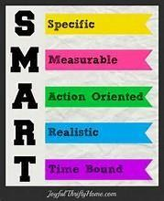
Now try setting 4-5 smart goals for the next fortnight! For example, A piece of
H/W you want to complete well or an upcoming test you want to perform well in.

Vision: Reflection
- Why is it important to have a positive vision to work towards?
- How often do you set goals (not daydreams) for yourself and give up? • Are your goals generally realistic or are you setting yourself up to fail?
- Do you acknowledge your successes or do you focus more on the times you gave up?
- How do you reward yourself or give yourself credit for achieving a goal?
Use the space below to record anything you would like to work on as a result of working through this section of VESPA on Vision.

