Transition Materials for A Level History

Introduction
It is great that you are considering studying History at A Level.
This pack contains a programme of activities and resources to prepare you to start an A Level in History in September. It is aimed to be used after you sign up for History on results day.

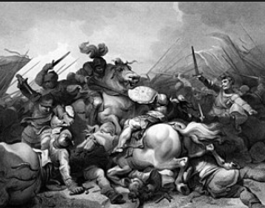
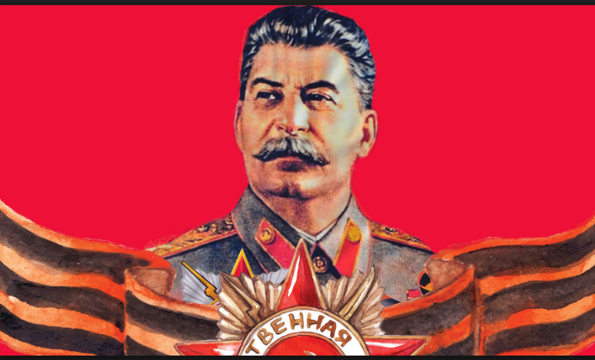

DUE DATE: 10th September
Any questions before school return – email fearonj@uptonhigh.co.uk
Contents
Tudors
- Reading List
  - Task 1
- Required Knowledge and Skills
  - Task 3 (questions 1-9)
- Baseline Assessment
  - Task 4

Russia
- Reading List
  - Task 1
- Independent Research
  - Task 2 (a-e)
- Required Knowledge and Skills
  - Task 3 (1&2)
- Baseline Assessment
  - Task 4

The Tudors:
England, 1485 - 1603
1. Reading List
Fiction
- The White Queen, Phillippa Gregory
- The Red Queen, Phillippa Gregory
- The Kingmaker’s Daughter, Phillippa Gregory
- The Sunne in Splendour, Sharon Kay Penman
- Winter King: the Dawn of Tudor England Penn, T. (2012)
- Richard III, William Shakespeare
Non-Fiction
- The Plantagenets, Dan Jones (2013)
- The Hollow Crown: The Wars of the Roses and the Rise of the Tudors, Dan Jones (2015)
- The Wars of the Roses, Michael Hicks (2012)
- The Family of Richard III, Michael Hicks (2015)
- Winter King: The Dawn of Tudor England, Thomas Penn (2012)
- Tudor: The Family Story. De Lisle, L. (2014)
- The King's Grave: The Search for Richard III, Jones, M. and Langley, P. (2014),
- Bosworth: The Birth of the Tudors Skidmore, C. (2014),
Film Resources
- The White Queen
- The Hollow Crown
- Richard III (1995)
- The Other Boleyn Girl (2003)
- Wolf Hall (2015)

TASK 1
Read one of the books on Tudor England (this can be fiction or non fiction)
Write a short report of the book (approx. 500words)
Consider
Questions to answer in your report.
• Can you identify why this book is on the summer reading list?
• What did you learn about the subject?
• What surprised you about the book?
• Which part of the book was the most helpful to your understanding? Why?
• What did you learn about learning itself?

- Required Knowledge and Skills
TASK 3
1) Draw a timeline explaining the Wars of the Roses.
2) What was the role of a medieval king? How does this differ when compared with the role of the British monarch today?
3) What was life like in medieval England? Create A3 fact files for each aspect, such as landscape, economy, education, religion and food. Feel free to add extra fact files following your research.
4) What role did religion play in Tudor England? What was the religious landscape of Europe in the C16th? Tip: Download and annotate a map of Europe.
5) Draw a family tree of the Tudors. Add images.
6) What is a Usurper? What was Henry VII’s claim to the throne?
7) Research the Princes in the Tower. What do you think happened to them? What motive would Richard III have had for murdering the boys?
8) Outline the key events of the Battle of Bosworth.
9) Why was Elizabeth of York’s marriage to Henry Tudor important?

4. Baseline Assessment
TASK 4
‘Henry VII deserved to become King of England in 1485’. Explain why you agree or disagree with this view.

Answer the above essay question.
You should aim to write at least 4 paragraphs and a conclusion..
Your teacher will be looking for the following:
• A balanced answer
• Arguments supported by precise historical knowledge
• Well-structured paragraphs
• A clear judgement that is sustained throughout your essay
Use the information in parts 1-3
You may also wish to use
https://publish.illinois.edu/nguyenhist446/2015/09/13/the-legitimacy-of-henry-vii-an-argument-for-henry-tudors-claim/
http://www.bbc.co.uk/history/people/henry_vii/
https://www.britishhistorytours.com/history-blog/the-controversial-king-how-the-tudors-came-to-rule-1
Transition materials for A Level History
Russia
1.Reading List
Books – Non Fiction
- Russian History: A very short introduction: Geoffrey Hosking – This book discusses all aspects of Russian history, from the struggle by the state to control society to the transformation of the nation into a multi-ethnic empire, Russia's relations with the West, and the post-Soviet era.
- Stalin: A Biography: Robert Service – A full assessment of Stalin from his early years in Georgia, his youthful activism, his relationship with Lenin, his family and his party members.
- The Russian Revolution: A Very Short Introduction – S.A Smith – This focusses on the main events and developments in Soviet Russia between 1917 – 1936.
- The Whisperers: Private Life in Stalin's Russia. Figes, O. (2008)
- Ten Days that Shook the World. Reed, J.(1919)
Books – Fiction
- Archangel. Harris, R. (2009),
- The Road of Bones: Fine, Anne - Based on life in Russia under Stalin, it is a fable about the nature of totalitarianism. It reveals how power corrupts and how quickly the oppressed can become the oppressors.
- Natasha’s Will: Joan Lingard - A dangerous journey into exile during the Russian Revolution. When Natasha’s grandfather is arrested in St Petersburg in 1917, her aristocratic family are forced to flee for their lives.
- Animal Farm: A Fairy Story: George Orwell – A well- known classic story detailing the events leading up to the Russian Revolution of 1917.
Films
- The Romanovs – An Imperial Family – A Russian film with subtitles, set in 1917 focussing on the last days of Tsar Nicholas II and the rest of the Romanov family.
- Enemy at the Gates – Set in 1942, in the Battle of Stalingrad, the main character, Vasily Zaytsev (played by Jude Law), becomes the poster boy for the Red Army due to his sniper skills.
- Animal Farm – The cartoon version of the book, showing the events leading up to the Russian Revolution.
- Child 44 – Featuring Tom Hardy, the film follows a disgraced member of the Russian military police. Charged with investigating a series of child murders during the Stalin era, where supposedly this sort of crime doesn’t exist.
- Bridge of Spies – Featuring Tom Hanks, an American lawyer is recruited to defend an arrested Soviet spy in court, and organise an exchange of the spy for a captured American pilot.
Read one of the books on Russia (this can be fiction or non fiction)
Write a short report of the book (approx. 500words)
Consider
Questions to answer in your report.
• Can you identify why this book is on the summer reading list?
• What did you learn about the subject?
• What surprised you about the book?
• Which part of the book was the most helpful to your understanding? Why?
• What did you learn about learning itself?
2. Independent Research
TASK 2
  - 1855-1905 – Alexander II, Alexander III, Nicholas II
Task: Create a one page fact file on each Tsar.
Each should include: Name, reign, family background, events during his reign, impact, end of reign, death.
3. Required Knowledge and Skills
TASK 3
Key Pre Knowledge topics
1. Glossary of key terms – Create a glossary of the following words:
• Tsar
• Liberalism
• Revolution
• Intelligentsia
• Serf
• Serfdom
• Zemstva
• Emancipation
• Taxation
• Autocracy
• Slav
• Communism
• Capitalism
• Assassination
• Bolshevik
• Menshevik
• Cheka
• Soviets
• New Economic Policy
• Politburo
• Proletariat
• Bourgeoisie
• Collectivisation
• Gulag
• Totalitarian
Baseline Assessment
TASK 4
Based on the research you have done
1. “Stalin was a ruthless dictator” How far do you agree with this statement?
Suggested structure:
Four paragraphs (two arguing each side), and a conclusion.

