As you know, the importance of background reading in Politics is essential. It can be the difference between getting the grade you are currently looking at and the grade you need.
Below is a list of worthwhile books for you to read. I’ve even made it easy for you by linking the relevant page in Amazon (other booksellers are available – or try your local library!) You need to read at least one of these books over the summer. If you’d prefer, you may choose an equivalent book.
You will then need to complete a brief (500 word) review, containing a short summary of the book and its main ideas.This should also include a short piece of reflective writing on the book, such as what you found particularly interesting about it. You will need to present this in class during the first week back. There will be a prize for the best review.
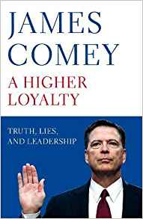
Click on the book for a hyperlink to the relevant Amazon page…


