A-LEVEL POLITICS


POLITICS: SUMMER RESEARCH TASK 2019

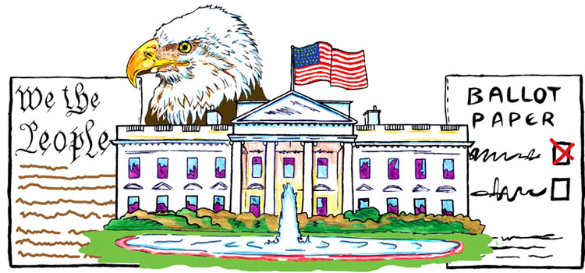
You are to produce a fact-file on US Politics. It is important you complete this over the summer and bring to the first week of lessons. This will be an invaluable resource for your study of A2 politics.
A level Politics Summer Task

Your fact-file needs to include the following:-
- Give a brief overview of each section of the US constitution
- Outline what Articles 1-7 of the constitution contains. No more than 30 words each.
- Outline the two powers of each of the following:
- Legislative branch (article 1)
- Executive branch (article 2)
- Judicial branch (article 3)
- Give a list of Amendments 1-27 (Year they were ratified Define/Explain what each amendment means) to the US Constitution. (Please remember I do not mind if these are downloaded I simply want you to have them to hand and have a solid knowledge of them.
- List the 5 amendments that you think are the most important.

- List of presidents since 1945, Year in power, Party, Electoral college votes and popular vote.

- The current party (Democrats and Republicans) balance in Congress:-
i) House of Representatives: How many republicans and democrats
ii) Senate: How many republicans and democrats (and independents)

- Outline the amount of the following in the 116th Congress. (2019-2021)

- Women
- African Americans
- Hispanics
- Native Americans

- Who holds the following leadership positions in Congress:-
- Speaker of the House of Representatives
- House and Senate majority and minority leaders
- President pro-tempore
- House and Senate majority and minority whips

- List of select committees in Congress.

- i. List of the 9 Supreme Court Justices ii. The last 4 ‘Chief Justices’ of the US Supreme Court and the terms the served for. iii) Barack Obama’s and Donald Trump’s appointments to the Supreme Court 2008-present.

- Create a diagram of the systems of ‘checks and balances’ of the powers of the 3 Branches of US Government (Legislative, Executive, Judiciary)

- Explain the process of electing the US President
- Outline the result of the last 3 presidential election results (2008,2012 and 2016) --How many (a) Electoral college votes (b) Popular vote did each candidate achieve?
- List 5 candidates for the Democratic nomination for president for 2020.
- Research into the 2000 US presidential election. Explain the result and explain why it was a controversial election.

- Offices/departments that make up the Executive Office of the President:- Who is a) White House Chief of Staff b) White House Press Secretary c) National Security Advisor.

- A brief profile of the following US pressure groups:-

- National Rifle Association
- EMILYS List
- American Civil Liberties Union
- National Association for the Advancement of Colored People
- National Conservation League
- AFL-CIO

- Provide a definition of the following terms.

- Divided government
- Earmarking and Logrolling
- Invisible primaries
- Gerrymandering
- Partisanship
- Pork barrel
- Affirmative Action
- Executive Orders
- Executive Agreements
- Iron Triangles

This fact file is intended to be used as a study aid to help you in your second year of study. With this in mind you may need to make amendments at a later date so save an electronic copy.
- Please make it as detailed as possible.
- Try to create tasks which are not simply lists in your own words try not to just copy and paste.
- Please word process your fact-file.
- Make sure your fact file is presentable -use pictures to illustrate your fact file
- This will form part of your initial assessment.
- There will be a prize for the best fact file (I have no idea what this will be at this point).
Submission Date: End of the first week back

Week beginning... | UK political news stories | US political news stories
24th June
1st July
8th July
15th July
22nd July
29th July
5th Aug
12th Aug
19th Aug
26th Aug
2nd Sept
Colour code:UK USA
Democracy and participation US Constitution and Federalism
Political parties Congress
Electoral systems US Presidency
Voting behaviour and the media The Supreme Court and Civil Rights
The Constitution Democracy and Participation
Parliament Comparative Approaches
Prime minister and executive
Relationship between institutions/Supreme Court

