Anatomy & Physiology, Exercise physiology assignments Year 1 A level PE
Assignment 1 - Skeletal system
- The skeleton can be said to have 2 parts what are they? (2 marks)

- Describe the functions of the skeleton. (5 marks)

- Explain the functions of flat, short, long, irregular, & sesamoid bones. Provide an example of a bone doing this to clarify your answer. (10 marks)

- Describe the key components of a synovial joint. (5 marks)

- Choose 2 of these components & critically evaluate their importance for having a healthy functioning joint. (4 marks)

- What is the most stable & unstable synovial joint? Justify your answer. (4 marks)

- Provide actions from gymnastics that move in a; frontal, sagittal, transverse plane. (3 marks)

- Describe how this athletes body would move if they were to create; 1) Shoulder flexion, 2) Hip abduction, 3) Plantar flexion, 4) Hip flexion, 5) Arm rotation (5 marks)

Assignment 2 – Muscular system
- Explain what the origin & insertion are on a muscle, give an example in the body of each. (4 marks)

- True or False, Tendons & Ligaments do the same job as they both attach onto bone and their purpose is to stabilise joints? (1 mark)

- Describe the role of agonist, antagonist & fixator muscles. (3 mark)

- State 4 muscles that create Abduction? (4 marks)

- Which muscles are pointed at on the diagram? (4 marks)

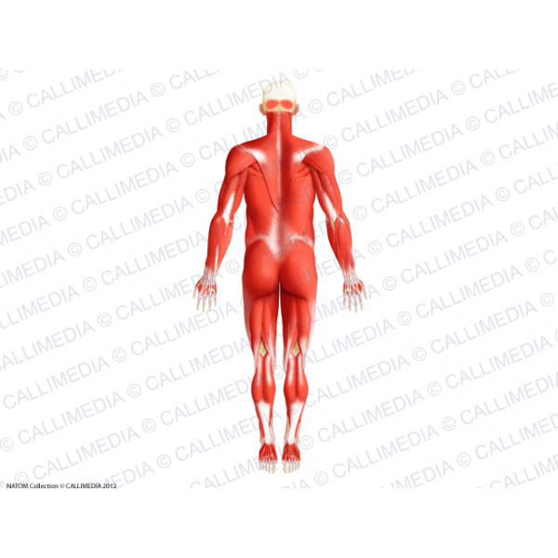
B
D
A
C

- Give examples of concentric, eccentric & isometric contractions in rugby? (3 marks)

- Explain all the components of a motor unit. (5 marks)

- What does the ‘all-or-none’ rule mean? (2 marks)

- Mo Farah has a large percentage of slow oxidative muscle fibres, explain why these fibres help him excel in his endurance events. (5 marks)

- Explain why a centre midfielder in football or centre in netball needs all 3 fibre types. (6 marks)

