Y11 to 12 Bridging Task

Chains of Analysis
One of the key skills in A level Business is to be able to write what are called chains of analysis. This is a way of extending a point into a paragraph with an end objective at the end.

To illustrate this lets take a question

Why does Mr Jones drink tea at break?

There could be lots of starters here, he’s thirsty, he likes the taste, it’s a sociable activity etc. Lets take one:

He’s thirsty therefore tea quenches his thirst.

Not really a paragraph so we need to extend it:

He’s thirsty therefore tea quenches his thirst. This means he will not be dehydrated. As a result, his brain will function better. This is important since Mr Jones is a teacher and uses his brain in his job. Therefore his lessons will be better than without drinking tea ultimately students will learn more and therefore grades will improve.

You might notice two additional things one is context, yes its about me and there is detail specifically about me ie I’m a teacher, how lessons are affected, students etc. This will be required in your essay and analytical answers which will be based upon a Business Case Study. Secondly the paragraph ends with an important objective. In a Business sense this would be one of the following:

Business Survival
Profitability
Other factors which lead ultimately to profitability such as business growth, increasing market share, maximising sales, maximizing revenue improving efficiency etc.
Social objectives such as being ethical or environmental.

Task 1 In your own words define the following:
Profit
Ethics
Market Share
Revenue
Efficiency
Social Objectives

Task 2
Using the techniques outlined before answer the following using any contextual information you can find on the internet. Your answer should have at least 2 points and therefore 2 paragraphs. There is no need for a conclusion.

Analyse why Richard Branson wanted to go to space.

Task 3

Research what a business plan is and why they are done.

Then answer the analysis question from a past A level paper, using some detail from the case study to add some context to your answer.

Will produced ‘a very detailed business plan’ (Line 15) and it helped him to gain the finance he needed to start WFC.
Other than helping to raise finance, analyse one likely advantage to Will of producing a detailed business plan for the start-up of his business.

Wills Fish and Chips
“It all started because I had a relative who owned a fish and chip shop and he asked me to help him out when he was ill. I was interested in the nature of the business and the interaction with the customers. I took a job in a local fish and chip shop and enjoyed it but felt that I could do better in terms of product and service.” So said Will Stevenson, the entrepreneur who opened an award-winning fish and chip shop in Middleton, close to central Milton Keynes.
Will’s Fish and Chips (WFC) was started in 2007 and finding the right location was a challenge. Will looked at the plans available from the council, including the plans for house construction that was to take place. He knew the vast majority of his customers would be local; most likely living within one or two miles of the shop. Fish and chips is a product that is best eaten fresh; once out of the shop it does not ‘travel’ well and customers are unlikely to drive for miles, especially as there are so many other fast-food outlets nearby. Location was therefore a crucial factor in the business’ success. WFC is currently open six days a week, Monday to Saturday from 11.30 am until 2.00 pm and from 4.30 pm until 10.00 pm.
The ‘start up’ process for WFC was lengthy. Will chose to establish WFC as a sole trader and raising the finance was not easy. Despite a very detailed business plan, several banks said that the venture was too risky and that they would not provide the necessary funding. As well as purchasing the shop there was a large amount of capital equipment involved; freezers and fryers are expensive with the typical cost for the equipment between £40,000 and £50,000. Some of the frying equipment has to be replaced on a regular basis, for example a ‘deep frying pan’ can cost around £5,000.
However, the finance was eventually raised via a bank loan and some personal savings. To raise the funds it was necessary for Will to construct a business plan and while doing so he had to consider a number of legal factors.
Once established, it was obvious that WFC faced a lot of competition and the years following the 2008 recession were difficult, although the Bank of England’s decision to keep the UK interest rate very low certainly helped WFC. The combination of the downturn in the economy and plenty of local competition for trade meant it was clear that a unique selling point (USP) was going to be of key importance. The shop has a website, although WFC’s marketing has always reflected the local nature of the business.
WFC’s USP is the product and the way it is served. Although other products are on sale, such as pies and pasties, WFC offers what Will considers to be ‘the traditional fish and chip experience’. To ensure this, both the fish and the batter are prepared in small batches and the frying oil is cleaned twice a day, in order to ensure freshness and good taste. He is very critical of other fish and chip shops that sell poorly cooked, greasy fish served with a ‘here you are approach’ rather than a smile and some conversation. Will’s aim is to offer a local service for local customers. This approach is distinctive because the large fast-food national chains do not do this. If a customer wants to stand and chat, Will and his staff are happy to do so. This means that, when recruiting, Will looks for potential employees who are outgoing and friendly.
All staff are trained in customer service and health and safety issues. Will ensures that his staff are fully aware of his business philosophy and WFC has developed a loyal customer base that comes mainly from repeat local customers who, knowing that they will get a freshly cooked meal with some conversation, come back time and again.
WFC has won a number of awards over the past few years, most recently the ‘Regional Takeaway Fish and Chip Shop of the Year’. WFC also has a 5-star hygiene ‘scores on the doors’ rating.
There is some discussion in the industry as to whether fish and chips is a ‘luxury’ or ‘a value for money meal’. The products on sale at WFC are aimed at those of all income levels. The average price of a meal is £6 and most customers pay in cash. Demand is considerably higher on a Friday and Saturday night. On a payday, at the end of the month, the shop is also much busier.
On average, two weeks’ stock is held in the freezers. WFC’s costs can change quite rapidly, since fish and vegetable prices can vary according to national supply and demand. Will does not like to continually alter prices but he recognises that WFC has to react to cost and demand factors, to a greater or lesser extent. Based on past experience and trends, Will has come up with the data shown in Table 1. At the current average price of £6, WFC sells on average 3,100 meals per month.
WFC is operated in an environmentally responsible manner. Fish is sourced from sustainable stocks. As many other ingredients as possible are sourced locally to support local trade and to reduce the carbon footprint. Will believes that sustainability is good for everyone, from the fishermen to those transporting the fish once they have been caught. He recognises that the success of one business in the supply chain is dependent on another. All packaging (glass, tin and cardboard) as well as oil from the shop is recycled.
Within the local community, the business supports several schools through the donation of raffle prizes, in the form of vouchers to use in the shop. There are collection tins in the shop for various charities, such as Help for Heroes and for people with Down’s syndrome.
Operating close to the town centre means there is a lot of competition which has intensified over the years. However, while competition has increased so have the opportunities for growth. Milton Keynes Development Partnership (MKDP), which is wholly owned by Milton Keynes Council, is an organisation which exists to help Milton Keynes’ continued growth and economic success. It plans to release land for development in two areas near WFC in the near future (see Fig. 1 & Table 2)

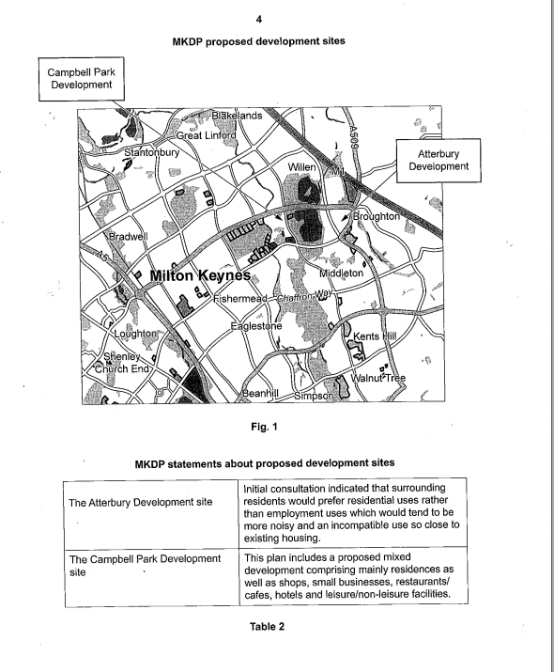

There comes a point where a sole trader operating from a single shop cannot grow any more, given the local nature of its customer base and the product it sells. Will is not at that point yet and, even after 10 years, the shop is still operating below full capacity which Will considers to be 5,000 meals a month, with the shop’s current opening hours. Will’s strategic objective is to increase the number of meals sold in the shop so that its capacity can be fully utilised by 2020. He has recently been considering ways to achieve this. One way may be via local advertising including:
• A local newspaper, the MK Citizen. This is also published online and readers are able to access an archive to find past articles and advertisements.
• A local radio station, MKFM which broadcasts across Milton Keynes and Buckinghamshire as well as three adjoining counties, with a potential audience of two million listeners.
Will has gathered some basic cost data about both of these (see Tables 3 & 4)



