A Level Chemistry

Transition Task

Name……………. Mark …./122

What do you need to do?

Answer the questions in the booklet. You can use:
- GCSE revision guide
- BBC Bitesize
- Doc Brown Chemistry (docbrown.info)
You can search clips on You Tube. Fuse School and Cognito have some great clips. Just search the topic you want, but add GCSE to it, to ensure it is at the correct level!

When you return to school, your teacher will collect this in, then review the work in class.

A couple of weeks later you will have an assessment on the basic things you should know when starting A Level Chemistry. Completing this task will help you prepare for the Assessment and for A Level Chemistry!

Q1. The table shows the formulae of six organic compounds, A, B, C, D, E and F.
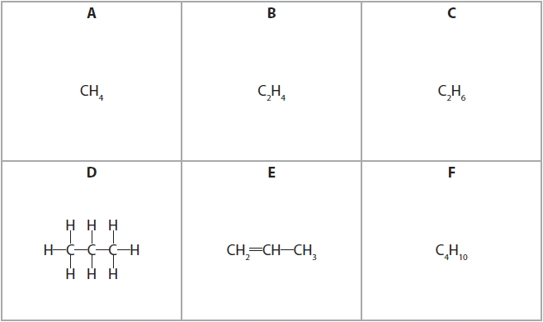

(a) State why each of these compounds is a hydrocarbon.
(2)
.............................................................................................................................................
.............................................................................................................................................

(b) State why the formula given for D is called a displayed formula.
(1)
.............................................................................................................................................
.............................................................................................................................................

(c) Give the letters that represent the four compounds with the general formula C_{n}H_{2n+2}
(1)
.............................................................................................................................................

(d) Many of the compounds in the table are found in a fuel called shale gas.
Shale gas contains many different compounds, including methane, propane and hydrogen sulfide (H₂S).

(i) Complete the equation to show the complete combustion of propane.
(2)
C₃H₈ + 5O₂ → ................................ + ................................

(ii) When shale gas is burned, the hydrogen sulfide reacts with oxygen.
2H₂S + 3O₂ → 2SO₂ + 2H₂O
Explain how the combustion of shale gas can lead to the formation of acid rain.
(2)
.............................................................................................................................................
.............................................................................................................................................
.............................................................................................................................................
.............................................................................................................................................
.............................................................................................................................................
.............................................................................................................................................

(Total for question = 8 marks)

Q2. The diagram shows the structures of two different atoms.
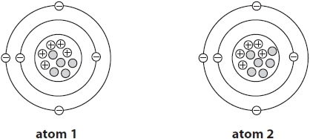
(a) State how the diagram shows that both of these atoms are neutral.
(1)
.............................................................................................................................................
.............................................................................................................................................
(b) Explain how the diagram shows that these atoms are isotopes.
(2)
.............................................................................................................................................
.............................................................................................................................................
.............................................................................................................................................
.............................................................................................................................................
(c) Complete the table to show the atomic number and mass number of atoms 1 and 2.
(2)
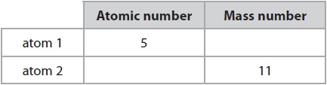
(d) The table shows the mass number and percentage of two different atoms of another element.
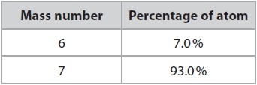
Calculate the relative atomic mass (A_{r}) of this element.
Give your answer to one decimal place.
(2)
relative atomic mass = ...........................................................
(Total for question = 7 marks)

Q3. This question is about alkanes.
(a) The graph shows the boiling points of several unbranched alkanes.
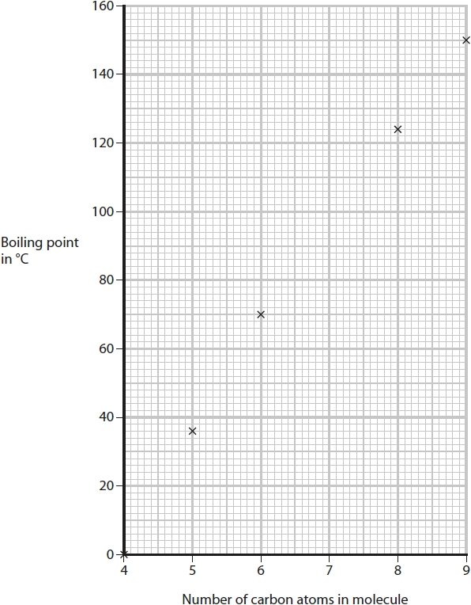
(i) Draw a curve of best fit.
(1)
(ii) Use the graph to find the boiling point of the alkane with 7 carbon atoms in its molecule.
Show on the graph how you obtain your answer.
(2)
boiling point = ........................................................... °C

(iii) Explain the trend shown by the graph.
(3)
.............................................................................................................................................
.............................................................................................................................................
.............................................................................................................................................
.............................................................................................................................................
.............................................................................................................................................
.............................................................................................................................................

(Total for question = 6 marks)

Q4. Halon 1301 is a compound used in some fire extinguishers.
Halon 1301 has the percentage composition by mass of
(a) Show, by calculation, that the empirical formula of this compound is CBrF₃
(2)

(b) The diagram shows the displayed formula of a molecule of Halon 1301.
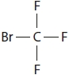
Draw a dot-and-cross diagram to show all the outer electrons in this molecule.
(2)

(c) The boiling point of Halon 1301 is −58 °C.
Explain why Halon 1301 has a low boiling point.
(2)
.............................................................................................................................................
.............................................................................................................................................
.............................................................................................................................................
.............................................................................................................................................

(Total for question = 6 marks)

Q5. Lead nitrate and potassium iodide react to form the insoluble solid lead iodide.
Crystals of lead nitrate and potassium iodide are placed at opposite ends of a container of water.
Solid lead iodide forms after several minutes.
The diagram shows the container at the start and after several minutes.
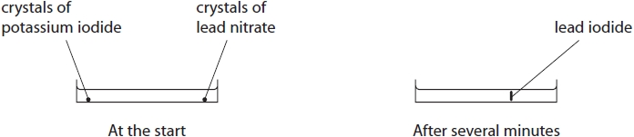
(a) Name the two processes that occur before the solid lead iodide forms.
(2)
1 ..........................................................................................................................................
2 ..........................................................................................................................................
(b) Explain why solid lead iodide takes less time to form when the reaction is repeated using water at a higher temperature.
(2)
.............................................................................................................................................
.............................................................................................................................................
.............................................................................................................................................
.............................................................................................................................................
(c) The formula for lead nitrate is Pb(NO₃)₂
(i) Give the number of different elements in lead nitrate.
(1)
.............................................................................................................................................
.............................................................................................................................................
(ii) Give the charge on the lead ion in Pb(NO₃)₂
(1)
.............................................................................................................................................
(d) Complete the chemical equation for the reaction between lead nitrate and potassium iodide.
(1)
Pb(NO₃)₂(aq) + ............................... KI(aq) → PbI₂(s) + ............................... KNO₃(aq)

(Total for question = 7 marks)

Q6. The diagram shows the electronic configuration of an atom of an element.
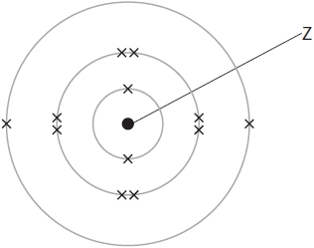
(a) Complete the table by giving the missing information about this atom.
(5)
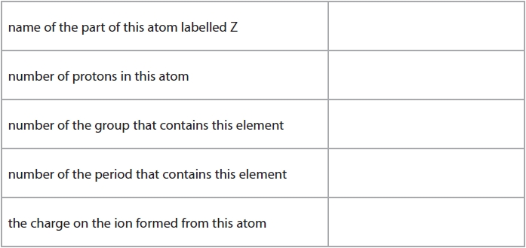
(b) This element has three isotopes.
The table shows the mass number and percentage abundance of each isotope in a sample of this element.
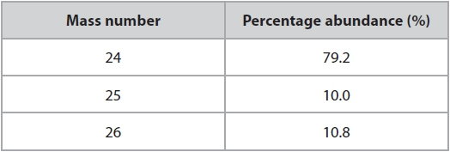
Calculate the relative atomic mass (A_{r}) of this element.
Give your answer to one decimal place.
(3)

relative atomic mass = ...........................................................
(Total for question = 8 marks)
Q7. Substances can be classified as elements, compounds or mixtures.
(a) Each of the boxes in the diagram represents either an element, a compound or a mixture.
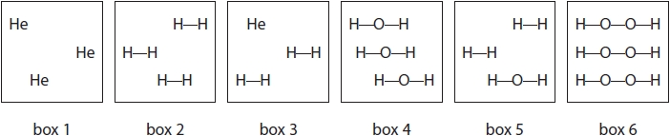
(i) Explain which two boxes represent an element.
(2)
.............................................................................................................................................
.............................................................................................................................................
.............................................................................................................................................
.............................................................................................................................................
(ii) Explain which two boxes represent a mixture.
(2)
.............................................................................................................................................
.............................................................................................................................................
.............................................................................................................................................
.............................................................................................................................................
(b) The list gives the names of some methods used in the separation of mixtures:

• chromatography
• crystallisation
• distillation
• filtration

Use names from the list to choose a suitable method for each separation.
Each name may be used once, more than once or not at all.

(i) Separating water from sodium chloride solution.
(1)
.............................................................................................................................................
(ii) Separating the blue dye from a mixture of blue and red dyes.
(1)
.............................................................................................................................................
(iii) Separating potassium nitrate from potassium nitrate solution.
(1)
.............................................................................................................................................

(Total for question = 7 marks)

Q8. A salt can be made by reacting an acid with an insoluble base.
A student has a sample of copper(II) oxide.
The student uses this method.
Stage 1 pour 50 cm³ of dilute sulfuric acid into a beaker
Stage 2 warm the acid using a Bunsen burner
Stage 3 add a small amount of copper(II) oxide to the warm acid and stir the mixture
Stage 4 add further amounts of copper(II) oxide until copper(II) oxide is in excess
Stage 5 filter the mixture
Stage 6 obtain crystals from the filtrate

(a) State why the acid is warmed in stage 2.
(1)
.............................................................................................................................................
.............................................................................................................................................

(b) State how the student would know that the copper(II) oxide is in excess in stage 4.
(1)
.............................................................................................................................................
.............................................................................................................................................

(c) State why the mixture is filtered in stage 5.
(1)
.............................................................................................................................................
.............................................................................................................................................

(d) State the colour of the filtrate obtained in stage 5.
(1)
.............................................................................................................................................

(e) Describe how the student could obtain a pure, dry sample of hydrated copper(II) sulfate crystals from the filtrate in stage 6. (more space on next page)
(5)
.............................................................................................................................................
.............................................................................................................................................
.............................................................................................................................................
.............................................................................................................................................
.............................................................................................................................................
.............................................................................................................................................
.............................................................................................................................................
.............................................................................................................................................
.............................................................................................................................................
.............................................................................................................................................
.............................................................................................................................................
.............................................................................................................................................
.............................................................................................................................................
.............................................................................................................................................
.............................................................................................................................................
(f) The overall equation for the formation of hydrated copper(II) sulfate crystals from copper(II) oxide is
(i) In an experiment, a student completely reacts 9.54 g copper(II) oxide.
Show that the maximum possible mass of CuSO₄.5H₂O crystals that can be obtained is about 30 g.
[M_{r} of CuO = 79.5 M_{r} of CuSO₄.5H₂O = 249.5]
Give your answer to an appropriate number of significant figures.
(3)
mass = ........................................................... g
(ii) In this experiment, the actual yield of CuSO₄.5H₂O crystals is 23.92 g.
Calculate the percentage yield of CuSO₄.5H₂O
(2)
percentage yield = ........................................................... %

(Total for question = 14 marks)

Q9. A student uses this apparatus to investigate the colours in four different inks, A, B, C and D.
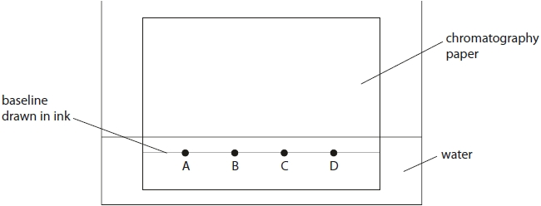
(a) Explain two mistakes the student made when setting up his experiment.
(4)
1 ..........................................................................................................................................
.............................................................................................................................................
.............................................................................................................................................
.............................................................................................................................................
2 ..........................................................................................................................................
.............................................................................................................................................
.............................................................................................................................................
.............................................................................................................................................
(b) Another student does the experiment but does not make any mistakes.
The diagram shows her results.
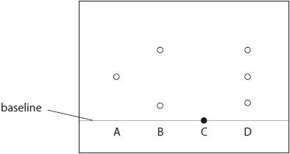
(i) State how many colours ink D contains.
(1)
.............................................................................................................................................
(ii) State which of the inks tested could be mixed together to make ink D.
(1)
.............................................................................................................................................
(iii) Explain which of the inks tested is insoluble in water.
(2)
.............................................................................................................................................
.............................................................................................................................................
.............................................................................................................................................
.............................................................................................................................................

(Total for question = 8 marks)

Q10. This question is about ionic compounds.
(a) The table shows the formulae of some positive and negative ions, and the formulae of some compounds containing these ions.
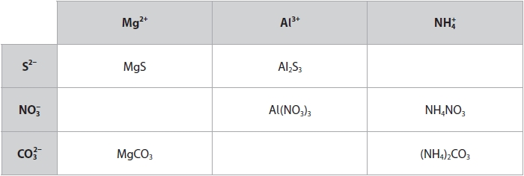

(i) Complete the table by giving the three missing formulae.
(3)
(ii) Give the name of the compound with the formula NH₄NO₃
(1)
.............................................................................................................................................
(b) Sodium oxide, Na₂O, is an ionic compound.

The sodium and oxide ions are held together by ionic bonds.

(i) State the meaning of the term ionic bond.
(2)
.............................................................................................................................................
.............................................................................................................................................
.............................................................................................................................................
.............................................................................................................................................

(ii) The diagram shows the arrangement of the electrons in a sodium atom and in an oxygen atom.
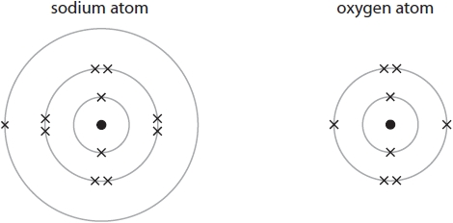
Draw diagrams in the boxes to show the arrangement of the electrons in the ions of sodium oxide.
Include the charges on the ions.
(3)
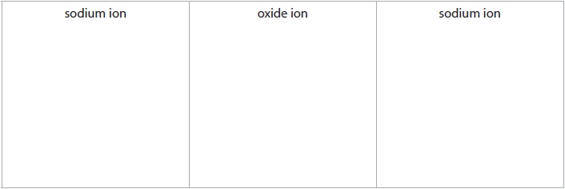

(Total for question = 9 marks)

Q11. This question is about the elements in Group 1 of the Periodic Table and their reactions with water.
(a) State why sodium and potassium are in Group 1 of the Periodic Table.
(1)
.............................................................................................................................................
.............................................................................................................................................
(b) A reaction occurs when a small piece of sodium is added to a large volume of water in a trough.
(i) Give two observations that you would make during this reaction.
(2)
1 ..........................................................................................................................................
.............................................................................................................................................
2 ..........................................................................................................................................
.............................................................................................................................................
(ii) After the reaction has finished, a few drops of universal indicator are added to the solution in the trough.
Explain the final colour of the universal indicator.
(2)
.............................................................................................................................................
.............................................................................................................................................
.............................................................................................................................................
(iii) What is the most likely pH value of the solution in the trough after the reaction is complete?
(1)
A 2
B 5
C 8
D 12
(c) Give the name of a Group 1 metal that is less reactive than sodium.
(1)
.............................................................................................................................................
(d) A small piece of potassium is added to a large volume of water in a trough.
Give one observation that is made when potassium is added to water that is not made when sodium is added to water.
(1)
.............................................................................................................................................
.............................................................................................................................................
(e) Complete the equation for the reaction of rubidium with water.
State symbols are not required.
(1)

(Total for question = 9 marks)

Q12. This question is about the halogens.
(a) The table gives some information about the halogens.
Complete the table by predicting the physical state of astatine at room temperature and the colour of astatine.
(2)
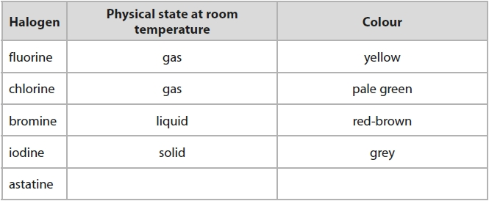

(b) Bromine has two isotopes with mass numbers 79 and 81

(i) The relative percentages of each isotope in a sample of bromine are
bromine-79 = 51.0% bromine-81 = 49.0%

Calculate the relative atomic mass of this sample of bromine.
Give your answer to one decimal place.
(3)
relative atomic mass = ...........................................................

(ii) Give a reason why both isotopes of bromine have the same chemical properties.
(1)
.............................................................................................................................................
.............................................................................................................................................
(c) A student investigates the reactivity of some halogens.
She uses these solutions of halogens and their halides.
• bromine, chlorine and iodine
• sodium bromide, sodium chloride and sodium iodide
She adds each halogen solution to each halide solution.
The table shows her results.
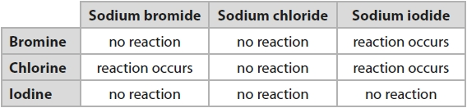

(i) Explain how these results show the order of reactivity of bromine, chlorine and iodine.
(3)
.............................................................................................................................................
.............................................................................................................................................
.............................................................................................................................................
.............................................................................................................................................
.............................................................................................................................................
.............................................................................................................................................

(ii) Suggest why the student does not need to add bromine solution to sodium bromide solution.
(1)
.............................................................................................................................................
.............................................................................................................................................
.............................................................................................................................................

(iii) The ionic equation for the reaction between bromine and sodium iodide is
Br₂(aq) + 2I⁻(aq) → I₂(aq) + 2Br⁻(aq)
Explain why this is a redox reaction.
(2)
.............................................................................................................................................
.............................................................................................................................................
.............................................................................................................................................
.............................................................................................................................................

(Total for question = 12 marks)

Q13. (a) Table 1 shows the formulae of some ions.
It also shows the formulae of some compounds containing these ions.
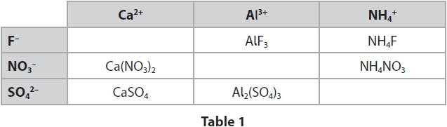
Complete Table 1 by giving the missing information.
(3)
(b) Table 2 gives information about aluminium fluoride and aluminium bromide.
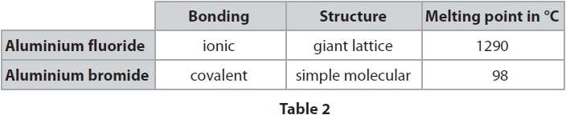
Explain the difference between the melting points of aluminium fluoride and
aluminium bromide. Refer to bonding and structure in your answer.
(5)
.............................................................................................................................................
.............................................................................................................................................
.............................................................................................................................................
.............................................................................................................................................
.............................................................................................................................................
.............................................................................................................................................
.............................................................................................................................................
.............................................................................................................................................
.............................................................................................................................................
.............................................................................................................................................
.............................................................................................................................................
.............................................................................................................................................
.............................................................................................................................................
.............................................................................................................................................
(Total for question = 8 marks)

Q14. Diamond, graphite and silicon dioxide all have giant covalent structures.
The diagram shows the structures of these three substances.
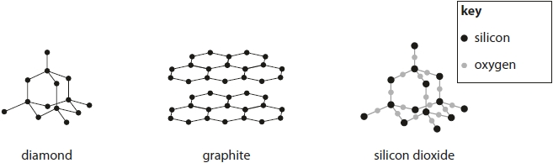

(a) Explain why silicon dioxide has a high melting point.
(2)
.............................................................................................................................................
.............................................................................................................................................
.............................................................................................................................................
.............................................................................................................................................

(b) Explain why graphite conducts electricity.
(2)
.............................................................................................................................................
.............................................................................................................................................
.............................................................................................................................................
.............................................................................................................................................

(c) State why diamond is hard but graphite is soft.
(2)
.............................................................................................................................................
.............................................................................................................................................
.............................................................................................................................................
.............................................................................................................................................

(Total for question = 6 marks)

Q15. Ammonium chloride decomposes in a reversible reaction. The equation for this reaction is
(a) State how the equation shows that the reaction is reversible.
(1)
.............................................................................................................................................
.............................................................................................................................................
(b) Some ammonium chloride is heated gently in a test tube.
The diagram shows the test tube after it has been heated gently for a short time.

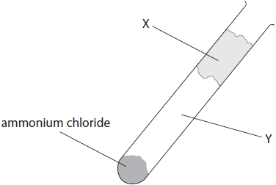

(i) Identify solid X and the two gases formed in region Y of the test tube.
(2)
Solid X .................................................................................................................................
Gases in region Y ..................................................................................................................
.............................................................................................................................................

(ii) Which change of state occurs in the test tube during heating?
(1)
A condensing
B evaporating
C melting
D subliming

(c) An experiment involving ammonium chloride can be used to show the process of diffusion.
The diagram shows the apparatus at the start of the experiment.

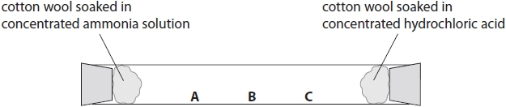

At the end of the experiment, a white solid forms in the test tube.
Explain which position, A, B or C, shows where the white solid forms.
(3)
.............................................................................................................................................
.............................................................................................................................................
.............................................................................................................................................
.............................................................................................................................................
.............................................................................................................................................
.............................................................................................................................................
.............................................................................................................................................
.............................................................................................................................................
.............................................................................................................................................

(Total for question = 7 marks)

