Induction task for A Level History
Introduction
It is great that you are considering studying History at A Level.
This pack contains a programme of activities and resources to prepare you to start an A Level in History in September. It is aimed to be used after you sign up for History on results day. However due to the challenges of COVID 19 we will be making this available at an earlier time and expecting a greater amount of content to be covered.
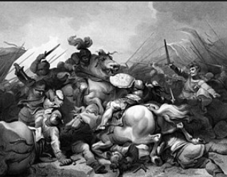

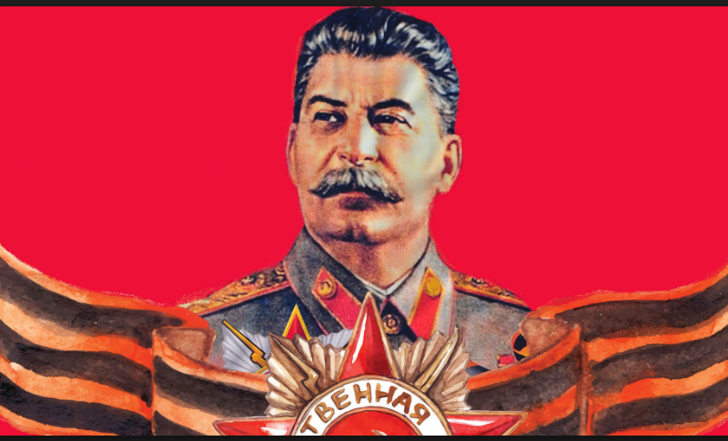

DUE DATE: Friday of the first full week back.
- Any questions before school return – email
- fearonj@uptonhigh.co.uk
- maink@uptonhigh.co.uk

Contents & tasks

Tudors
- Reading List (page 3)
  - Task 1 book review
- Section 2 The War of Roses & How Henry VII claimed the throne (pages 4-6)
  - Task 2 Questions A-M
- Section 3 Preparation for the Baseline Assessment (pages 7-8)
  - Task 3 Planning sheet
Russia
- Reading List (page 9)
  - Task 4 book review)
- Section 2 Conditions in Russia by 1914 (pages 10-23)
  - Task 5 (a-g)
- Section 3 Preparation for the Baseline Assessment Baseline Assessment (pages 24-25)
  - Task 6 Planning sheet

The Tudors:
England, 1485 - 1603
1. Reading List
Fiction
- The White Queen, Phillippa Gregory
- The Red Queen, Phillippa Gregory
- The Kingmaker’s Daughter, Phillippa Gregory
- The Sunne in Splendour, Sharon Kay Penman
- Winter King: the Dawn of Tudor England Penn, T. (2012)
- Richard III, William Shakespeare
Non-Fiction
- The Plantagenets, Dan Jones (2013)
- The Hollow Crown: The Wars of the Roses and the Rise of the Tudors, Dan Jones (2015)
- The Wars of the Roses, Michael Hicks (2012)
- The Family of Richard III, Michael Hicks (2015)
- Winter King: The Dawn of Tudor England, Thomas Penn (2012)
- Tudor: The Family Story. De Lisle, L. (2014)
- The King's Grave: The Search for Richard III, Jones, M. and Langley, P. (2014),
- Bosworth: The Birth of the Tudors Skidmore, C. (2014),
- G W Bernard, The Kings Reformation, Yale, (2005)
- C Carpenter, The Wars of the Roses, (1997)
- C S L Davies, Peace, Print and Protestantism, Paladin, (1995)
- G R Elton, England Under the Tudors, (1991)
- A Fletcher & D MacCulloch, Tudor Rebellions, (2004)
- S Gunn, Early Tudor Government, (1995)
- J Guy, Tudor England, (1998)
Film Resources
- The White Queen
- The Hollow Crown
- Richard III (1995)
- The Other Boleyn Girl (2003)
- Wolf Hall (2015)
- The Winter King (Avaliable on Youtube)
Task 1
Pick one book from the Tudor Reading list. and complete the reading review. This review should be approximately 500 words You should identify
• Can you identify why this book is on the summer reading list?
• What did you learn about the subject?
• What surprised you about the book?
• Which part of the book was the most helpful to your understanding? Why?

Section 2: The War of Roses & How Henry VII claimed the throne
This course is a study in breadth of issues of change, continuity, cause and consequence in this period.
During the course you will be assessed on your understanding of interpretations and your knowledge of the events covered.
For each monarch, you will consider:
- How effectively did the Tudors restore and develop the powers of the monarchy?
- In what ways and how effectively was England governed during this period?
- How did relations with foreign powers change and how was the succession secured?
- How did English society and economy change and with what effects?
- How far did intellectual and religious ideas change and develop and with what effects?
- How important was the role of key individuals and groups and how were they affected by developments?
For our summer tasks we will build up a context of what happened in England before Henry VII came to the throne. The Tudors is a very exciting era of history to learn about but it is vital to understand the context within which Henry Tudor (Henry VII) usurped the throne, so the late medieval history of events in 1400s England. How did this little known man with a very tenuous claim to the throne of England raise an army, gather supporters and defeat Richard III at Bosworth, 1485? Why was it that Richard III was so disliked? What impact had the 30 years of civil war had on England? You should research England from 1455-1485. This will contribute to an essay in the opening weeks of Year 12 where we consider why Henry deserved the throne
Complete some research on the wars of the Roses and Henry coming to the throne. I have included some useful websites below – but these are not the only places you can use. I’ve also uploaded a short section of a textbook to the google classroom
- https://www.redditch.tgacademy.org.uk/files/2016/02/War-of-the-Roses-Revision-Guide.pdf
- https://schoolshistory.org.uk/topics/british-history/wars-of-the-roses/
- https://publish.illinois.edu/nguyenhist446/2015/09/13/the-legitimacy-of-henry-vii-an-argument-for-henry-tudors-claim/
- http://www.bbc.co.uk/history/people/henry_vii/
- https://www.britishhistorytours.com/history-blog/the-controversial-king-how-the-tudors-came-to-rule-1
- https://www.historyonthenet.com/category/tudors
- https://www.thehistorypress.co.uk/the-tudors/?p=1&ps=9

- Watch https://www.youtube.com/watch?v=dANvIjbtuDk From the clip answer
    - What were the 2 sides in the Wars of the Roses?
    - What happened in 1461 on the 29th March and why was it exceptional?
    - What happened at the Battle of Bosworth according to the Tudors and Shakespeare?
    - What problems did Henry VII face immediately after Bosworth?
    - How did Henry use the story of the War of the Roses to solve his problems?
    - How did Historians under Henry VII manipulate the Wars of the Roses?
    - How did Henry VIII continue the propaganda started by his father?
    - What problems did Elizabeth I have when she became queen?
    - How did she use the War of the Roses to help her?
    - How and why did Shakespeare write about the Wars of the Roses in the 1590s?
    - How did the Stuarts use the tale of the Princes in the Tower?
    - Where does the name ‘Wars of the Roses’ come from?
    - What is Whig History and what was its view of the Wars of the Roses?
    - How have the Wars of the Roses continued into the 20th century?
    - What is the view of ‘Good King Richard’?
    - What is the link with a car park in Leicester?
    - Do you agree more with the Henry Tudor Society or the Richard II Society? Why?
- Draw a timeline explaining the Wars of the Roses.
- What was the role of a medieval king? How does this differ when compared with the role of the British monarch today?
- What was life like in medieval England? Create A3 fact files for each aspect, such as landscape/regional variations, economy, education, religion and food. Feel free to add extra fact files following your research.
- https://www.s-cool.co.uk/a-level/history/henry-vii/revise-it/foreign-policy
    - What were the powerful countries in Europe at this time?
    - Who was a friend of England? Who was an enemy?
    - What was the Auld Alliance?
- What role did religion play in Tudor England? What was the religious landscape of Europe in the C16th? Tip: Download and annotate a map of Europe.
- Draw a family tree of the Tudors.
- What is a Usurper? What was Henry VII’s claim to the throne?
- Research the Princes in the Tower. What do you think happened to them? What motive would Richard III have had for murdering the boys?
- Outline the key events of the Battle of Bosworth.
- Why was Elizabeth of York’s marriage to Henry Tudor important?
- Create a factfile on each of the people below. For each person you should include who they were, what was their background, what key events happened to them
      - Edward IV
      - Richard III
      - Jasper Tudor
      - Elizabeth of York
      - Margaret Beaufort
      - William Stanley
      - Elizabeth Woodville
- Read the document below and answer the following questions
    - How would Henry’s character have been shaped by his upbringing? Think about his attitude to others, his levels of trust, his approach to problems, his view of kingship, etc.
    - Why does C.S.L Davies argue that Henry had ‘the most useful training of any king in English history’? Do you agree with this statement?
    - Henry’s support came from three main quarters: Long-standing supporters of the House of Lancaster (eg the Earl of Oxford). Relatives and their followers (eg Jasper Tudor and Margaret Beaufort). Former Yorkists who had opposed Richard’s usurpation. How useful would each of these groups of supporters be in helping Henry to govern, if he succeeded in usurping Richard.
    - When he became King in 1485, Henry was very isolated. What were the advantages and disadvantages of this?
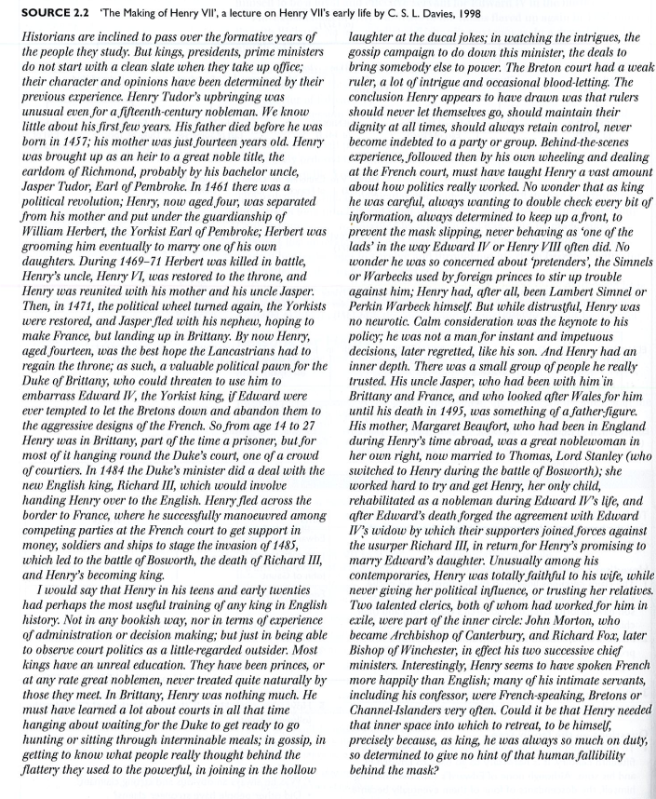

4. Baseline Assessment – Planning Sheet
TASK 3
‘Henry VII deserved to become King of England in 1485’. Explain why you agree or disagree with this view.
We will be completing this essay early September. Please complete this planning sheet for your summer learning. Your summer learning should help
 |  | How far does this contribute to Henry deserving the throne
Introduction | Define the question/set out the context of the time
Strengths of Henry’s position | Think about why Henry was well suited for Kingship – this may be based on his claim to the throne or his experience. Were there any weaknesses to his position – and if so did he manage to overcome them?
Mistakes made by Richard/impact of war of the Roses | Think about the context of the War of the Roses, how might this have led to increased support despite the weakness of the claim of Richard
Decisions made by Henry | Think about the actions that Henry took. How much of his success was down to his actions or merely luck. This may be before, during and after the Battle of Bosworth
Conclusion | So overall what do you think – how far did Henry deserve to become King – was he just lucky or instead a worthy claimant

Transition materials for A Level History
Russia
1.Reading List
Books – Non Fiction
- Russian History: A very short introduction: Geoffrey Hosking – A breadth introduction looking at the struggle by the state to control society to the transformation of the nation into a multi-ethnic empire, relations with the West, and the post-Soviet era.
- Stalin: A Biography: Robert Service – An assessment of Stalin from his early years in Georgia, his activism, his relationship with Lenin, his family and his party members.
- The Russian Revolution: A Very Short Introduction – S.A Smith – This focusses on the main events and developments in Soviet Russia between 1917 – 1936.
- The Whisperers: Private Life in Stalin's Russia. Figes, O. (2008)
- Ten Days that Shook the World. Reed, J.(1919)
- Stalingrad by Anthony Beaver, visceral, brutal and compelling story of a key turning point in World War Two.
- Stalin: Court of the Red Tsar: One of the most in depth biographies available on Stalin and the inner court. By Simon Sebag Monefiore.
Books – Fiction
- Archangel. Harris, R. (2009),
- The Road of Bones: Fine, Anne - Based on life in Russia under Stalin, it is a fable about the nature of totalitarianism. Natasha’s Will: Joan Lingard - A dangerous journey into exile during the Russian Revolution. When Natasha’s grandfather is arrested in St Petersburg in 1917, her aristocratic family flee for their lives.
- Animal Farm: A Fairy Story: George Orwell – A well- known classic story detailing the events leading up to the Russian Revolution of 1917.
Films
- The Romanovs – An Imperial Family – A Russian film with subtitles, set in 1917 focussing on the last days of Tsar Nicholas II and the rest of the Romanov family.
- Enemy at the Gates – Set in 1942, in the Battle of Stalingrad, the main character, Vasily Zaytsev becomes the poster boy for the Red Army due to his sniper skills.
- Animal Farm – The cartoon version of the book, showing the events leading up to the Russian Revolution.
- Child 44 – the film follows a disgraced member of the Russian military police. Charged with investigating a series of child murders during the Stalin era, where supposedly this sort of crime doesn’t exist.
- Bridge of Spies – an American lawyer is recruited to defend an arrested Soviet spy in court, and organise an exchange of the spy for a captured American pilot.
Task 4
Pick one book from the Russia list and complete the reading review. This review should be approximately 500 words You should identify
• Can you identify why this book is on the summer reading list?
• What did you learn about the subject?
• What surprised you about the book?
• Which part of the book was the most helpful to your understanding? Why?

2. Conditions in Russia by 1914
Task 5
Complete the chunks of research over the next few pages
a. Create a factfile on the three Tsars. Each should include: Name, reign, family background, events during his reign, impact, end of reign, death.
  - Alexander II,
  - Alexander III,
  - Nicholas II
b. Glossary of key terms – Create a glossary of the following words:

• Tsar
• Liberalism
• Revolution
• Intelligentsia
• Serf
• Serfdom
• Zemstva
• Emancipation
• Taxation
• Autocracy
• Slav
• Communism
• Capitalism
• Assassination
• Bolshevik
• Menshevik
• Cheka
• Soviets
• New Economic Policy
• Politburo
• Proletariat
• Bourgeoisie
• Collectivisation
• Gulag
• Mirs
• Totalitarian

c. Read this section on the background to Russia. For each category explain how that would make it difficult to rule Russia
The Background

Russian Geography
- 8 million sq miles: 2 x size Europe and 1/6th world surface
- Mainly rural – 11:1 village to town ratio
- Natural resources: timber, coal, oil, gold, precious minerals/metals
- Most of Russia inhospitable
- North and East had many barren lands
- Beyond the Ural Mountains, Russia was a wild place with frontier settlements.
- Transport and communication across the empire poor and difficult
- ¾ population lived within European Russia (west of Urals) – this is on less than ¼ of the
total land mass!

Nationalities
- 130 million population - Less than ½ population of the empire were Russian
- Nationalities: Romanian, Polish, Finns, Jews, Georgians etc.
- Religions: Slav/Orthodox (state religion), Muslim, Catholic, Jewish
- Each had own customs, culture, language and sometimes religion
- Many resented Russian control (Tsar’s often introduced policies which discriminated
against nationalities)

Towns and cities
- St Petersburg capital
- The Tsar and his Ministers ruled the country from there. (pop. 500,000 = size of Liverpool’s,
London was 3.5 million!)
- Towns were mainly small market centres or admin centres
- Middle class and intelligentsia almost non-existent

Agriculture
- Only 25% of Russia was really good farmland.
- Most of this was in the South and West of the country, especially in the Ukraine, the
“Bread basket” of Russia.
- The rest of Russia was either desert, arctic tundra, or taiga (woods).
- 85% or 4 out of 5 Russians were peasants. They had a hard life and there was often
starvation and disease.

Peasants
- Peasants had been emancipated in 1861 – no long had to live on mirs (communes).
- Hoped by freeing them they would become either entrepreneurial private farmers or
become mobile workers who would go to work in cities.
- Did not work as hoped; entrepreneurial class did not emerge and most continued strip
method of farming on their allotted strip using wooden tools, and lived primitive lifestyles.
Still had to ask village elders for permission to leave.
- They were generally illiterate, deeply religious, superstitious and hostile to change
- If peasants protested (for example during times of famine), the Tsar would use his feared
Cossack soldiers against them.

Middle Class and Intelligentsia
- Based in towns and cities
- Almost non-existent class – had grown during reformist era of Alexander II
thanks to university and education reforms
- Generally more educated
- Doctors, lawyers, teachers

Nobility
- 10% population yet owned 75%
- Held positions in government, army, provincial governors or administration
- Not obliged to obey Tsar but generally did
- Landowners controlled the mirs

d. Look at the diagram on the next page. What are the strengths and weaknesses of a system like this
AUTOCRACY IN ACTION (TOP-DOWN SYSTEM) : Task does this make effective government more or less likely?
Emperor and autocrat.
He alone had the power to rule.
God on earth.
Russia was his private land, the people his children.
Ruled using ukase (laws)

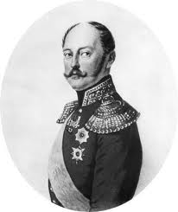
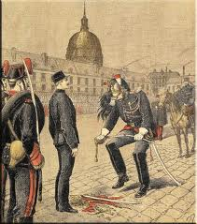
Police State
No freedom of speech, travel abroad or press. Censorship in place.
‘Third Section’ kept surveillance.
Meetings and strikes forbidden.
Anti-Tsarist behaviour = arrest or exile

Orthodox Church.
Russia deeply religious
Patriach of Moscow worked with the Tsar and Over-Procurator was appointed by the Tsar to oversee church affairs.
Bishops subject to Tsarist control over appointments, religious education and finances

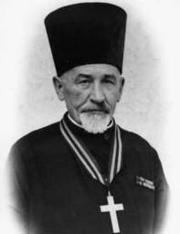
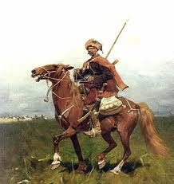
Army
1.5 million conscripted serfs – 25 years forced service.
45% gov expenditure.
Higher posts given to nobles who bought positions. Used for wars and internal uprisings.

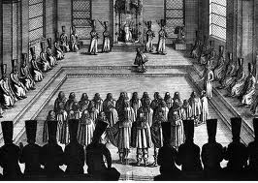
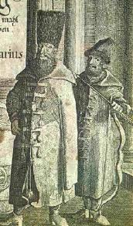
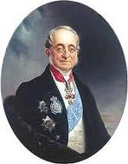

Advisors
Chosen by Tsar and could not act without Tsar’s approval.
Made up of nobles.

Bureaucracy
Paid nobles. Corrupt and incompetent. Orders passed from centre to governors of the 50 provinces. One way system - no ideas flowed up to the Tsar

Nobility
Tsar needed them for support.
Many did support as Provincial Governors. Used to control peasants on the mir. Tsar sometimes appointed committees but rarely listened to them

e. Look at the information sheets over the next few pages. Use them to make a detailed copy of this table
Group | Key facts (leader, membership, liberal or communist etc) | Key actions | Successes and failures
Mensheviks
Bolsheviks
Social Revolutionaries
Union of Liberation
Octoberists
Kadets

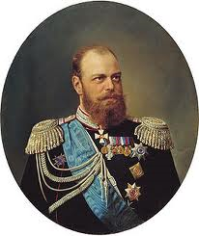
THE OPPONENTS OF TSARDOM – GROWTH OF OPPOSTION

WHAT EXTENT HAD OPPOSITION GROWN 1881-1917
- Assassination of Alexander II 1881
- Assassination was a disappointment to the opposition:

- Yielded no practical benefits for revolutionaries
- Led to accession of Alexander III (more repressive and reactionary)

- Repression: led to wave of arrests, greater police surveillance
- Counter reform: abandonment of Loris-Melikov’s proposed reforms
- Did have symbolic significance:
- Vulnerability of tsarist autocracy
- Winning some support overseas
- Creating martyrs who popularised the revolutionary cause

Two main types of group opposed Tsardom during Nicholas II’s time:
- Revolutionaries (extremists) –believed Russia could not progress unless tsarist system destroyed.
- Reformers (liberals) – strong critics of Tsarist regime, by believed it could be changed for better by reform from within

Revolutionaries (extremists)
Three groups:
- Populists
- Social Revolutionaries (SRs)
- Social Democrats (SDs)

Populists (Narodniks)
ORIGINS:
- 1870s.
VIEW:
- Tsarist system is flawed and must end.
- Future is in the hand of the peasants – mass of population. Peasants must take lead in transforming Russia.
- Populists aaw it as their duty to educate the uniformed peasantry into an awareness of their revolutionary role.
MEMBERS WERE:
- University thinkers.
- Upper/middle class men
ATTITUDE TOWARDS THE TSAR:
- Tsarist system to end. Overthrow of the Tsar by the peasants.
- People’s Will group would have been happy to kill the Tsar if necessary.
METHODS/TACTICS:
- ‘Going to the people’ – educated Populists went to the countryside to live for periods with the peasants to turn them into revolutionaries.
(-) rarely a successful tactic; peasants saw them as people with no real knowledge of real life.
- Terrorism – desperation turned some into terrorists = The People’s Will created 1879. Declared intention of murdering the ruling class. 400 members. Assassination of Alexander II – achieved this but weakened rather than strengthened populist movement: murder of tsar who initiated many reforms seemed to discredit the idea of reform itself and so justified use of repression by Alexander III. Assassins publicly executed.

Successes | Failures
- Assassinated Alexander II  - Established an anti-tsarist tradition. All the revolutionaries in Russia after 1870 were influenced, if not inspired, by the Populist challenge to tsardom | - Going to the people – peasants saw them as men who had no knowledge of real life.  - Idea of peasant based revolution was unrealistic; peasants not interested in political revolution, they just wanted the land issue to be resolved  - Assassinated the Tsar most likely to make concessions – national assembly. Murder of a reforming Tsar discredited the idea of reform and so justified repression.  - Resulted in reign of Alexander III – reactionary and repressive.

Emergence of Social Revolutionaries
ORIGINS:
- Created in 1901. Grew from Populist movement (group just before)
INFLUENCES:
- Viktor Chernov - leader.
SUPPORT BASE:
- Members: intelligentsia, middle class
- Wide national base with peasants and 50% urban working class. By 1905 – 50,000 but influence decreases 1906
BELIEFS:
- Wanted social and political change – inspired by the misery of the peasants.
- Wanted a federal government instead of Tsar (wanted a system unique to Russia)
- Concerned with ‘Labouring poor’ – Importance of peasantry as revolutionary force but wanted to broaden the appeal of the party by not just focusing on the peasants but now the workers too. Argued that workers and peasants the same and should therefore work together to bring down autocracy.
- Talked of ‘land socialisation’ (land policy) – redistribution of the land to the peasants
METHODS:
- Growth spurt 1890s led to quickening of interest in political and social issues = SRs saw this as opportunity to gain recruits from rapidly growing urban working class = sent in agitators amongst workers.
- Widen earlier populist notion of ‘going to the people’ to now include not just peasants but all those wanting end to stardom.
- Right– moderate element. propaganda, ‘going to the people’ to educate them about change. Willing to work with other parties to bring about improvements for conditions of workers and peasants.
- Left– anarchists. Terrorist actions; continue People’s Will tactics. Frustrated with lack of success of propaganda. 1901-1905 = 2000 deaths including Plehve, Grand Duke Sergei
- Terrorist faction dominated party 1901-05 = limited success.
= divisions and disagreements within the party about direction/methods etc weakened them as a party and challenge to tsar.
Divisions within party and impact….
- 1905 revolution – right wing moderate side began to dominate party policy = greater success. 1906 onwards = more support from professional classes, from trade unions and All-Russian Congress of Peasants (1905).
- Revolutionary socialism (violent overthrow of tsarist system,1906) – SR announces pledge to peasants that it would end principle of private ownership and return land to peasants = land policy explains why they’re the most popular party with peasants.
- Left wing of party protested against this saying workers were ignored and that the policy was unworkable in current Russian conditions.
- 1906 onwards Chernov tries to hold party together doesn’t work = becomes party of collection of radical groups rather than united party
- Until outlawed by Bolsheviks (1917) they were the most popular party (due to peasant support)

Successes | Failures
- Key political assassinations e.g. Plehve, Grand Duke Sergei, 2000 assassinations (1901-05) = attention. Gained recognition through assassinations. Put revolutionary ideas into the public eye.  - Land policy pledge 1906 was popular with peasants (return land to peasants = most popular party. Gain greater support from All-Russian Congress of Peasants.  - After 1906 when right wing of SRs dominate, they gain more support from professional classes and trade unions.  - 1917 they were the most popular group in Russia’s only democratic elections. Until outlawed by Bolsheviks 1917. Most influential revolutionary group up until 1917 | - Disagreements amongst themselves weakened them as a group – ‘Left SRs’ and ‘Right SRs’ (see dvisions and impact above) = limits strength as opposition to Tsar. Loose organisation with variety of views never centrally controlled – never a close knit group and there were always factions. Splits (Trotsky talked of this problem) which meant from 1906 they were never more than a collection of radical factions rather than united party.  - Did not wholly achieve desired link with the urban workers  - Still many peasants not interested; loyal to Tsar still and mainly blamed nobles for their problems. Saw them as middle class people that did not understand them.  - Most rural unrest was spontaneous (e.g. 1904 Red Cockerel unrest was mainly due to poor harvests and famine 1901-2) relating to land and food issues rather than support of actual revolutionary party and the overthrow of Tsar. Just wanted better conditions, not a change in system.  - No coherent long term plan to achieve power

Emergence of the Social Democrats
ORIGINS:
- 1898. Founded by Plekhanov.
VIEW:
- Achieve revolution following Marx’s ideas and scientific principles – class struggle (‘haves’ vs ‘have-nots’), a process that operated throughout history involved in a dialetic (violent struggle)
- Contemporary industrial era (industrial spurt of 1980s) marked the final stage in this struggle = human history about to reach its culmination in the revolutionary victory of the proletariat (worker) over the bourgeoisie (middle class) = result in ‘dictatorship of the proletariat’
- Dictatorship of proletarist was the last but one stage (they would hunt down and destroy surviving reactionaries/class enemies) = violence/bloody affair = all conflict would then end harmonious society would emerge.
- 1890s spurt = gave theory relevance. Promised to create conditions that would make successful revolution possible.
KEY INFLUECE:
- Marx
- Plekhanov’s Emancipation of Labour movement – translated Marx’s writings into Russian. Founded SD party. (Father of Russian Marxism)
MEMBERS WERE:
- University thinkers. Upper/middle class men
METHODS:
- Plekhanov argued their beliefs should be:
- Revolutionaries must accept the inevitability of Marx’s ‘stages of development’ - Russia was already moving towards the capitalist phase.
- Methods: Task One for revolutionaries should therefore be:
- Accelerate the socialist revolution by working among the workers in Russian cities
yo improve their conditions (economism)

- Focus on the workers and create dynamism to drive the
revolution forward – peasants were misguided and it would
be a waste of time trying to rouse them.

Some grew impatient with theoretical side and wanted a more
active,revolutionary programme.

= SPLIT IN SOCIAL DEMOCRATS

LENIN:
- 1900 – returns from exile = starts trying to turn SDs into a truly revolutionary party.
- Iskra (The Spark) – creates party newspaper with Martov to put case to members.
Lenin’s beliefs:
- Reject economism, conditions of workers to decline - Criticised Plekhanov saying he’s too interested in reform not revolution. Lenin rejected ‘economism’ (improving conditions of workers) and championed transforming workers into revolutionaries (doesn’t want to improve conditions like Plekhanov as he says this will delay rev, instead allow conditions to continue to decline which will turn more workers into revolutionaries due to discontent/bitterness = spark revolution)
- Telescope revolution – this content would quicken the pace of revolution and FastTrack through bourgeois phase to proletariat phase.
- Dedicated small group of professional revolutionaries only (small, tight knit and exclusive party)– no working with other anti-tsar parties - ‘What is to be done?” (1902) – strongest attack on Plekhanov. Criticised him for working with other parties to try to improve conditions - said working with other parties was wrong; dedicated, professional party of revolutionaries only.
- Democratic centralism – party disciple. Elite, informed revolutionaries at the top to direct the efforts of party.
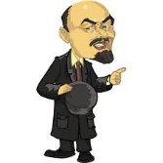
- Workers needed direction too - Workers could not be left alone to themselves. Did not know enough; needed directing by professional, informed revolutionaries.
Q1 WATCH OUT! Keep an eye out for sources by:
Martov (started Iskra with Lenin, then 1903 Congress sides with Plekhanov, accuses Lenin trying to be dictator of party
Potresov – he will say same.

SPLIT IN SD PARTY 1903 - Emergence of the Mensheviks and Bolsheviks
1903 Second Party Congress 51 delegates
- Aim: to decide how the party should move forward
- Divisions over: nature, timing and organisation of the revolution
- Martov sides with Plekhanov rather than Lenin – thinks Lenin is trying to be dictator of party
- SD congress vote – evenly split between Martov and Lenin = split
- Split hardened the two groups into a set of opposed attitudes.
ISSUE | MENSHEVIK VIEW | BOLSHEVIK VIEW
Revolution | Russia not ready yet – bourgeois stage first. | Telescope – bourgeois and proletarian stages could be telescoped into one revolution
Party | Mass organization, membership open to all revolutionaries | A tight-knit, exclusive organisation of professional revolutionaries
Decision-making | Open, democratic discussion within the party – decisions arrived at by votes of members | Democratic centralism – authority exercised by central committee of party
Strategy | Alliance with other revolutionary and bourgeoius liberal parties.  Economism – improve conditions for workers (wages etc) and work with trade unions to achieve this. | No cooperation with other parties.  Economism dismissed as playing into hands of bourgeoisie.  No working with trade unions – they dilute chances of revolution.  Aimed to turn workers into revolutionaries.
Lenin’: Bolsheviks (‘majority’)
- Strong, ideologically pure, tight knit, disciplined organisation with membership of only professional revolutionaries
- Would lead the proletariat and overthrow bourgeoisie
- Total dedication to revolution – no cooperation with other parties.
REMEMBER: Don’t overstate the importance of Lenin/Bolsheviks before 1917 – whilst they had been systematically preparing the ground since 1903 for a revolution, Lenin was largely absent from Russia 1904—17 (exile, visits rare and fleeting) – did issue stream of instructions to followers but was largely absent.

- Democratic centralism - Centralised party structure (Central Committee)
- No TU’s – they would dilute chances of a revolution
- Reject economism - Thought poor conditions in Russia would encourage revolution and so argued Plekhanov would undermine revolution by helping them
METHODS:
- Newspaper – Pravda (The Truth) which criticised Mensheviks
- Training school for revolutionaries – taught to infiltrate trade unions and other organisations
to stir up workers (‘agitators’)
- Terrorist attacks e.g. post offices to get funds use for propaganda
- Propaganda – masses of hadbills, leaflets and newspapers attacking tsarist regime,
calling for revolution.

Successes | Failures
- Seen as fringe group by police; not on the police check list as a major challenge to the tsar  - Did help to cause industrial unrest.  - October 1917 revolution – establishment of communism. Come 1917 they were best prepared and willing to seize opportunity. Bolshevik readiness was one of Lenin’s major political achievements. Overall winners but do not overstate their role at this time. Was it not more the failings of the provisional government? | - Regarded by authorities as a fringe group of extremists at this time – not on police check list  - Many members spent long time periods in exile (Lenin) limiting impact  - Don’t overstate the importance of Lenin/Bolsheviks before 1917 – whilst they had been systematically preparing the ground since 1903 for a revolution, Lenin was largely absent from Russia 1904—17 (exile, visits rare and fleeting) – did issue stream of instructions to followers but was largely absent.  - Membership – varied between 5-10,000 with no more than 25,000 by 1917. Outnumbered by Mensheviks.  - Attempted revolution in 1905 and Feb 1917 revolution overthrowing the Tsar was spontaneous and Bolsheviks weren’t too involved.

Martov’s Mensheviks (‘minority’)
- Broad based party with a mass working class membership. Open membership to all revolutionaries
- Should cooperate with other liberal parties and other revolutionary parties.
- Stages of Marxism MUST occur – bourgeois must occur then proletariat. No telescoping
Proletariat should provide impetus for revolution and should not be
METHODS:
- Newspaper – Vyperod (Forward)
- Economism - Work with other parties to improve conditions and work with trade unions to improve conditions (e.g. wages)
- Propaganda
Successes | Failures
- Seen as group of concern by the police  - Greater membership numbers than the Bolsheviks – 40,000 members 1904 | - Fringe group of extremists.  - Minimal role in Feb 1917 revolution and it was the Bolsheviks who succeeded in October 1917.

Liberals and Intelligentsia
- Number of reforming groups seeking change – ‘liberals’ – but never came together to form a common front.
- Until October Manifesto 1905 parties were illegal. Hadn’t stopped formation of them but made it difficult for them to develop as genuinely democratic bodies. No tradition of open debate in Russia
- Parties did not cooperate with one another 1906-21 when parties were permitted (suspicious, intolerant of each other) = made cooperation and collective action difficult to organise = limited impact they could have on the Tsar and amount of support they achieved.
ORIGINS:
- Economic boom 1890s – rapid development of small, ambitious class of lawyers, industrialists and financiers = social group who wanted to modernise Russia.
- Middle class had grown and was more politicised – Great Famine 1891-2 had shown incompetence of Tsarist bureaucracy resulting in voluntary organisations and the zemstva having to organise relief. This fuelled belief that educated members of society should have some direct say in the nation’s governance.

Beliefs:
- Promote welfare, education, liberty and the rule of law
- Reform autocracy so the Tsar would listen directly to his people. Tsar to rule in conjunction with the people
- Did not have a revolutionary attitude – wanted change and reform
- Beseda formed in 1900 (more radical thinkers) which met in secret focused on judicial reform and universal education

Key members/influences:
- Tolstoy ‘What I believe’ 1883 – opposed Tsarist oppression and injustice of legal system but rejected violence. Pure and simple living would bring about moral regeneration of Russia
- Prince Lvov (liberal noble) – wanted an all-class Zemstvo at district level and a National Assembly
- Struve 1903 – Russia needed ‘peaceful evolution’ to adapt to new industrialising status, wanted to see constitutional system where urban workers could campaign legally to improve conditions
- Slavophile thinkers

Organisations – three main Liberal parties.

Union of Liberation (1904-1917):
- Struve and Milyukov (principal leaders)
- Programme 1904: liberation of Russia. Abolition of autocracy. Establishment of a constitutional regime. Principle of universal, equal, secret and direct elections.
Successes | Failures
Indicated range of anti-tsarist feeling and helped to advance ideas that more progressive members of the government (Witte) took to heart.  Union’s 1904 programme was expressed in the type of language that all liberal and reforming parties subsequently asserted their claims | Tried to find common ground between liberal groups but unable to create a single, coherent reforming movement with a single purpose.  Members of government such as Witte were sacked so whilst such progressives in government were receptive to their ideas, this was not widespread/long term.

The Octoberists (October 1905)
- Dated from issuing of October Manifesto 1905 which had created the duma
- Moderates, loyal to tsar. Belived in maintenance of the empire. Saw October Manifesto and establishment of duma as major constitutional advances.
- Members: Guchkov (later member of PG), Rodzianko (later member of PG), members drawn from larger, commercial industrial and landowning interests.
Successes | Failures
Members Guchkov and Rodzianko were members of the Provisional Government 1917  Despite 1905 programme (see opposite), during the duma phase they became increasingly more critical and vocal of the short-sightedness or incompetence of the tsarist government. May not have wanted the overthrow of it, but were willing to point to its failings/challenge it to try to improve it | Limited aims – programme 1905 called for unity and the rule of law and appealed for the continuation of a ‘strong and authoritative regime’ (Tsar/government) to work with ‘representatives of the people’ (Duma) – ideas dismissed by revolutionaries.

Kadets (Constitutional Democrats) (1905)
- Largest of liberal parties.
- Wanted constitutional monarchy but different from Octoberists – wanted greater checks on Tsar’s powers. Powers of Tsar to be restricted by democratically elected constituent assembly (a national assembly, voted for by people). This body would settle the nations social, economic and political problems with reforms.
- Kadet Programme included: All-Russian Constituent Assembly, full equality&civil rights for all ditizens, end censorship, abolition of mortgage repayments on land, free and universal education, recognition of trade unions.
SUCCESS | FAILURE
Largest of liberal parties | Dismissed by Lenin as politically naïve – dream of a constituent assembly.

Overall for the liberals…..
Successes | Failures
- Middle class had grown and was more politicised – Great Famine 1891-2 had shown incompetence of Tsarist government resulting in voluntary organisations and the zemstva having to organise relief = fuelled belief that educated members of society should have some direct say in the nation’s governance.  - Attracted influential members – Prince Lvov, Tolstoy  - 1904 – Union held series of banquets which were attended by members of the liberal elite and zemstva representatives  - Escaped heavy police focus as they were pre-occupied by SR’s and SD’s  - Contributed to momentum for political change | - Government restrictions: reduction in zemstva powers under Alexander III  - Nicholas II dismissed ideas of the Tver Zemstvo who petitioned him to set up advisory body in 1895 – ‘senseless dream’  - Shipov’s attempt to set up an ‘All Zemstvo Organisation’ 1896 was banned  - 1900 – government ordered the dismissal of hundreds of Liberals from the elected boards of the zemstva  - Limited influence before 1905  - Never united to form a coherent front – suspicious, intolerant of one another  - Liberal groups divided in aims so never united  - No tradition of open debate in Russia which limited efforts  - Criticised by Lenin

f. Read the information on each of the Four Dumas. Summarise each one – you should think about – what were the main outcomes of each Duma

HOW SUCCESSFUL WAS THE DUMA EXPERIMENT?
Duma experiment started with a lot of hope, especially from the Liberals…. However, the actions that Nicholas II takes soon results in discontent.

Duma | Character | Details | Achievements
First Duma (May - July 1906)  ‘Duma of National Hope’ | Dominated by reformist parties | High hope at start.  Fundamental Laws 1906 introduced by Tsar = declared ‘Supreme autocratic power belongs to Emperor of Russia’ reasserted Tsar’s control, could dissolve the Duma if desired.  Tsar declared no law could come into being without his approval and also creates a second chamber in the Duma; a state council which is filled with his ministers who have the right to veto = deprived the elected Duma of any real power.  Angered the parties in the Duma they demand more power and rights = Goremykin (Chief Minister) told them their demands were ‘inadmissable’ and Tsar says ‘Curse the duma. It is all Witte’s doing.”  Kadets try to challenge him in Duma = Tsar dissolves the Duma after only 72 days.  200 Kadets react issuing a Vyborg appeal brutal repression, arrested, not allowed to be re-elected to Duma.  Tsar appoints Stolypin as Chief Minister to introduce strong control. | Short lived – achieved little
Second Duma (Feb-June 1907)  Duma of National Anger | Clash between revolutionaries and left wing | More SR and SD participation due to Kadet members arrest/not allowed re-election= more left wing parties involved = critical of Tsar/hostile nature.  Disagreement in the Duma between parties - increase in right wing as well as left wing parties (SR, SD) – attempts to find common ground between them limited by suspicions and intolerance of each other. Lead to clashes, disagreements.  Stolypin tries to introduce his ‘Land Reform’ – opposed by parties.  Duma parties directed a strong attack on how the imperial army was deployed and organized = angers Tsar.  = Nicholas II accuses the SR and SR deputies of subversive activities  = Duma is dissolved by Tsar using Fundamental Laws. | Dissolved in disorder – very little achieved
Third Duma (Nov 1907-June 1912)  Duma of Lords and Lackeys | Electoral changes by Stolypin before election of Third Duma = more cooperative deputies from moderate/right wing parties | Stolypin changed the electoral arrangements before the election of the Third Duma peasants, workers lost right to vote  = docile Duma as they were more heavily dominated by right wing parties (supportive of Tsar) = Duma was ‘docile’ in nature (= ‘Duma of Lords and Lackeys’) – any criticism was now much more muted.  Stolypin found the third duma more cooperative = could pursue his Land Reforms without opposition from deputies. They agreed to 2,300 out of 2,500 government proposals.  However, be careful not to say they were too docile or subservient!!!! Still …  - Exercised right to question ministers and finances  - Used committee system to make important proposals to change armed forces  - Approved social bills which included: setting up schools for children, national insurance for workers. | Committees did achieve effective work on social reform
Fourth Duma  (Nov 1912-Aug 1914) | Dominated by right-wing parties again more willing to cooperate. | Historians sometimes dismiss fourth duma as a ‘rubber stamp of government polic’ (basically, passed anything the Tsar and Chief Ministers put before them). This is the argument the Bolsheviks would give too.  However, they still:  - Voices criticism of tsar’s government  - Moscow Okhrana report 1912 blamed the tension in Russia on the awkward and searching questions continually being asked in the duma about government policy = evidence not totally subservient to tsar.  - Progressive nature of Duma = beginnings of state welfare resulted from Duma – this was only limited from being more than it was due to blindness of tsar = Rodzianko (1913) appeals directly to the Tsar humbly requesting the duma be given clarification on its role so that it could be more constructive in Russian affairs | Social reform work continued but prepared to criticize government

g. Using Revolutionary Russia make a timeline of 8 key events up to 1914

Online research: The department pays a subscription for the website www.revolutionaryrussia.com (pictured below). This wonderful website includes access to notes, academic extracts, galleries and podcasts of taped university seminars. You need to use fearonj@uptonhigh.co.uk as a login and ‘Trotsky’ as a password. This will give you access to the full content I want you to focus on the 3 first sections.
Make a timeline of 8 key events up to 1914.

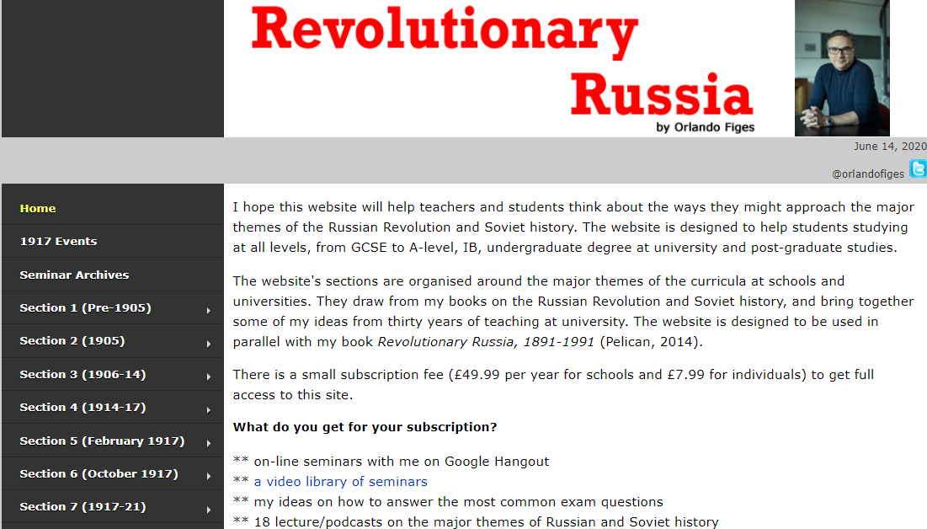

TASK 6
“Russia was always likely to fall to rebellion” How far do you agree with this statement?
We will be completing this essay early September. Please complete this planning sheet for your summer learning. Your summer learning should help

 | Essay Title: “Russia was always likely to fall to rebellion” How far do you agree with this statement? | How far is this likely to lead to revolution
Introduction | Outline your main arguments. You only need to use 3 central points.
The impact of the Government on Russian stability | The system of government. E.g. Did it allow clear government? Did it support the Russian leader? Was it more likely to close down a rebellion or to start one?
The ineffectiveness of the Duma on Russian stability | The various Duma sessions, what they did, how they ended. Did they have any power at all? Could listening to them have been a better way of stopping rebellion?
The Revolutionary movements of the time | You could consider: the size, effectiveness and methods of any of the key groups: (Social Revolutionaries, Mensheviks, Bolsheviks, Union of Liberation, Octoberist,  Kadets) Where they creating a situation which would make revolution more likely? Did they actually have the power to fight the Tsar? Were the movements popular?
The Geography or background Russia | You could consider: Geography. Ethnic groups. Social Groups. Economic or Industrial groups. Was it naturally too large, too diverse or too oppositional?
Conclusion | Make a clear judgement. Which factors did you think were the most important?

