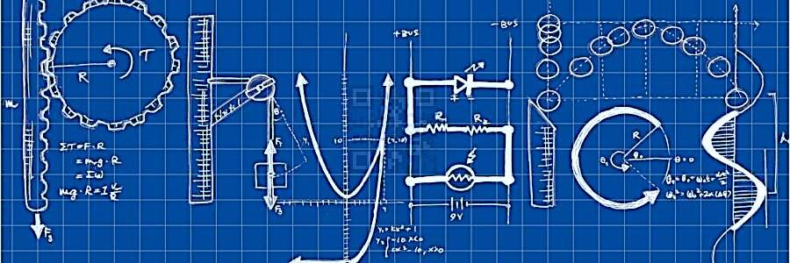

AS Physics at
Upton By Chester

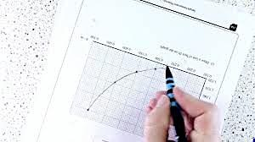

Transition Booklet from GCSE Physics to AS Physics

Introduction

This booklet will assist you in getting better prepared to study AS Physics at Upton By Chester. You must work through the booklet and self assess to identify the topics/areas for improvement. Write a brief comment on your progress in the comments box as you complete each topic.This help will inform you with what you must revise prior to beginning the AS Physics course. Bring your copy of the completed booklet to your first AS Physics lesson.

AS Physics | Contents
Skills | Contents

Topic | Title | Completed  (date) | Comments.  Do you need more practice?  Are you confident with this area?  What areas of weakness have you identified?
1 | Prefixes and units
2 | Significant Figures
3 | Converting Length, Area and Volume
4 | Rearranging Equations
5 | Constructing Graphs
6 | Calculating Gradients – Straight Lines
7 | Calculating Gradients – Curved Lines
8 | Calculating Areas – Straight Line Graphs
9 | Interpreting Graphs

AS Physics | 1. Prefixes and units
Skills | 1. Prefixes and units

In Physics we have to deal with quantities from the very large to the very small. A prefix is something that goes in front of a unit and acts as a multiplier. This sheet will give you practice at converting figures between prefixes.

Symbol | Name | What it means |  | How to convert
P | peta | 10¹⁵ | 1000000000000000 |  | ↓ x1000
T | tera | 10¹² | 1000000000000 | ↑ ÷ 1000 | ↓ x1000
G | giga | 10⁹ | 1000000000 | ↑ ÷ 1000 | ↓ x1000
M | mega | 10⁶ | 1000000 | ↑ ÷ 1000 | ↓ x1000
k | kilo | 10³ | 1000 | ↑ ÷ 1000 | ↓ x1000
 |  |  | 1 | ↑ ÷ 1000 | ↓ x1000
m | milli | 10⁻³ | 0.001 | ↑ ÷ 1000 | ↓ x1000
μ | micro | 10⁻⁶ | 0.000001 | ↑ ÷ 1000 | ↓ x1000
n | nano | 10⁻⁹ | 0.000000001 | ↑ ÷ 1000 | ↓ x1000
p | pico | 10⁻¹² | 0.000000000001 | ↑ ÷ 1000 | ↓ x1000
f | femto | 10⁻¹⁵ | 0.000000000000001 | ↑ ÷ 1000

Convert the figures into the units required. Convert these figures to suitable prefixed units.
6 km | = | 6 x 10³ m |  | 640 GV | = | 640 x 10⁹ V
54 MN | = | N |  |  | = | 0.5 x 10⁻⁶ A
0.086 µV | = | V |  |  | = | 93.09 x 10⁹ m
753 GPa | = | Pa |  | kN | = | 32 x 10⁵ N
23.87 mm/s | = | m/s |  | nm | = | 0.024 x 10⁻⁷ m

Convert the figures into the prefixes required.
s | ms | μs | ns | ps
0.00045 | 0.45 | 450 | 450 000  or 450 x10³ | 450 x 10⁶
0.000000789
0.000 000 000 64

mm | m | km | µm | Mm
1287360
295

The equation for wave speed is:
$$wave speed=frequency ×wavelength$$
$$(m/s) \left(Hz\right) (m)$$
Whenever this equation is used, the quantities must be in the units stated above. At GCSE we accepted m/s but at AS/A Level we use the index notation. m/s becomes m s⁻¹ and m/s² becomes m s⁻².
By convention we should also leave one space between values and units. 10m should be 10 m.
We also leave a space between different units but no space between a prefix and units.
This is to remove ambiguity when reading values.
Example ms⁻¹ means 1/millisecond because the ms means millisecond, 10⁻³ s
but m s⁻¹ means metre per second the SI unit for speed.
or mms⁻¹ could mean mm s⁻¹ compared with m ms⁻¹
millimeters per second compared with meters per millisecond - quite a difference!!!
Calculate the following quantities using the above equation, giving answers in the required units.
- Calculate the speed in m s⁻¹ of a wave with a frequency of 75 THz and a wavelength 4.0 µm.
v = f λ = 75 x 10¹² x 4.0 x 10⁻⁶ = 3.0 x 10⁸ m s⁻¹ ( 300 Mm s⁻¹)
- Calculate the speed of a wave in m s⁻¹ which has a wavelength of 5.6 mm and frequency of 0.25 MHz.

- Calculate the wavelength in metres of a wave travelling at 0.33 km s⁻¹ with a frequency of 3.0 GHz.

- Calculate the frequency in Hz of a wave travelling at 300 x 10³ km s⁻¹ with a wavelength of 0.050 mm.

- Calculate the frequency in GHz of a wave travelling at 300 Mm s⁻¹ that has a wavelength of 6.0 cm.

AS Physics | 2. Significant Figures
Skills | 2. Significant Figures

1. All non-zero numbers ARE significant. The number 33.2 has THREE significant figures because all of the digits present are non-zero.
2. Zeros between two non-zero digits ARE significant. 2051 has FOUR significant figures. The zero is between 2 and 5
3. Leading zeros are NOT significant. They're nothing more than "place holders." The number 0.54 has only TWO significant figures. 0.0032 also has TWO significant figures. All of the zeros are leading.
4. Trailing zeros when a decimal is shown ARE significant. There are FOUR significant figures in 92.00 and there are FOUR significant figures in 230.0.
5. Trailing zeros in a whole number with no decimal shown are NOT significant. Writing just "540" indicates that the zero is NOT significant, and there are only TWO significant figures in this value.
(THIS CAN CAUSE PROBLEMS!!! WE SHOULD USE POINT 8 FOR CLARITY, BUT OFTEN DON’T - 2/3 significant figures is accepted in IAL final answers - eg 500/260 = 1.9 to 2 sf. Better 5.0 x 10² / 2.6 x 10² = 1.9)
8. For a number in scientific notation: N x 10^{x}, all digits comprising N ARE significant by the first 5 rules; "10" and "x" are NOT significant. 5.02 x 10⁴ has THREE significant figures.
For each value state how many significant figures it is stated to.
Value | Sig Figs | Value | Sig Figs | Value | Sig Figs | Value | Sig Figs
2 |  | 1066 |  | 1800.45 |  | 0.070
2.0 |  | 82.42 |  | 2.483 x 10⁴ |  | 69324.8
500 |  | 750000 |  | 0.0006 |  | 0.0063
0.136 |  | 310 |  | 5906.4291 |  | 9.81 x 10⁴
0.0300 |  | 3.10 x 10⁴ |  | 200000 |  | 40000.00
54.1 |  | 3.1 x 10² |  | 12.711 |  | 0.0004 x 10⁴

When adding or subtracting numbers
Round the final answer to the least precise number of decimal places in the original values.
Eg. 0.88 + 10.2 – 5.776 (= 5.304) = 5.3 (to 1d.p. , since 10.2 only contains 1 decimal place)
(Khan Academy- Addition/ subtraction with sig fig excellent video- make sure you watch .)
Add the values below then write the answer to the appropriate number of significant figures

Value 1 | Value 2 | Value 3 | Total Value | Total to correct sig figs
51.4 | 1.67 | 3.23
7146 | –32.54 | 12.8
20.8 | 18.72 | 0.851
1.4693 | 10.18 | –1.062
9.07 | 0.56 | 3.14
739762 | 26017 | 2.058
8.15 | 0.002 | 106
152 | 0.8 | 0.55

When multiplying or dividing numbers
Round the final answer to the least number of significant figures found in the initial values.
E.g. 4.02 x 3.1 ⎟ 0.114 = (109.315…) = 110 (to 2s.f. as 3.1 only has 2 significant figures.
Multiply the values below then write the answer to the appropriate number of significant figures
Value 1 | Value 2 | Total Value | Total to correct sig figs
0.91 | 1.23
8.764 | 7.63
2.6 | 31.7
937 | 40.01
0.722 | 634.23

Divide value 1 by value 2 then write the answer to the appropriate number of significant figures
Value 1 | Value 2 | Total Value | Total to correct sig figs
5.3 | 748
3781 | 6.50
91 x 10² | 180
5.56 | 22 x 10⁻³
3.142 | 8.314

When calculating a mean

- Remove any obvious anomalies (circle these in the table)
- Calculate the mean with the remaining values, and record this to the least number of decimal places in the included values
E.g. Average 8.0, 10.00 and 145.60:
1) Remove 145.60
2) The average of 8.0 and 10.00 is 9.0 (to 1 d.p.)

Calculate the mean of the values below then write the answer to the appropriate number of significant figures
Value 1 | Value 2 | Value 3 | Mean Value | Mean to correct sig figs
1 | 1 | 2
435 | 299 | 437
5.00 | 6.0 | 29.50
5.038 | 4.925 | 4.900
720.00 | 728.0 | 725
0.00040 | 0.00039 | 0.000380
31 | 30.314 | 29.7

AS Physics | 3. Converting length, area and volume
Skills | 3. Converting length, area and volume

Whenever substituting quantities into an equation, you must always do this in SI units – such as time in seconds, mass in kilograms, distance in metres…
If the question doesn’t give you the quantity in the correct units, you should always convert the units first, rather than at the end. Sometimes the question may give you an area in mm² or a volume in cm³, and you will need to convert these into m² and m³ respectively before using an equation.
To do this, you first need to know your length conversions:
1m = 100 cm = 1000 mm (1 cm = 10 mm)
m 🡪 cm | x 100 | cm 🡪 m | ÷ 100
m 🡪 mm | x 1000 | m 🡪 mm | ÷ 1000

Always think –
“Should my number be getting larger or smaller?” This will make it easier to decide whether to multiply or divide.
Converting Areas
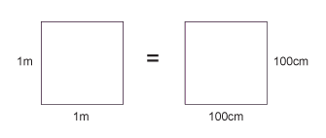
A 1m x 1m square is equivalent to a 100 cm x 100 cm square.
Therefore, 1 m² = 10 000 cm²
Similarly, this is equivalent to a 1000 mm x 1000 mm square;
So, 1 m² = 1 000 000 mm²
m² → cm² | x 10 000 | cm² → m² | ÷ 10 000
m² → mm² | x 1 000 000 | m²→mm² | ÷ 1 000 000

Converting Volumes
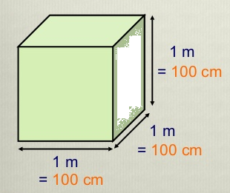
A 1m x 1m x 1m cube is equivalent to a 100 cm x 100 cm x 100 cm cube.
Therefore, 1 m³ = 1 000 000 cm³
Similarly, this is equivalent to a 1000 mm x 1000 mm x 1000 mm cube;
So, 1 m³ = 10⁹ mm³
m³ → cm³ | x 1 000 000 | cm³ → m³ | ÷ 1 000 000
m³→mm³ | x 10⁹ | m³→mm³ | ÷ 10⁹

6 m² | = | cm² |  | 750 mm² | = | m²
0.002 m² | = | mm² |  | 5 x 10⁻⁴ cm³ | = | m³
24 000 cm² | = | m² |  | 8.3 x 10⁻⁶ m³ | = | mm³
46 000 000 mm³ | = | m³ |  | 3.5 x 10² m² | = | cm²
0.56 m³ | = | cm³ |  | 152000 mm² | = | m²

Now use the technique shown on the previous page to work out the following conversions:
31 x 10⁸ m² | = | km²
59 cm² | = | mm²
24 dm³ | = | cm³
4 500 mm² | = | cm²
5 x 10⁻⁴ km³ | = | m³
(Hint: There are 10 cm in 1 dm)

A 2.0 m long solid copper cylinder has a cross-sectional area of 3.0 x10² mm². What is its volume in cm³?

Volume = cm³

For the following, think about whether you should be writing a smaller or a larger number down to help decide whether you multiply or divide.
Eg. To convert 5 m ms⁻¹ into m s⁻¹ – you will travel more metres in 1 second than in 1 millisecond, therefore you should multiply by 1000 to get 5000 m s⁻¹.
5 N cm⁻² | = | N m⁻²
1150 kg m⁻³ | = | g cm⁻³
3.0 m s⁻¹ | = | km h⁻¹
65 kN cm⁻² | = | N mm⁻²
7.86 g cm⁻³ | = | kg m⁻³

AS Physics | 4. Rearranging Equations
Skills | 4. Rearranging Equations

Rearrange each equation into the subject shown in the middle column.
Equation |  | Rearrange Equation
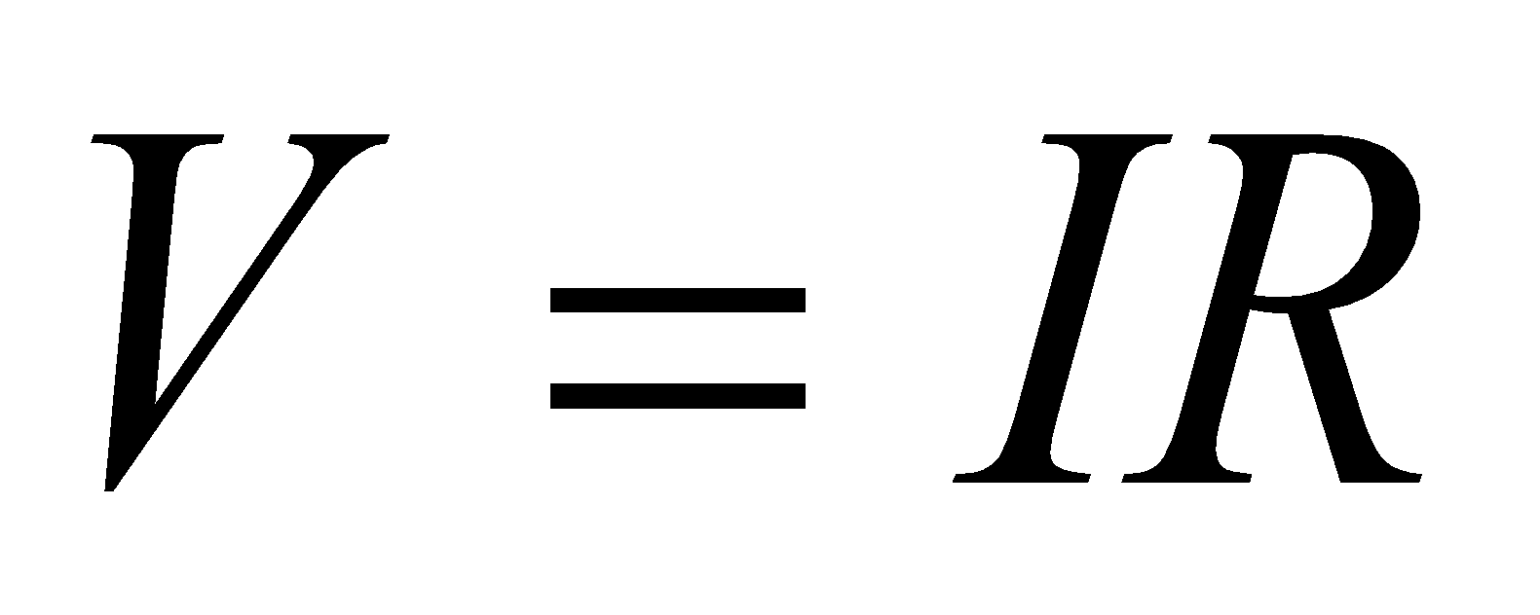 | R
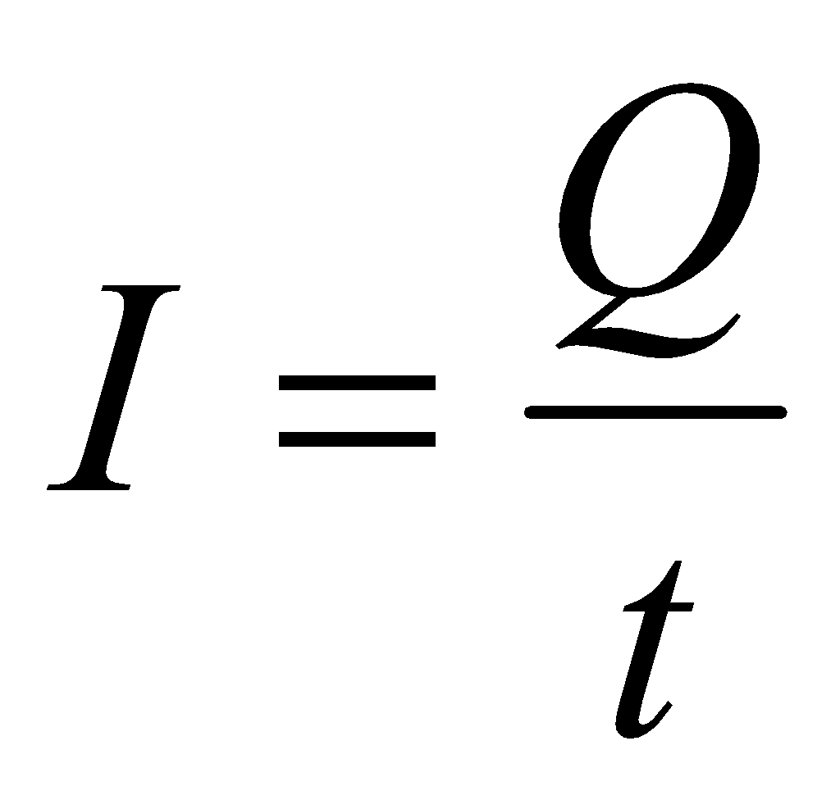 | t
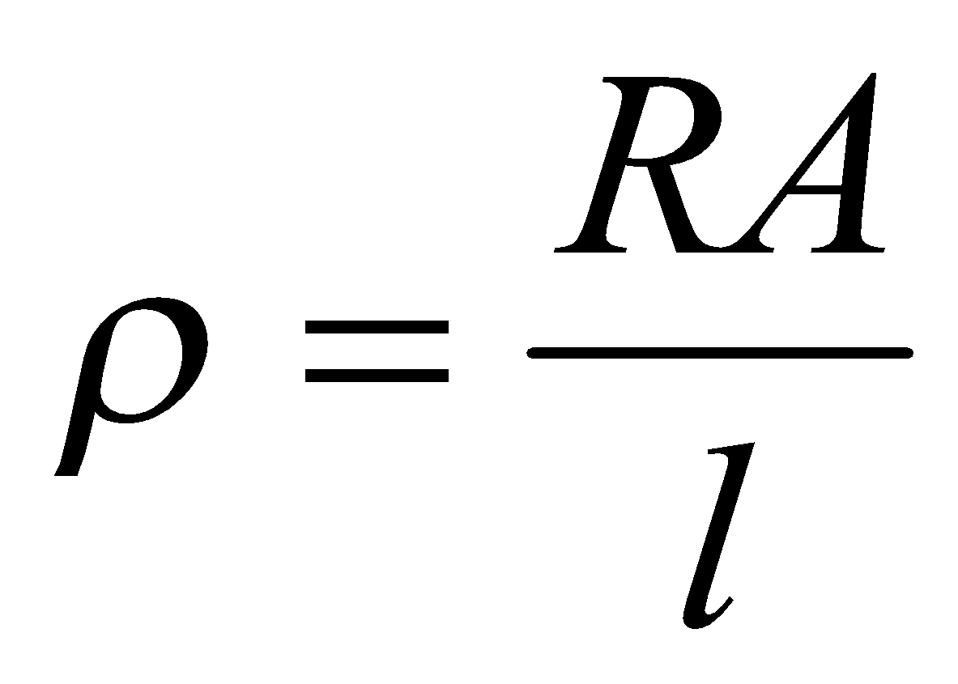 | A
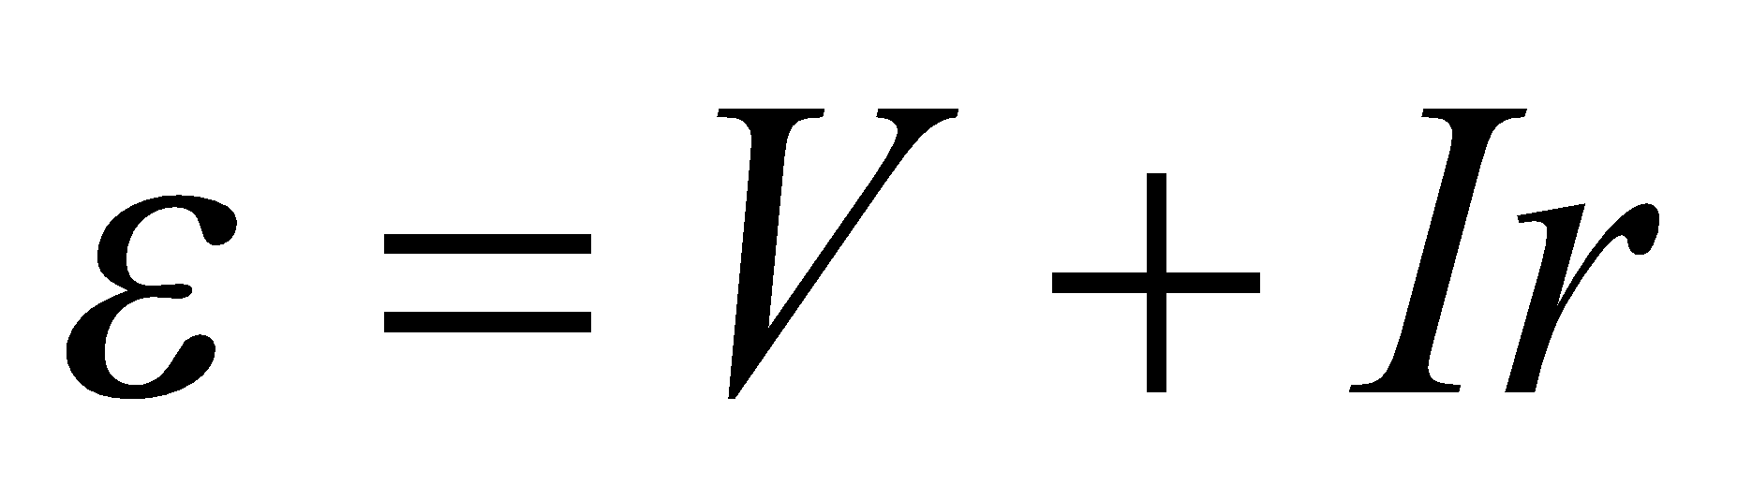 | r
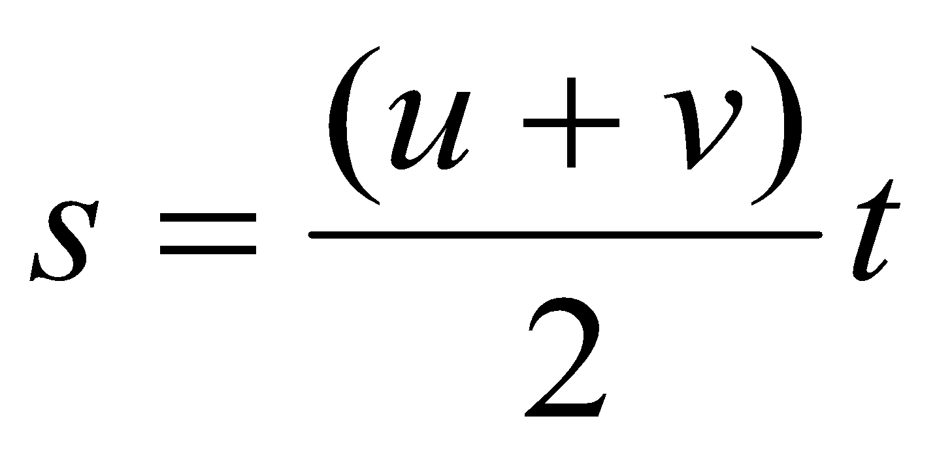 | u

Equation |  | Rearrange Equation
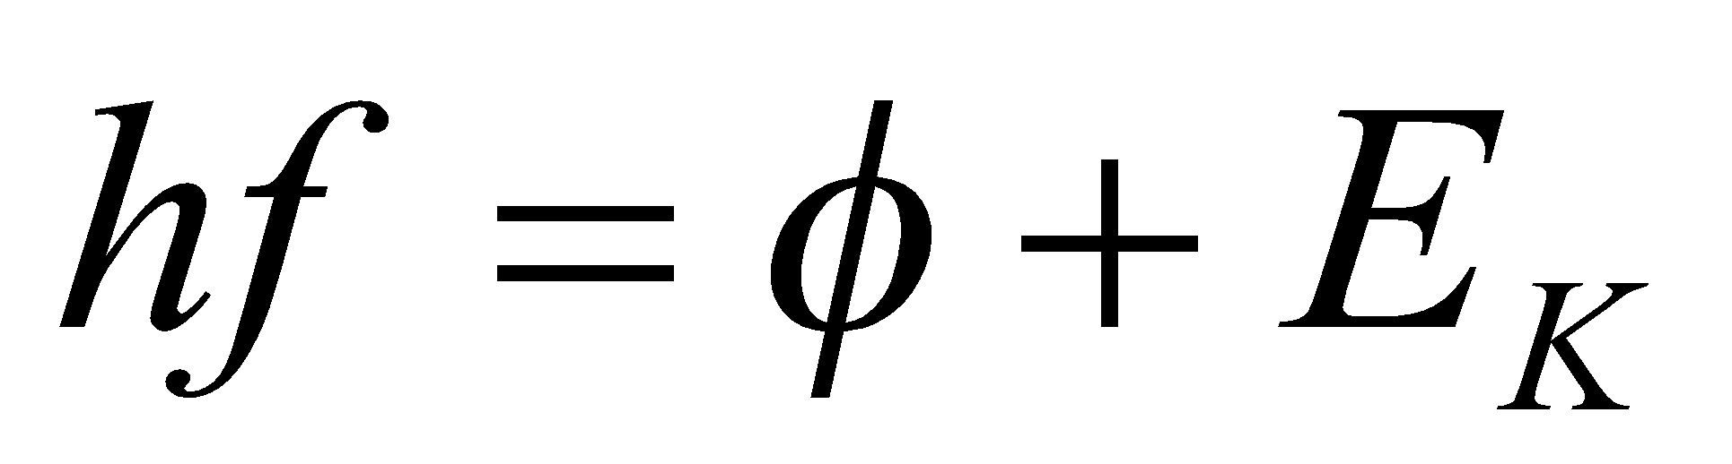 | f
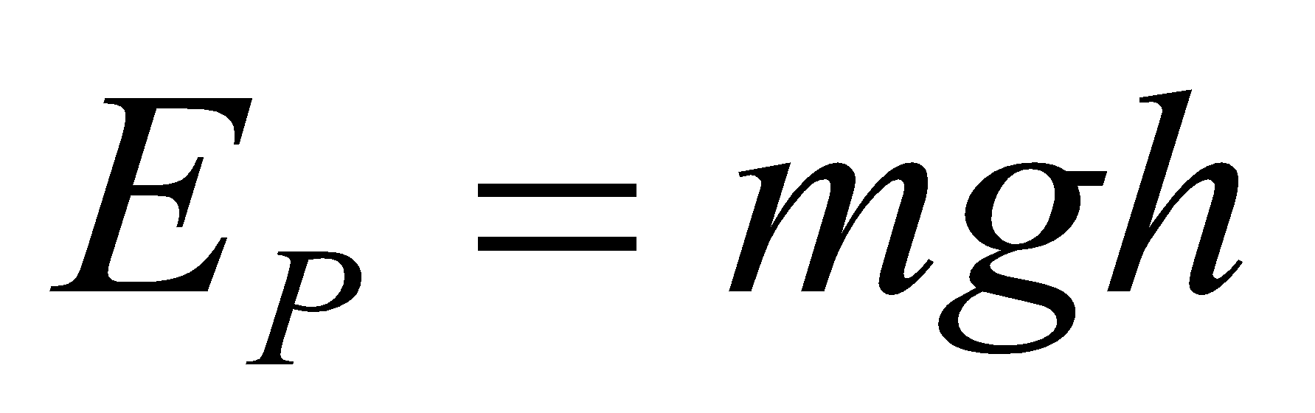 | g
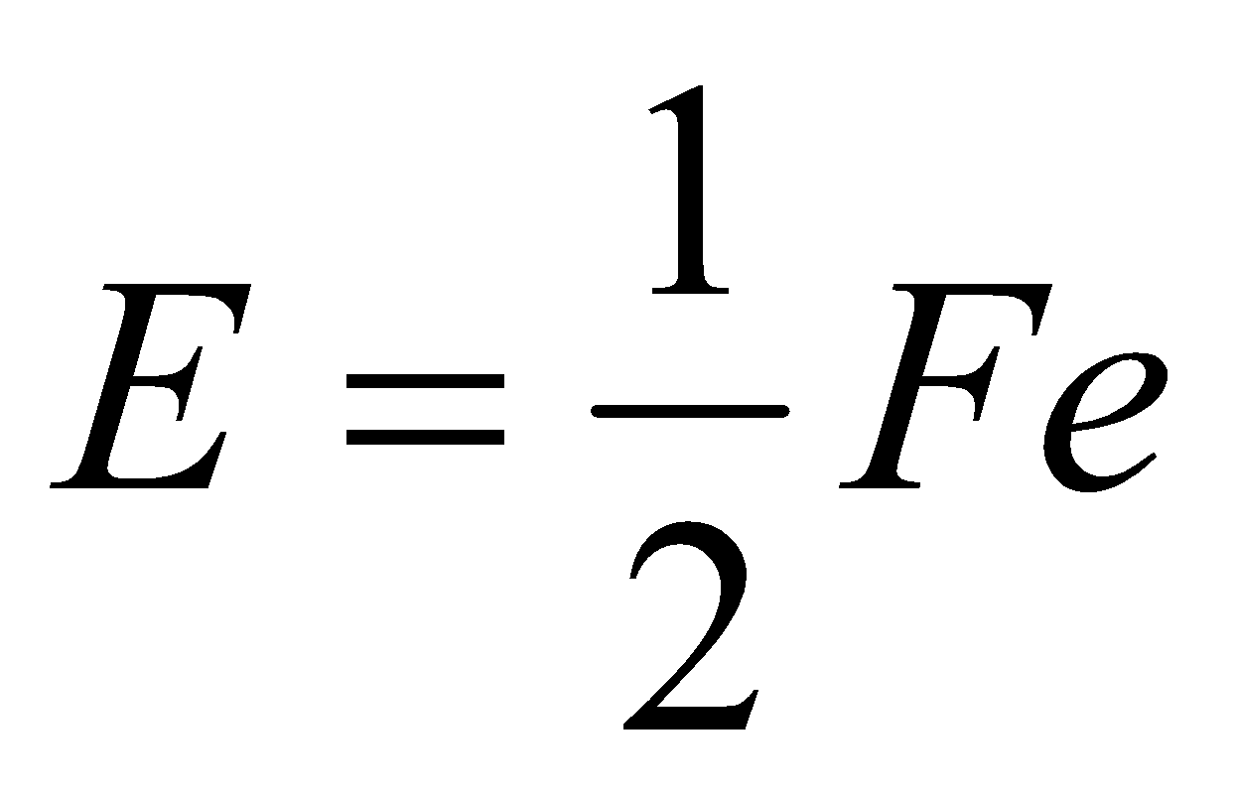 | F
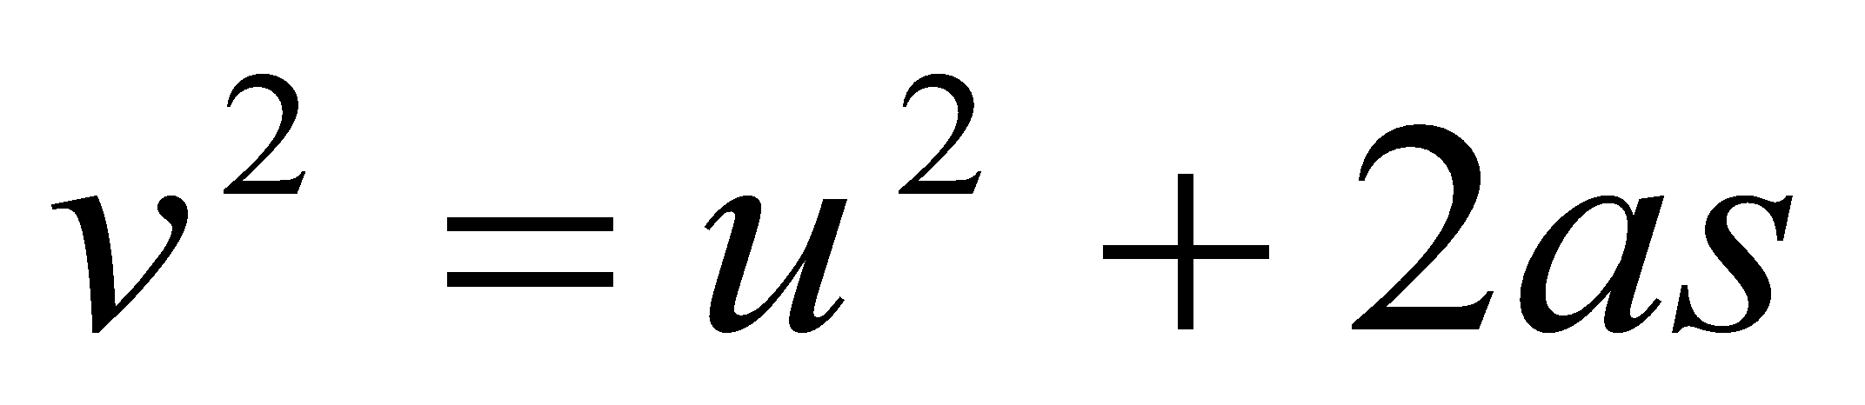 | u
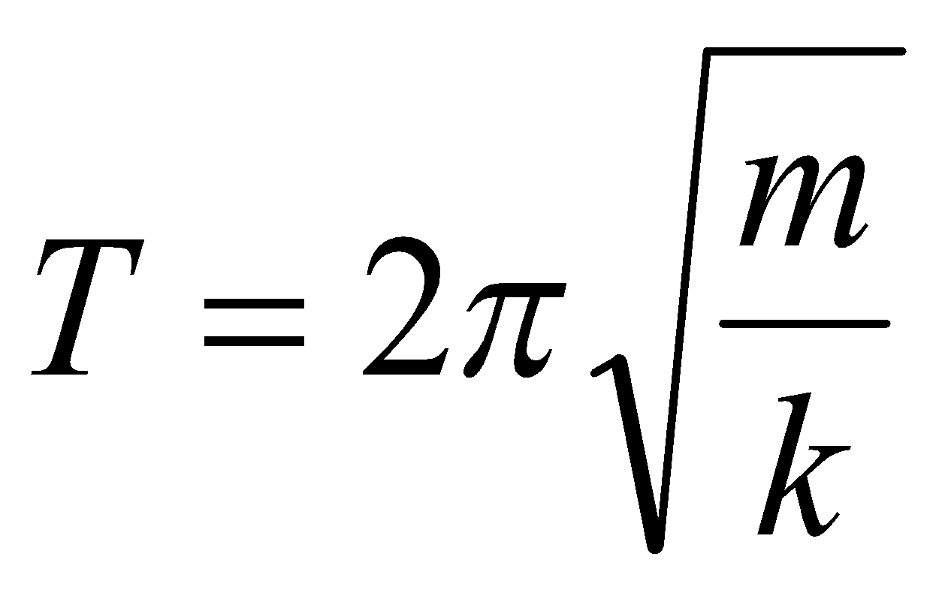 | m

AS Physics | 8. Constructing Graphs
Skills | 8. Constructing Graphs

When drawing graphs, you will be marked on the following criteria:
- Axes – Your independent variable is on the x axis, and your dependent variable is on the y axis. Both axes need to be labelled.
- Units – Add units to your axes when labelling.
- Scale – Make your scale as large as possible so that your data fills most of the page. You don’t have to start your axes at the origin. Make sure you have a regular scale that goes up in nice numbers – 1, 2, 5, 10 etc…
- Points – mark each point with a cross using a sharp pencil. Don’t use circles or dots as points.
- Line of best fit – draw a smooth line of best fit – straight or curved depending on what pattern your data follows.
An easy way to remember these points is….. S cale
L ine
A xes
P oints
U nits
Plot graphs for the following sets of data, including a line of best fit for each.
Surface area of pendulum / cm² | Time taken for pendulum to stop/ s
5.0 | 170
6.2 | 127
7.4 | 99
8.0 | 86
8.8 | 70
9.9 | 56
Current / A | Voltage / V
0.07 | 1.46
0.14 | 1.44
0.21 | 1.42
0.30 | 1.40
0.41 | 1.38
0.57 | 1.33
0.81 | 1.29
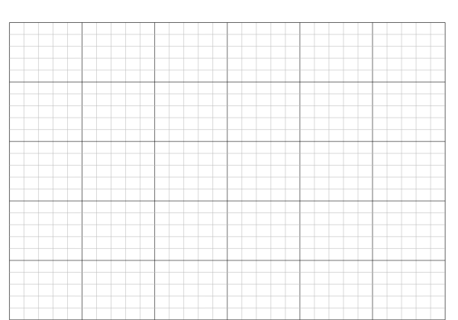
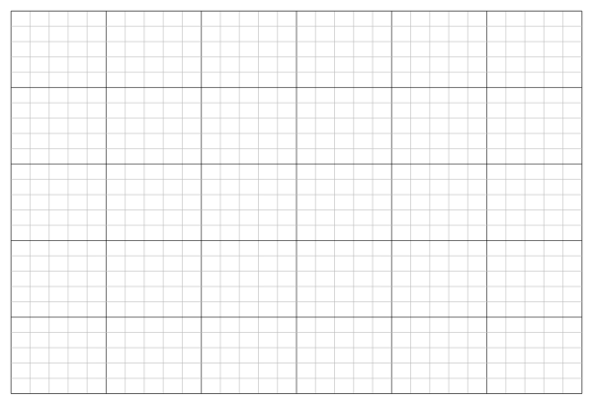

AS Physics | 9. Calculating Gradients – Straight Lines
Skills | 9. Calculating Gradients – Straight Lines
Gradients are a useful tool that show how fast or slow quantities change – eg speed tells us how fast distance is changing, or how quickly energy is being lost over time.

To calculate the gradient, pick any two points on the line as far away as possible and draw a large triangle between them.
The gradient is given by:
$gradient= \frac{diffference in y values}{difference in x values}$
But make sure the you subtract the values in the same order! Remember – if the line slopes up, the gradient should be positive; if the line slopes down, then the gradient should be negative.

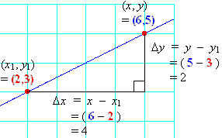
Gradient = $\frac{5-3}{6-2}$
= $\frac{2}{4}$
= 0.5

Calculate the gradients of the graphs below
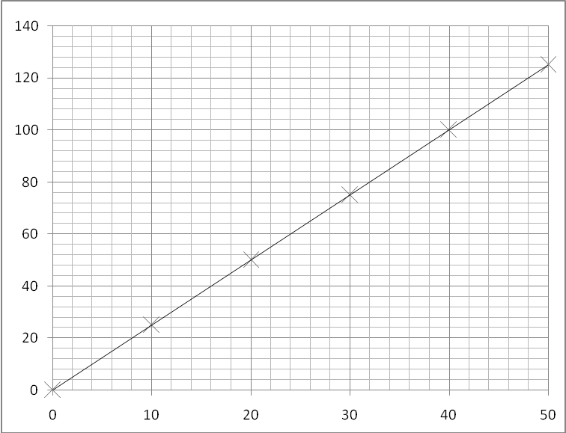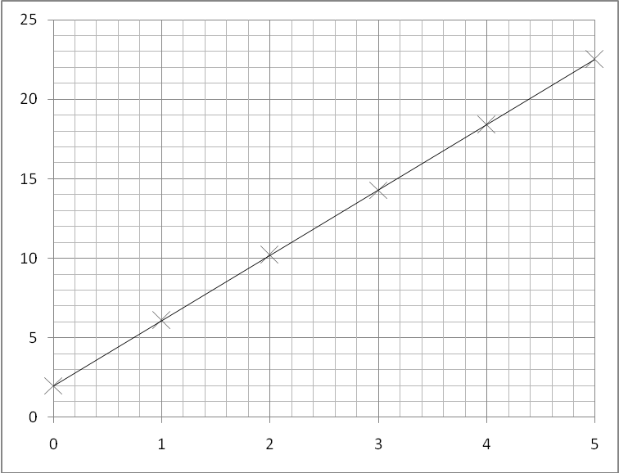
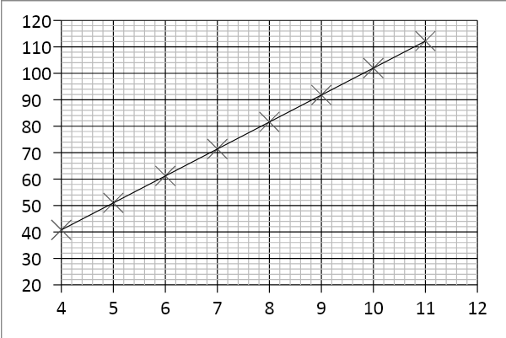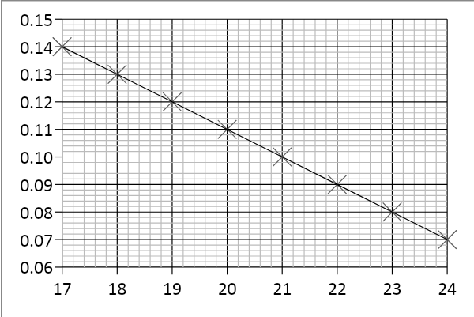
AS Physics | 10. Calculating Gradients – Curved Lines
Skills | 10. Calculating Gradients – Curved Lines

Most graphs in real life are not straight lines, but curves; however it is still useful to know how the quantity changes over time, hence we still need to calculate gradients.

If we want to know the gradient at a particular point, firstly we need to draw a tangent to the curve at that point.
A tangent is a straight line that follows the gradient at the required point. Once we have drawn the straight line tangent, its gradient can be calculated in exactly the same way as the previous page showed.

Tip – make sure your tangents and gradient triangles are as big as possible to be as accurate as you can!

Examples of drawing tangents and calculating the gradient of a tangent:

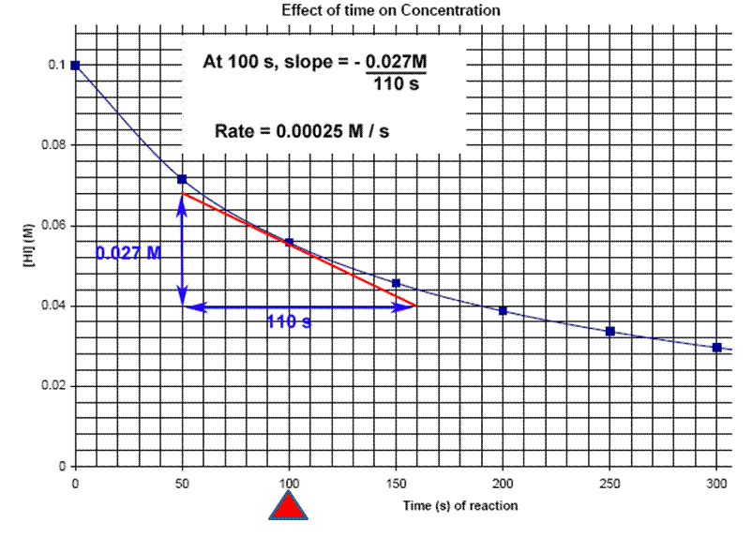
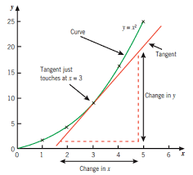

Rate = - 0.00025 M/s

Draw a tangent to the line and calculate its gradient at the following x-axis values:
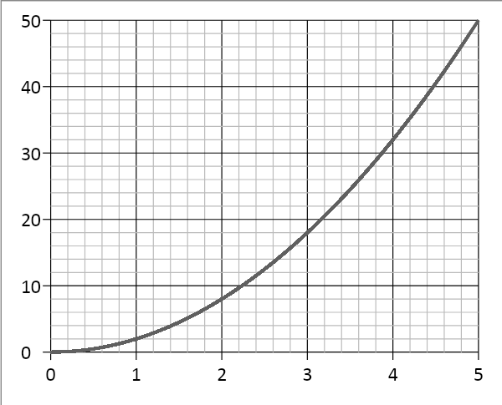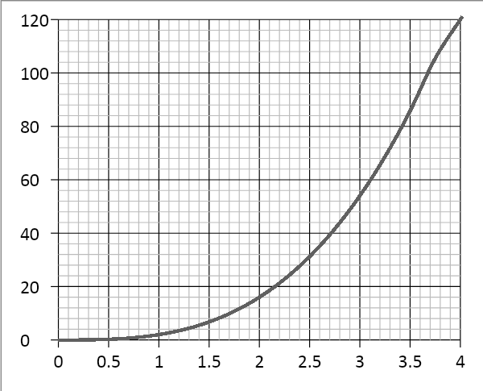
2.0 and 4.0 1.5 and 3.5
( Note - gradients in Physics often have units, this is something we will consider as we progress in the course)

AS Physics | 11. Calculating Areas – Straight line Graphs
Skills | 11. Calculating Areas – Straight line Graphs

Often other quantities can be found by multiplying the two quantities represented on a graph together (for example, multiplying velocity and time gives distance travelled). The exact quantity can be found by calculating the area under the graph.
If the graph is made of straight lines, the total area can be found by splitting the graph into segments of rectangles and triangles (or into a trapezium) and adding those areas together.
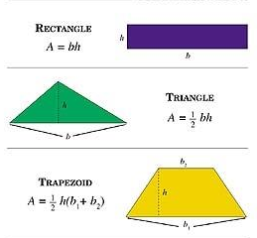

Important – the heights that you use should always be the perpendicular height from the base.

Calculate the distance travelled by determining the area under the graph:
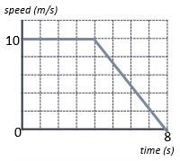

Area A = 10 x 4 = 40 m
Area B = ½ x 4 x 10 = 20 m
A
Total Area = A + B = 40 + 20 = 60 m
B
Or
Area of trapezium = ½ (4 + 8) x 10 = 60 m

Calculate the area of the below graphs and the correct unit for that area.

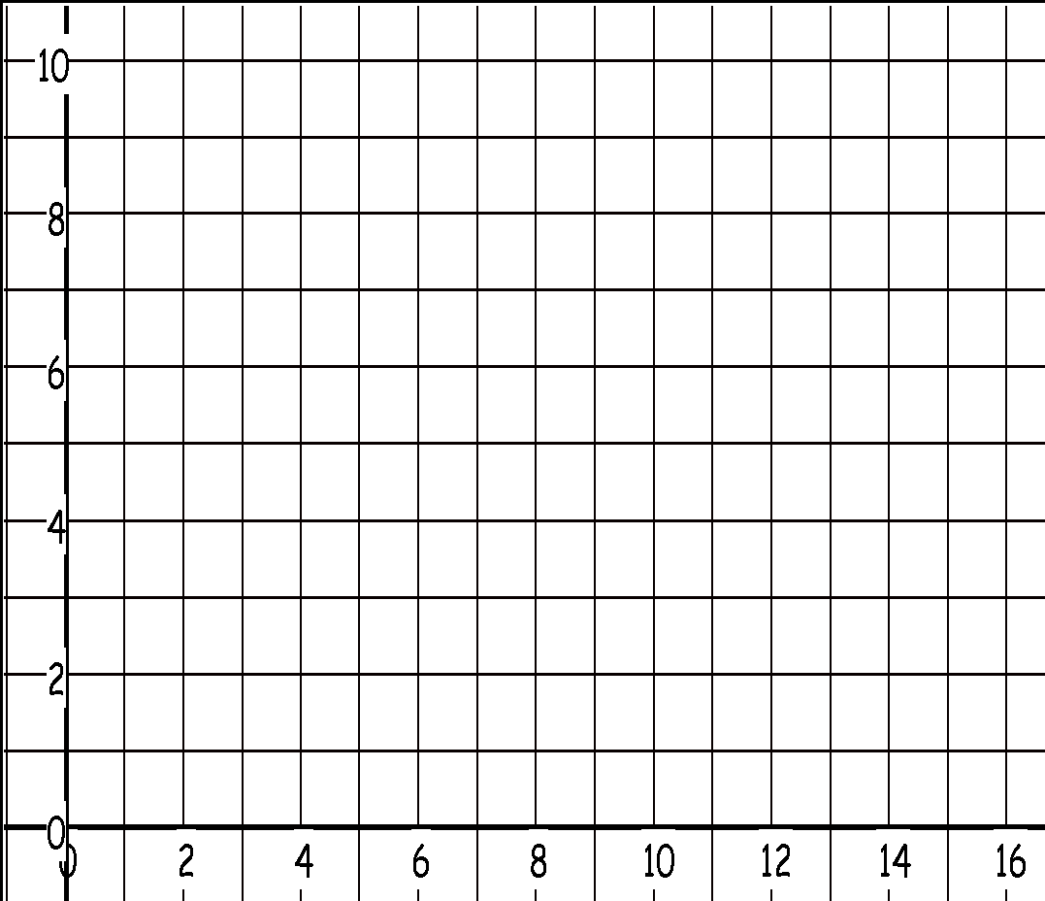

Time/s
Velocity/ m s⁻¹

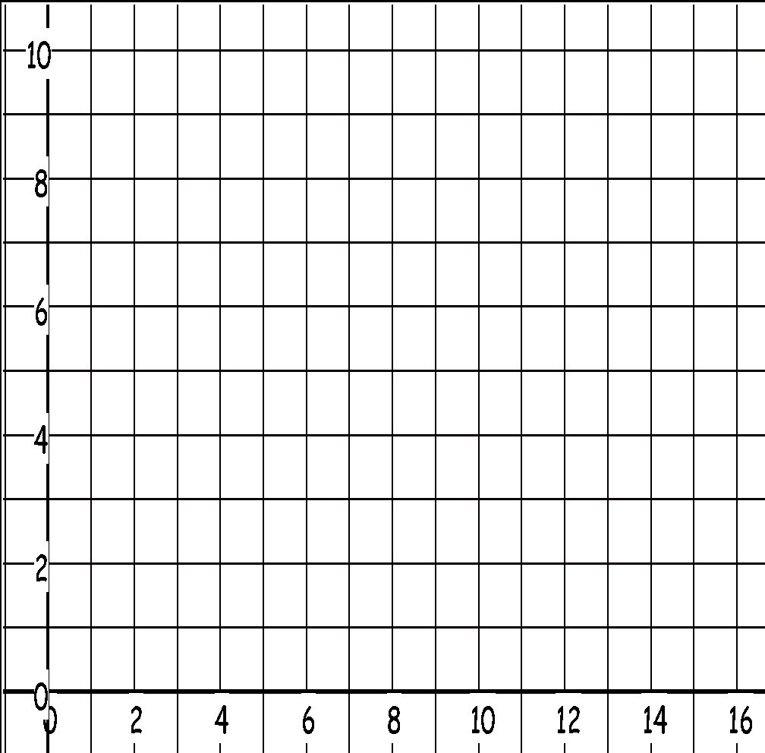

Time / s
Velocity /m s⁻¹

AS Physics | 13. Interpreting Graphs
Skills | 13. Interpreting Graphs

When interpreting graphs that are worth more than 2 marks, you need to go into more detail describing how the gradient changes over time and pick specific values to help support your answer.

Tips:
Use the quantities on the axes to support your answer.
Are there any points where the y value doesn’t change? What is this value? When does this happen on the x axis?
Are there any maximum or minimum values? What are they? When do they occur?
The gradient increases/decreases at a constant/increasing/decreasing rate….
Does the gradient represent anything (eg. velocity or acceleration)?
Are there multiple gradients? Are some steeper than others?

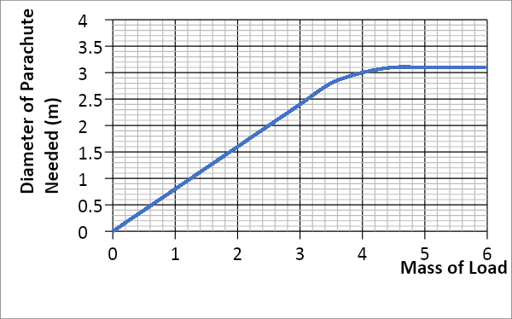

As the mass of the load increases, the diameter of the parachute needed also increases at a constant rate. This occurs to a mass of 3.4kg (which gives a diameter of 2.8m), where the gradient increases at a decreasing rate until the diameter remains constant at 3.1m for any load beyond 4.4kg. .
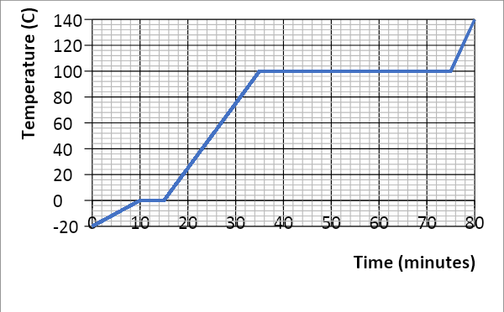
Describe in detail each graph. Write your answer at the side of each graph. Include the points mentioned under ‘tips’ in your answers.



