A. Cell structure Part 1 – Eukaryotes, prokaryotes and animal and plant cells

1. Describe the similarities and differences between a typical plant and a typical animal cell. (4)
.......................................................................................................................................

.......................................................................................................................................

.......................................................................................................................................

.......................................................................................................................................

.......................................................................................................................................

.......................................................................................................................................

2. Ribosomes synthesise proteins. Explain what this means. (2)
.......................................................................................................................................

.......................................................................................................................................

.......................................................................................................................................

3. Explain why the mitochondria in cells are important. (3)
.......................................................................................................................................

.......................................................................................................................................

.......................................................................................................................................

4. The table below shows the number of mitochondria in different mammalian cells.
Type of mammalian cell | Number of mitochondria per cell |  |  | Mean number of mitochondria
 | 1 | 2 | 3
Stomach lining | 1720 | 1850 | 1680
Liver | 2095 | 2210 | 1995
Skin | 290 | 315 | 295
Large intestine lining | 1295 | 1429 | 1476
Muscle | 1853 | 1746 | 1801
Kidney | 1450 | 1650 | 1400

a. Calculate the mean number of mitochondria in each cell and write these in the table. (6)
.......................................................................................................................................

.......................................................................................................................................

.......................................................................................................................................

.......................................................................................................................................

.......................................................................................................................................

.......................................................................................................................................

.......................................................................................................................................

.......................................................................................................................................

.......................................................................................................................................

.......................................................................................................................................

.......................................................................................................................................

.......................................................................................................................................

.......................................................................................................................................

.......................................................................................................................................

.......................................................................................................................................

b. Use graph paper and a suitable method to display the data from the table. (4)
(Remember to add labels).

5. Extended response question:
The image below shows a type of bacteria called Bacillus cereus. It can cause food poisoning by releasing toxins that can make you vomit.
Bacteria are prokaryotic cells.

Recall the typical structures in a prokaryotic cell and describe the function of each of the structures. (6)

.......................................................................................................................................

.......................................................................................................................................

.......................................................................................................................................

.......................................................................................................................................

.......................................................................................................................................

.......................................................................................................................................

.......................................................................................................................................

.......................................................................................................................................

.......................................................................................................................................

.......................................................................................................................................

.......................................................................................................................................

.......................................................................................................................................

B. Cell structure Part 2 - Cell specialisation and cell differentiation

1. Extended response question:
Compare and contrast the structure and function of sperm cells and egg cells. (6)
.......................................................................................................................................

.......................................................................................................................................

.......................................................................................................................................

.......................................................................................................................................

.......................................................................................................................................

.......................................................................................................................................

.......................................................................................................................................

.......................................................................................................................................

.......................................................................................................................................

.......................................................................................................................................

.......................................................................................................................................

.......................................................................................................................................

.......................................................................................................................................

.......................................................................................................................................

.......................................................................................................................................

C. Cell structure Part 3 – Microscopy

1. Describe some advantages and disadvantages of the light microscope as compared to an electron microscope. (4)
.......................................................................................................................................

.......................................................................................................................................

.......................................................................................................................................
.......................................................................................................................................

.......................................................................................................................................

.......................................................................................................................................

2. The diagram below shows sperm cells travelling towards an egg cell.
The real length of the sperm cell labelled A is 42 μm.
Calculate the magnification of the sperm cell. (4)

A

.......................................................................................................................................

.......................................................................................................................................

.......................................................................................................................................

3. The diagram shows an image of human cheek cells.
The magnification of the cheek cells is x 100.
Calculate the real length of the cheek cell labelled B. (3)
B

.......................................................................................................................................

.......................................................................................................................................

.......................................................................................................................................

4. Extended response question:
A student has been asked to observe onion cells under a microscope.
State the equipment they would need and describe the procedure they would use. (6)

You do not need to discuss the risks.
.......................................................................................................................................

.......................................................................................................................................

.......................................................................................................................................

.......................................................................................................................................

.......................................................................................................................................

.......................................................................................................................................

.......................................................................................................................................

.......................................................................................................................................

.......................................................................................................................................

.......................................................................................................................................

.......................................................................................................................................

.......................................................................................................................................

D. Enzymes

1. Explain why enzymes are needed in digestion. (4)
.......................................................................................................................................

.......................................................................................................................................

.......................................................................................................................................

.......................................................................................................................................

.......................................................................................................................................

.......................................................................................................................................

2. Explain how the release of bile into the small intestines increases the rate of fat breakdown. (3)
.......................................................................................................................................

.......................................................................................................................................

.......................................................................................................................................

.......................................................................................................................................

3. Different enzymes work best at different temperatures.
The graph shows the effect of temperature on different enzymes.
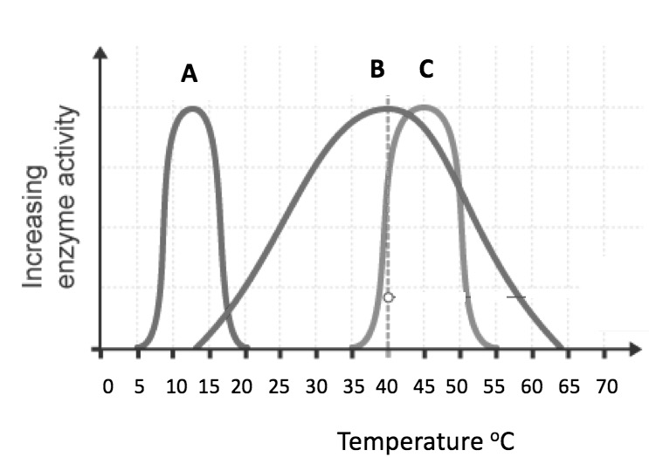

a. Describe and explain the shape of the graph for enzyme A. (4)
.......................................................................................................................................

.......................................................................................................................................

.......................................................................................................................................

.......................................................................................................................................

b. Enzyme B is protease and is produced in the stomach, pancreas and small intestine.
Explain why protease works more effectively in the stomach. (3)
.......................................................................................................................................

.......................................................................................................................................

.......................................................................................................................................

.......................................................................................................................................

.......................................................................................................................................

E. Transport in cells

1. The image below shows beetroot in different temperatures of water. The beetroot pieces are all the same size and shape and this is the result after 20 minutes.
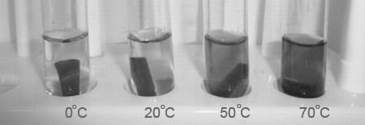

Explain the results of this experiment. (4)
.......................................................................................................................................

.......................................................................................................................................

.......................................................................................................................................

.......................................................................................................................................

.......................................................................................................................................

.......................................................................................................................................

2. Plants and animals have adaptations that allow for efficient transport of substances in and out of cells. One of these adaptations is maintaining the concentration gradient.
Explain the importance of maintaining the concentration gradient in diffusion. (2)
.......................................................................................................................................

.......................................................................................................................................

.......................................................................................................................................

.......................................................................................................................................

.......................................................................................................................................

.......................................................................................................................................

3. Extended response question:
A student has been given the following equipment and has been asked to investigate the rate of osmosis in potato tissue at different salt concentrations.

Describe how you would use this equipment to investigate the rate of osmosis in potato tissue at different salt concentrations. How will you make it a fair test? (6)

Not all the equipment you will need is shown here. You will not need to write a risk assessment.
.......................................................................................................................................

.......................................................................................................................................

.......................................................................................................................................

.......................................................................................................................................

.......................................................................................................................................

.......................................................................................................................................

.......................................................................................................................................

.......................................................................................................................................

.......................................................................................................................................

.......................................................................................................................................

.......................................................................................................................................

.......................................................................................................................................

F. Using chemical reagents to identify starch, reducing sugars, protein and fats.

1. Write a risk assessment for the experiment required to investigate whether a new type of food, “Chefapie”, contains reducing sugars. (4)
.......................................................................................................................................

.......................................................................................................................................

.......................................................................................................................................

.......................................................................................................................................

.......................................................................................................................................

.......................................................................................................................................

