A. Reactivity series and displacement reactions as redox reactions
- Three metals, X, Y and Z were put into water. The reactions are shown below:
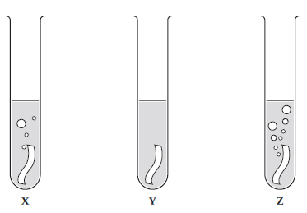
a) Use the diagrams to put metals X, Y and Z in order of reactivity, starting with the most reactive. (1)
Z X Y (1)

b) When a metal reacts with water, it produces hydrogen gas and a metal hydroxide. Describe how you can test for the gas. (2)
Hydrogen [1] – gives a squeak pop with a lit splint (1)

c) Give two variables that should be controlled in this investigation. (2)
Any two from:
• same temperature of the water
• same mass / number of moles of the metal
• same surface area of the metal

- A student carried out some displacement reactions using three metals and three sulfate solutions.
The results are shown in the table below:

 | Iron sulfate  (FeSO₄) | Copper sulfate  (CuSO₄) | Magnesium sulfate (MgSO₄)
Iron (Fe) |  | ✓ | ✗
Copper (Cu) | ✗ |  | ✗
Magnesium (Mg) | ✓ | ✓

- i) Explain what is observed when iron reacts with copper sulfate. (2)
Iron nail turns (from grey to) brown (1)
Solution turns (from blue to) pale green (1)

ii) HT: Write an ionic equation for the reaction between iron and copper sulfate solution. (2)
Fe + Cu²⁺ → Fe²⁺ + Cu (1 mark for reactants and 1 mark for products)

- Explain why there is no observation between copper and iron sulfate. (2)
Copper does not react with iron sulfate (1) (because) copper is less reactive than iron (1)

- i) Explain what is observed when magnesium reacts with iron sulfate. (2)
Magnesium ribbon turns (from silver to) grey (1)
Solution turns (from colourless to) pale green (1)

ii) HT: Write a half equation to show the reduction of iron ions (Fe²⁺) when magnesium reacts with iron sulfate. Use the half equation to explain why Fe²⁺ ions are reduced.
Fe²⁺ + 2e- → Fe (1)
(Fe²⁺ ions are reduced because they have) gained electrons (1)

B. Extracting metals: Metal ores; oxidation and reduction; methods of extraction and biological methods of extraction
1. Extended response question:

Describe how phytomining and bioleaching are now being used to extract copper and why these methods are being used. (6)

0 marks | Level 1 (1–2 marks) | Level 2 (3–4 marks) | Level 3 (5–6 marks)
No relevant content | Phytomining  uses plants to absorb copper [1]  they are burnt the ash contains copper [1]  OR  bioleaching  uses bacteria to produce leachate solutions that contain copper [1]  copper extracted by displacement or electrolysis [1]  OR  Copper ores becoming scarce/limited [1]  Avoids digging/moving and disposing of rock/traditional methods of mining [1] | Two of the relevant pieces of information. | All three relevant pieces of information.

- Explain how the position of a metal in the reactivity series is linked to the method used to extract a metal from its ore. (4)
Metals more reactive than carbon [1] are extracted using electrolysis [1], metals less reactive than carbon [1] extracted by heating with carbon [1]

- Explain the terms oxidation and reduction in terms of electrons and in terms of oxygen. (4)
Oxidation is loss of electrons [1] / gain of oxygen [1]
Reduction is gain of electrons [1] / loss of oxygen [1]

- When metals are extracted from their ores do they undergo oxidation or reduction? Explain your answer. (2)
Reduction [1], loss of oxygen [1]

- How is a metal’s relative position in the reactivity series linked to oxidation? (3)
A metal’s relative resistance to oxidation [1]; more resistant = less likely to form an ion [1] therefore less reactive [1]

C. Extracting metals: Recycling metals and life-cycle assessment
1. In the given stages below, compare the life cycle assessments for a plastic and a paper bag used for shopping. The first stage has been completed for you.

Extracting and processing raw materials
Plastic bag – crude oil needs to be extracted from the Earth which requires energy and may cause pollution.
Paper bag – trees need to be cut down and removed which causes destruction of forests and loss of habitats but can be sustainable.

In all cases look for comparisons in need for chemicals/fuel/transport
Manufacturing and packaging (2)
Plastic bag – requires the use of energy/non-renewable, catalysts will require transport to place of use
Paper bag – requires energy/ possibly bleaching/ will require transport/ paper bags are heavier more use of fuels

Use and operation during its lifetime (2)
Plastic bag – can be reused a number of times/is flexible so less likely to tear/ waterproof
Paper bag – ORA from above

Disposal at the end of its useful life (2)
Plastic bag – non-biodegradable/will not decay for a long time/OWTTE
Paper bag – ORA from above

- Evaluate the advantages of recycling metals. (4)
Less energy to melt and remould than extract from ores [1]; mining ores has negative impact on environment (any suitable example) [1]; waste metals used reduced need for landfill [1]; less raw materials needed [1]
- Describe some potential issues associated with carrying out life time assessments. (4)
Difficult to allocate numbers to the impact of pollutants [1]; requires a judgement which could be biased [1]; a simplified version may be used [1]; could be misused to reach a pre-determined conclusion [1]
D. Reversible reactions, dynamic equilibrium and the Haber process
- Ammonia can be used to produce nitrogen-based fertilisers. It is manufactured on an industrial scale using the Haber process. Explain how ammonia is produced using the Haber process. You should include the following in your response:
  - an equation nitrogen + hydrogen 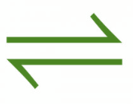 ammonia
  - a source for each raw material Nitrogen – air; hydrogen – natural gas
  - the reaction conditions. Temperature – 450ºC; Pressure 200 atm; iron catalyst
(6)
0 marks | Level 1 (1–2 marks) | Level 2 (3–4 marks) | Level 3 (5–6 marks)
No relevant content | One of the three bullet points covered with relevant information | Two of the three bullet points covered with relevant information | All three bullet points covered with relevant information

- The following graph outlines the impact of reaction conditions on the percentage yield of ammonia from the Haber process. Describe the conditions which give the highest yield and explain why there is a compromise on these conditions in industry [4].
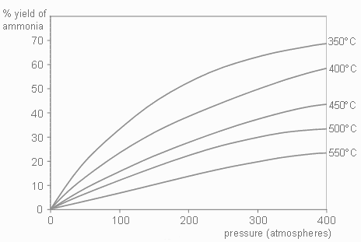
High pressure [1]; low temperature [1]
High pressure is expensive and dangerous [1]; low temperature gives a low rate of reaction [1]

- Explain what is meant by the term dynamic equilibrium. (1)
Rate of forward reaction = rate of backward reaction [1]

- Other than changing the pressure, for the reaction below describe and explain how you would produce more ammonia NH₃ (2)

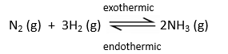
Decrease the temperature [1]
The forward reaction is exothermic [1]

- For the reaction below, 135 kJ of energy is put in to make anhydrous copper sulfate. How much energy will be released if the same amount of water is added to the anhydrous copper sulfate as was removed in the forward reaction? Explain your answer. (2)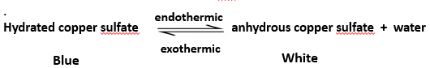
135Kj [1]
The same amount of energy is transferred in each direction/case [1]
E. Factors affecting dynamic equilibria (HT)
- The following reversible reaction is used in the manufacture of sulfuric acid. The forward reaction is exothermic.
2SO₂ + O₂ 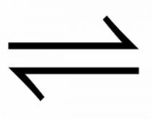 2SO₃
Describe the conditions which would favour the forward reaction by changing the position of dynamic equilibrium. Explain the reasons for your choice. (6)
Increase pressure [1] fewer molecules/ moles on right hand side [1]
Decrease temperature [1] reaction is exothermic [1]
Increase concentration of reactants [1] will increase concentration of products [1]

DO NOT accept catalyst as this will increase the rate of reaction in both directions – it will not favour the forward reaction.

- A student is investigating the following reaction;

Describe what would happen if the student increased the concentration of reactants, then the concentration of products and explain why you think this. (6)

If concentration of reactants is increased, then more products will be formed [1] until equilibrium is reached again [1]
If concentration of products is increased, then more reactants will be formed [1] until equilibrium is reached again [1]
Due to Le Chatelier’s principal [1] if a change is made then system responds to counteract the change [1]

- A reaction is at equilibrium. The reactants are iodine gas I₂ and hydrogen gas H₂; the product is hydrogen iodide gas HI. When the temperature of the system is increased, more iodine and hydrogen are produced.
Write the balanced symbol equation for this reaction and include the directions of the endothermic and exothermic reactions and the state symbols (4).
exothermic

I₂ (g) + H₂ (g) 2HI (g)
endothermic

Symbol equation with reversible sign [1]
Balanced [1]
State symbols [1]
Exothermic and endothermic in the correct place [1]

- Explain what would happen in the following equilibrium reaction if we increased the pressure. (3)

N₂ (g) + 3H₂ (g) 2NH₃ (g)

Equilibrium would move to the right/we would get more ammonia [1]
There are less molecules/moles on the right hand side [1]
Any further explanation using Le Chatelier’s principal [1]

