A. Acids and alkalis, indicators, strong and weak acids and reactions with metals
- Zinc reacts with hydrochloric acid.
  - Write a word and a balanced symbol equation, with state symbols, to show this reaction. (3)

.......................................................................................................................................
.......................................................................................................................................

  - HT: write an ionic equation for the reaction. (2)

.......................................................................................................................................
.......................................................................................................................................

  - HT: Give both half equations to show the electron transfers taking place. (2)

.......................................................................................................................................
.......................................................................................................................................

  - HT: Explain why this reaction is a redox reaction. (4)

.......................................................................................................................................
.......................................................................................................................................

.......................................................................................................................................

- Acids can be described as weak or strong.
  - HT: Explain why ethanoic acid (found in vinegar) is described as a weak acid, whereas nitric acid is a strong acid. (4)

.......................................................................................................................................
.......................................................................................................................................

.......................................................................................................................................

.......................................................................................................................................
.......................................................................................................................................

  - HT: Magnesium reacts with ethanoic acid and nitric acid. What difference would you see if magnesium carbonate was reacted with ethanoic acid of the same concentration as nitric acid? (2)

.......................................................................................................................................
.......................................................................................................................................

.......................................................................................................................................

- Explain the difference between acids and alkalis in terms of hydrogen ions and pH. (4)

.......................................................................................................................................
.......................................................................................................................................

.......................................................................................................................................

.......................................................................................................................................

- Explain the difference between an alkali and a base. (1)

.......................................................................................................................................
.......................................................................................................................................

- Describe the effect of adding a strong acid to each of the following indicators: (3)
  - Litmus
.......................................................................................................................................

  - Methyl orange
.......................................................................................................................................

  - Phenolphthalein
.......................................................................................................................................

- HT: You are given a 0.50mol/dm³ solution of nitric acid (strong) and ethanoic acid (weak).
  - Calculate the concentration of each acid, giving your answer in g/dm³ to 3 significant figures. (2)

.......................................................................................................................................
.......................................................................................................................................

.......................................................................................................................................

  - The solution of ethanoic acid has a pH of 4 and the solution of nitric acid a pH of 1. How many times greater is the concentration of H⁺ ions in the nitric acid compared to the concentration in the ethanoic acid? (2)

.......................................................................................................................................
.......................................................................................................................................

.......................................................................................................................................

- HT: Explain the difference between a dilute and concentrated acid. Why can an acid be both weak and concentrated? (6)
.......................................................................................................................................
.......................................................................................................................................

.......................................................................................................................................

.......................................................................................................................................
.......................................................................................................................................

.......................................................................................................................................

.......................................................................................................................................
.......................................................................................................................................

.......................................................................................................................................

B. Reactions of acids: Neutralisation, salts and titration
- A student carried out a reaction by adding zinc to sulfuric acid. Write a word equation for the reaction and explain how they would test the gas produced to identify it. (3)

.......................................................................................................................................
.......................................................................................................................................

.......................................................................................................................................

- Describe an acid-alkali neutralisation reaction in terms of ions. (3)

.......................................................................................................................................
.......................................................................................................................................

.......................................................................................................................................

- Describe how to carry out an acid-alkali titration to prepare a pure, dry salt. (6)

.......................................................................................................................................
.......................................................................................................................................

.......................................................................................................................................

.......................................................................................................................................
.......................................................................................................................................

.......................................................................................................................................

.......................................................................................................................................
.......................................................................................................................................

.......................................................................................................................................

- Complete the following table to indicate the solubility of the following substances in water. (5)
Substance | Solubility in water
Ammonium nitrate
Sodium chloride
Lead sulfate
Calcium carbonate
Sodium carbonate

- For the following reactions predict whether a precipitate will form. Name the precipitate if one is formed. (2)
  - Sulfuric acid + calcium

.......................................................................................................................................

  - Sulfuric acid + sodium

.......................................................................................................................................

- Magnesium carbonate reacts with nitric acid. The equation is shown below:

MgCO₃(aq) + 2 HNO₃(aq) ---> Mg(NO₃)₂(aq) + H₂O(l) + CO₂(g)

Extended writing:
Plan a method to produce dry crystals of magnesium nitrate. (6)

.......................................................................................................................................
.......................................................................................................................................

.......................................................................................................................................

.......................................................................................................................................
.......................................................................................................................................

.......................................................................................................................................

.......................................................................................................................................
.......................................................................................................................................

.......................................................................................................................................

.......................................................................................................................................
.......................................................................................................................................

.......................................................................................................................................

- A titration is carried out between hydrochloric acid and sodium hydroxide.
  - The following results show the volumes of acid added to neutralize the sodium hydroxide.

 | Rough | Trial 1 | Trial 2 | Trial 3
Volume of acid added (cm³) | 15.70 | 15.30 | 15.25 | 15.30

Calculate the mean volume of solution added and explain your answer. (3)
.......................................................................................................................................
.......................................................................................................................................

.......................................................................................................................................

  - HT: In another investigation, it takes 27.00cm³ of hydrochloric acid to neutralise 25.00cm³ of sodium hydroxide at a concentration of 1.0 mol/dm³. Calculate the concentration of hydrochloric acid in g/cm³. (4)
.......................................................................................................................................
.......................................................................................................................................

.......................................................................................................................................

C. Electrolysis of a molten ionic compound; electrolysis of an aqueous solution
- The diagram shows how molten lead bromide is electrolysed. Lead bromide contains Pb²⁺ and Br⁻ ions.
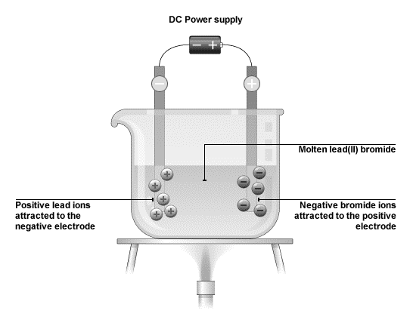

  - Explain why molten lead bromide conducts electricity. (1)
.......................................................................................................................................
.......................................................................................................................................

- HT: Write the half equations, including the state symbols, for the changes at the anode and cathode. (4)

.......................................................................................................................................
.......................................................................................................................................

.......................................................................................................................................

- The diagram shows how sodium chloride is electrolysed in the laboratory:
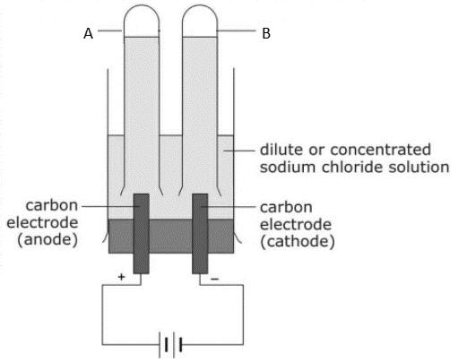
- Name the products A and B? (2)

.......................................................................................................................................
.......................................................................................................................................

- Give one use of substance A. (1)

.......................................................................................................................................
.......................................................................................................................................

- A few drops of universal indicator was added to the solution after the reaction and it turned blue. Explain why. (2)

.......................................................................................................................................
.......................................................................................................................................

.......................................................................................................................................

- HT: Write the half equations, including the state symbols, for the changes as the anode and cathode. (4)

.......................................................................................................................................
.......................................................................................................................................

.......................................................................................................................................

.......................................................................................................................................
.......................................................................................................................................

D. Electrolysis: Purification of copper
- Explain the formation of products in the electrolysis of copper sulfate solution using copper electrodes. (3)

.......................................................................................................................................
.......................................................................................................................................

.......................................................................................................................................

- Explain how the electrolysis of copper sulfate solution with copper electrodes can be used to purify copper. (4)

.......................................................................................................................................
.......................................................................................................................................

.......................................................................................................................................

.......................................................................................................................................
.......................................................................................................................................

.......................................................................................................................................

