A. Surface area and gas exchange
1. Describe the levels of organisation in the human circulatory system in size order from the smallest to largest part. (4)
.......................................................................................................................................

.......................................................................................................................................

.......................................................................................................................................

.......................................................................................................................................

.......................................................................................................................................

.......................................................................................................................................

2. The following illustrations show the potential effect of smoking on the lungs.

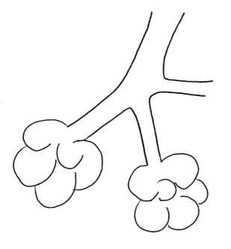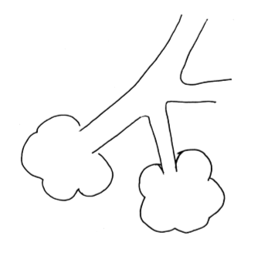
B

A

- Explain which illustration represents the smokers lung and why you made this decision. (2)

.......................................................................................................................................

.......................................................................................................................................

.......................................................................................................................................

- How will gas exchange be affected? (1)

.......................................................................................................................................

.......................................................................................................................................

.......................................................................................................................................

3. Three organisms have had their surface area and volume measured.

- Calculate their surface area: volume ratio and record this in the table below. (3)

 | Organism A | Organism B | Organism C
Surface area cm² | 6 | 600 | 60000
Volume cm³ | 1 | 1000 | 1000000
Surface area : volume ratio

- Which organism will receive all the oxygen it requires through diffusion through its outer surface? (1)

.......................................................................................................................................

- Explain which organism is most likely to receive little or no oxygen through its outer surface. (2)
.......................................................................................................................................

.......................................................................................................................................

.......................................................................................................................................

B. Human circulation
1. The diagram below shows the structure of the heart.
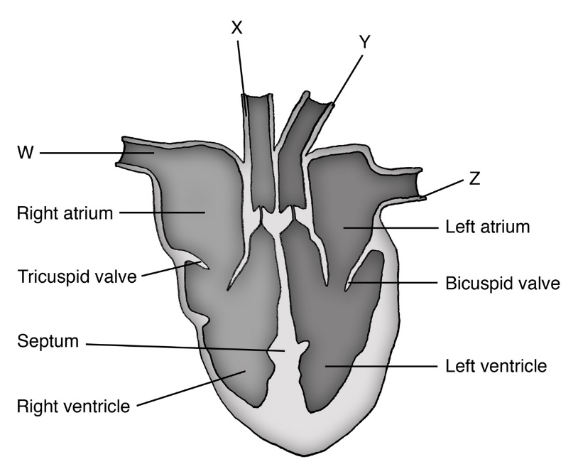

- Name and describe the function of the parts W, X, Y and Z. (4)
.......................................................................................................................................

.......................................................................................................................................

.......................................................................................................................................

.......................................................................................................................................

b. The heart is described as a ‘double pump’; explain why two separate circulation systems are needed. (2)
.......................................................................................................................................

.......................................................................................................................................

.......................................................................................................................................

c. Look at the bicuspid valve on the diagram of the heart. This is one of the atrioventricular valves.
Using this information, explain the function of this valve. (2)
.......................................................................................................................................

.......................................................................................................................................

.......................................................................................................................................

d. Janeth was carrying out a heart dissection. He was trying to work out which ventricle was the one which pumps blood around the body.

Explain one observation he could make which would help him decide. (1)

.......................................................................................................................................

.......................................................................................................................................

.......................................................................................................................................

C. Aerobic and anaerobic respiration
1. Describe the differences between anaerobic and aerobic respiration in animal cells. (4)
.......................................................................................................................................

.......................................................................................................................................

.......................................................................................................................................

.......................................................................................................................................

.......................................................................................................................................

.......................................................................................................................................

2. ‘Some uses for the energy transferred from respiration are the same in plants and animals and some are different.’ Explain what this statement means. (3)

.......................................................................................................................................

.......................................................................................................................................

.......................................................................................................................................

3. Explain why the mitochondria in cells are important. (3)
.......................................................................................................................................

.......................................................................................................................................

.......................................................................................................................................

4. Suggest how the rate of respiration in an animal cell might change over a typical 24 hour period. (2)
.......................................................................................................................................

.......................................................................................................................................

.......................................................................................................................................

5. A patient was linked to a heart rate monitor whilst doing exercise.
a) Explain why the patient’s heart rate increased from 75 beats per minute to 120 beats per minute. (5)
.......................................................................................................................................

.......................................................................................................................................

.......................................................................................................................................

.......................................................................................................................................

.......................................................................................................................................

.......................................................................................................................................

.......................................................................................................................................

.......................................................................................................................................

.......................................................................................................................................

b) The doctor was given a print out which showed the patient had a resting heart rate of 75 beats per minute and a cardiac output of 8 litres per minute.

Calculate the stroke volume for this patient in ml per beat. (3)
.......................................................................................................................................

.......................................................................................................................................

.......................................................................................................................................

7. Extended response question:
Wild dogs tend to rely on stamina and wear down their prey with a long chase which can be up to an hour. Their muscles fatigue slowly as they pace themselves.
This graph shows how much energy is being produced for muscle cells from anaerobic and aerobic respiration during exercise.

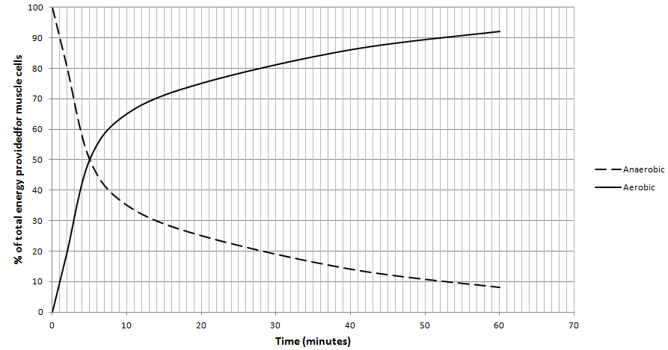

Using the information provided and your own knowledge describe and explain how energy is being transferred to the muscles in the dog at the start, middle and end of a 60 minute hunt. Include word equations in your answer. (6)

.......................................................................................................................................

.......................................................................................................................................

.......................................................................................................................................

.......................................................................................................................................

.......................................................................................................................................

.......................................................................................................................................

.......................................................................................................................................

.......................................................................................................................................

.......................................................................................................................................

.......................................................................................................................................

.......................................................................................................................................

8. An experiment was set up to investigate the rate of respiration by woodlice. Two identical pieces of apparatus were used. In tube A, 5 woodlice were placed on the gauze tray and in tube B, 5 glass beads of a similar size were added.
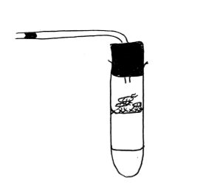
Coloured ink in a glass capillary tube
Potassium hydroxide solution
Woodlice/Glass beads on a gauze tray
10 cm ³ of potassium hydroxide solution was used in each tube to absorb carbon dioxide.
A drop of coloured ink was introduced into both the capillary tubes and the position marked with a permanent marker on the glass. The tubes were left for one hour and then the position of the ink remarked.
Tube | Start position of ink mm | End position of ink after 1 hour mm
A | 2 | 12
B | 3 | 3
- Explain what must have caused the movement of the ink in tube A? (2)
.......................................................................................................................................

.......................................................................................................................................

- Why was a gauze tray used to suspend the woodlice/beads? (2)
.......................................................................................................................................

.......................................................................................................................................

- Why are glass beads used in tube B? (1)
.......................................................................................................................................

.......................................................................................................................................

- What other variable must be kept constant to ensure this is a controlled investigation? (1)
.......................................................................................................................................

.......................................................................................................................................

