- Abiotic and biotic factors
- The photograph below shows a Great Crested Newt (Triturus cristalus). It is found in large ponds with lots of plants but no fish. Triturus cristalus feeds off invertebrates and tadpoles mainly. It is active at night and spends the day at the bottom of the pond or in vegetation. Predators include foxes, rats, cats and badgers.
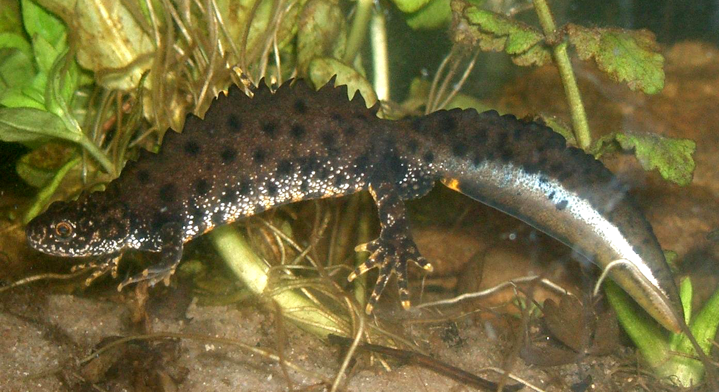
- An ideal habitat for a population of Great Crested Newts is where many ponds are found close to each other, separated by grassland. Suggest the benefits of having several ponds close to each other. (2)
.......................................................................................................................................

.......................................................................................................................................

.......................................................................................................................................

- Describe 3 biotic factors which may affect a population of Great Crested Newts. (3)
.......................................................................................................................................

.......................................................................................................................................

.......................................................................................................................................

- Dunsbury Park is home to a small herd of red deer which feed on grass, tree bark and the new shoots of plants. A rare type of violet plant is found to occur on the land in shaded woodland. Wolves roamed wild in the area and were predators of deer. The landowner wanted to preserve the herd of deer and so began to shoot the wolves when they came onto his land. By the end of 2013, all the wolves were killed.

Number of organisms | May 2010 | Nov 2010 | May 2011 | Nov 2011 | May 2012 | Nov 2012 | May 2013 | Nov 2013 | May 2014
Deer | 2302 | 2130 | 2370 | 2267 | 2705 | 2690 | 2752 | 2712 | 1946
Violet plants | 24 | 21 | 23 | 16 | 5 | 2 | 4 | 1 | 0

- Use graph paper and a suitable method to display the data about the population of red deer from 2010 to 2014. (4)
(Remember to add labels).

- Use the information to estimate when the landowner began shooting wolves. (1)
.......................................................................................................................................

.......................................................................................................................................

.......................................................................................................................................

- What effect did the decision to shoot the wolves appear to have on the community? (2)
.......................................................................................................................................

.......................................................................................................................................

.......................................................................................................................................

- Why does the population of deer rise and then fall each year? (2)
.......................................................................................................................................

.......................................................................................................................................

.......................................................................................................................................

- Suggest why deer numbers fell significantly in May 2014. (2)
.......................................................................................................................................

.......................................................................................................................................

.......................................................................................................................................

- Extended response
Survival of some living organisms depends on mutualism.
Give a definition of mutualism and explain, using three named examples, how organisms benefit from mutualism. (6)

.......................................................................................................................................

.......................................................................................................................................

.......................................................................................................................................

.......................................................................................................................................

.......................................................................................................................................

.......................................................................................................................................

.......................................................................................................................................

.......................................................................................................................................

.......................................................................................................................................

.......................................................................................................................................

.......................................................................................................................................

.......................................................................................................................................

.......................................................................................................................................

.......................................................................................................................................

.......................................................................................................................................

B: Levels of organisation

- Describe the difference between a population and a community. (2)
.......................................................................................................................................

.......................................................................................................................................

.......................................................................................................................................

- Study the relationships of a variety of living organisms found in the garden.
Sparrow

Large spider
Cat

Earwig
Small spider

Tomato plant
Ladybird
Wasp larva

Aphid
Cabbage caterpillar

Cabbages

- Complete the table with the names of all the organisms from the diagram which fit the description: (5)

Description of trophic level | Organism

- If all the cabbages were destroyed by a pathogen which animal’s food supply would disappear completely? (1)
.......................................................................................................................................

- If the cabbages were destroyed, which animal’s food supply would reduce and why? (2)
.......................................................................................................................................

.......................................................................................................................................

- If the ladybird numbers increased, which animals would also increase and why? (2)
.......................................................................................................................................

.......................................................................................................................................

- Which organisms, apart from the cat, could also be described as predators? (2)
.......................................................................................................................................

.......................................................................................................................................

- Which organism/s has cell walls? (2)
.......................................................................................................................................

.......................................................................................................................................

C: Field work techniques

- Clover plants are a good indication of the mineral content of the soil in a field. A student wanted to determine how many clover plants there were in a particular field.
Extended response
- State the equipment needed and describe the procedure that the student could use to sample the field and calculate the mean number of clover plants per m². (6)

.......................................................................................................................................

.......................................................................................................................................

.......................................................................................................................................

.......................................................................................................................................

.......................................................................................................................................

.......................................................................................................................................

.......................................................................................................................................

.......................................................................................................................................

.......................................................................................................................................

.......................................................................................................................................

.......................................................................................................................................

.......................................................................................................................................

.......................................................................................................................................

.......................................................................................................................................

.......................................................................................................................................

- How could the student estimate how many clover plants were in the field? (2)

.......................................................................................................................................

.......................................................................................................................................

.......................................................................................................................................

- A scientist placed a transect line across the field and recorded the percentage cover of each plant found in the quadrat at 2 metre intervals.

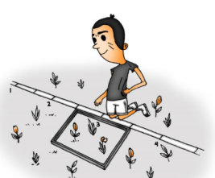

Why did the scientist use this method rather than the random sampling technique? (2)

.......................................................................................................................................

.......................................................................................................................................

.......................................................................................................................................

- Trophic levels in an ecosystem (biology only)

- The food chain below shows the biomass available at each trophic level.

cabbages cabbage white caterpillars sparrows fleas
8445g 775g 85g 2g

- Calculate the efficiency of biomass transferred from the caterpillars to the sparrows. (2)
.......................................................................................................................................

.......................................................................................................................................

.......................................................................................................................................

- Describe three reasons why the efficiency of biomass transfer is not higher between the caterpillars and sparrows. (3)
.......................................................................................................................................

.......................................................................................................................................

.......................................................................................................................................

- Draw an accurate pyramid of biomass on graph paper using the information from the table below. (3)
Trophic level | % Biomass available
1 | 100
2 | 10
3 | 2
4 | 1
X

- Place an X on the trophic level which represents the secondary consumer on the diagram above. (1)

- Decomposers could be described as the final trophic level in each food chain. Explain how a microscopic decomposer receives its nutrition. (3)
.......................................................................................................................................

.......................................................................................................................................

.......................................................................................................................................

E: Biodiversity and the effect on the human interaction on ecosystems

- The concentration of carbon dioxide in the atmosphere is thought to be changing as the human population increases. The graph shows the atmospheric carbon dioxide levels which were measured at one particular location over time. Similar readings have been recorded in different places around the world.

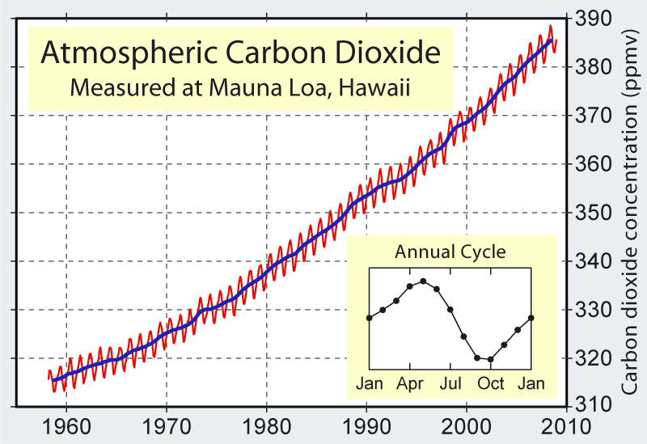

- What is the main trend shown from 1960 to 2010? (1)
.......................................................................................................................................

.......................................................................................................................................

- Calculate the increase in mean carbon dioxide concentration between 1970 and 2000. (3)

.......................................................................................................................................

.......................................................................................................................................

.......................................................................................................................................

- Suggest why the carbon dioxide concentration changes during the year? (2)

.......................................................................................................................................

.......................................................................................................................................

.......................................................................................................................................

- Scientists discovered evidence of an extinct plant by analysing peat layers in a waterlogged Scottish bog. They found pollen in layers that were over 600 years old.
Suggest why the pollen was so well preserved. (2)
.......................................................................................................................................

.......................................................................................................................................

.......................................................................................................................................

- Farming can decrease the biodiversity of an area. Explain how this can occur and suggest what can be done to improve the situation. (4)

.......................................................................................................................................

.......................................................................................................................................

.......................................................................................................................................

.......................................................................................................................................

.......................................................................................................................................

.......................................................................................................................................

F: Food production (biology only)

- Mrs Smith keeps 100 chickens to sell their eggs at the local market. Her chickens are free range.
She sells 6 eggs for £2.10.
Mrs Jones also keeps 100 chickens to sell their eggs at the market. She keeps her chickens in cages in a shed. She sells 6 eggs for £1.75.
- Suggest why Mrs Jones can sell her eggs more cheaply than Mrs Smith. (3)
.......................................................................................................................................

.......................................................................................................................................

.......................................................................................................................................

.......................................................................................................................................

.......................................................................................................................................

.......................................................................................................................................

- Mrs Jones uses chicken feed which is high in protein and low in fibre. Explain how this helps increase the efficiency of biomass transfer. (2)
.......................................................................................................................................

.......................................................................................................................................

.......................................................................................................................................

- India is a country which is growing economically yet there is still widespread poverty and hunger.
India has one of the largest areas of cultivated land used for food production in the world. In 2012, India was the world’s largest producer of milk, pulses and spices but also had over 30% of its rural population living in poverty. The human population of India continues to increase year on year.

The table below shows the quantity of foods exported from India in mega tonnes (MT)
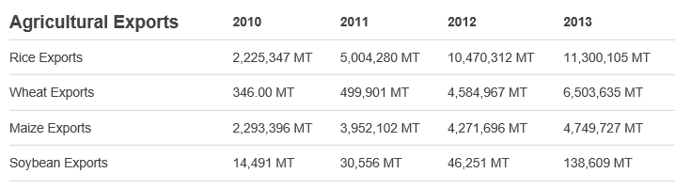
(Information taken from www.foodsecurityportal.org/india)

- Calculate the increase in soybean exports from 2010 to 2013. Express the answer as a percentage. (2)
.......................................................................................................................................

.......................................................................................................................................

.......................................................................................................................................

- Suggest reasons why India exports food rather than using it to feed people who are starving in India. (2)
.......................................................................................................................................

.......................................................................................................................................

.......................................................................................................................................

Extended response question
- A genetically modified plant called short-duration rice has been developed. These plants produce smaller grains of rice in higher yields in 100 days. Unmodified plants take 130 days to produce a crop of larger rice grains but in smaller amounts.
Suggest why this GM crop could improve food security in countries like India. (6)

.......................................................................................................................................

.......................................................................................................................................

.......................................................................................................................................

.......................................................................................................................................

.......................................................................................................................................

.......................................................................................................................................

.......................................................................................................................................

.......................................................................................................................................

.......................................................................................................................................

.......................................................................................................................................

.......................................................................................................................................

.......................................................................................................................................

.......................................................................................................................................

.......................................................................................................................................

.......................................................................................................................................

G: Material cycles, decay and indicator species

Extended Response question

- Explain how carbon is cycled in the natural environment. (6)

.......................................................................................................................................

.......................................................................................................................................

.......................................................................................................................................

.......................................................................................................................................

.......................................................................................................................................

.......................................................................................................................................

.......................................................................................................................................

.......................................................................................................................................

.......................................................................................................................................

.......................................................................................................................................

.......................................................................................................................................

.......................................................................................................................................

.......................................................................................................................................

.......................................................................................................................................

.......................................................................................................................................

.......................................................................................................................................

.......................................................................................................................................

.......................................................................................................................................

Extended response question (biology only)
- Design an experiment to investigate the effect of temperature on the growth of mould on bread. Include an equipment list, method and risk assessment in the answer. (6)
.......................................................................................................................................

.......................................................................................................................................

.......................................................................................................................................

.......................................................................................................................................

.......................................................................................................................................

.......................................................................................................................................

.......................................................................................................................................

.......................................................................................................................................

.......................................................................................................................................

.......................................................................................................................................

.......................................................................................................................................

.......................................................................................................................................

.......................................................................................................................................

.......................................................................................................................................

.......................................................................................................................................

.......................................................................................................................................

.......................................................................................................................................

.......................................................................................................................................

- (Biology HT) Indicator species can be used to show the levels of water pollution.
Evaluate the advantages and disadvantages of using the presence of a species such as the rat tailed maggot which is found in polluted water to measure pollution levels in a river. (5)



























