Part 1

1. Describe the energy store changes when a rocket firework is lit, goes up in the air and then falls back
to the ground. (4)

Chemical thermal kinetic gravitational kinetic thermal
(1 mark for each correct energy store change, maximum 4 marks)

2. A cyclist is braking hard to avoid a collision.
Describe the energy store changes as the bicycle and rider decelerate to a stop. (3)

- Rider and bicycle have a store of kinetic energy (1)
- The energy store shifts to heat energy in the brakes and wheel rims due to friction (1)
- When the bicycle stops the heat store is dissipated into the environment (1)

3. When a battery stops working people often say the energy has been used up. Explain why this statement is not
correct. (2)

Energy cannot be used up as it cannot be created or destroyed (1)

The energy has been transferred into a less useful energy store (1)

4. The Sankey diagram shows the simple energy store transfers for a car.
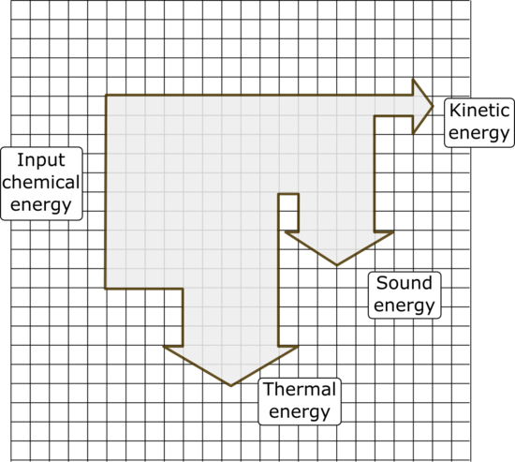

Chemical energy from the petrol = 20 000 J

- Calculate the amount of useful energy
transferred by the engine. (1)

4000 J (1) (each small square equates to 2000 J)

- What is the total amount of “wasted” energy
in the system? (1)

18 000 J (1) (thermal and sound)

5. An eagle has a mass of 4 kg and is flying at a velocity of 35 m/s. Calculate the kinetic energy of the bird. (3)

KE = ½ m v² (1) KE = ½ (4 x 35²) (1) KE = 2450 J (1)

6. The spring on a car wheel extends by 0.05 m when the wheel goes down a pothole in the road.

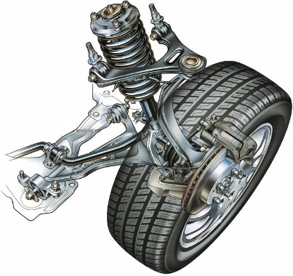
spring

E = ½ k e²

If the spring constant is 20 kN/m, calculate the elastic potential energy in the spring when it is extended. (2)

E = ½ x 20 000 x 0.05² (1) E = 25 J (1)

7. A 48 kg person diving off a cliff has 3500 J of stored gravitational potential energy. Calculate the height of the cliff (3)

GPE = m g h h = GPE (1) h = 3500 (1) Height of cliff = 7.3m (1)
m g 48 x 10

Part 2

1. The diagram represents the energy transfers for an oil-fired power station.
Generator
Turbine
Water and steam
Oil

Energy transferred as movement
Useful energy out
X
Energy transferred as heat

- What is the useful energy out? (1)

Electrical energy (1)

- In what form will energy be “wasted” in this process? (1)

Thermal (internal) energy (1)

- What useful energy store is represented by the box labelled X? (1)

Movement or kinetic (1)

2. Loft insulation reduces heat loss from a home.

Loft insulation can be made out of many different materials.

Give two properties of the insulating material that will affect the amount of heat lost through the roof. (2)

Thermal conductivity (1) and thickness (1) of the material

3. Describe two ways you could increase the efficiency of a household central heating system. (2)

Lag pipes carrying hot water to reduce thermal energy loss

Buy a more efficient boiler
Re-use the waste thermal energy to pre-heat water (any 2 valid answers) (2)
Part 3

1. Name four renewable and four non-renewable energy resources. (2)
Energy Resources
Renewable resources | Non-renewable resources
Wind, wave | Coal
Hydro – electric, tidal | Oil
Bio – fuel, solar | Gas
Geothermal (1) | Nuclear, peat (1)

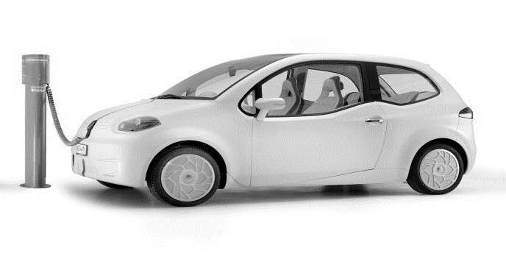
2. An electric car uses no fossil fuels to turn its motor.

The manufacturer claims that this car does not contribute to carbon dioxide emissions into the atmosphere.

Explain why the manufacturer's claim is not true. (3)

Electrical energy store to run the car may have been produced by burning fossil fuels (1)

Burning fossil fuels releases carbon dioxide into the atmosphere (1)

Carbon dioxide emissions from the manufacture and transport of the electric car (1)

3. Explain why fossil fuels are considered to be a more reliable energy resource for electricity production than the
use of wind turbines. (3)

Fossil fuels deliver a consistent electricity supply from a power station (1)

Wind turbines do not produce electricity when the wind is not blowing so they are less reliable (1)

Wind turbines do not produce electricity when it is too windy (1)

4. Name an appropriate energy source for each of the following uses and briefly describe how it is used for
this purpose. (3)
Use | Energy source | How it is used
Producing electricity | Coal, oil, gas, bio-fuel,  Nuclear  Wind, wave, hydro – electric  Geothermal | Burning fuel used in the production of electricity  Nuclear reaction provides heat for the production of electricity  Movement of air or water turns a turbine to produce electricity  Steam from hot rocks used to produce electricity  (any one source and simple description 1)
Transport | Oil (petrol, diesel, fuel oil, LPG)  Renewable resources may supply electricity | Burning fuel drives an engine  Electricity to drive a motor  (any one source and simple description 1)
Heating a hospital | Coal, oil, gas, bio-fuel,  Renewable resources may supply electricity | Burnt to heat water  Electricity to run electric heating  (any one source and simple description 1)

5. Worldwide agreements to reduce CO₂ emissions are intended to slow down climate change. Describe how CO₂ emissions contribute to climate change. (4)

CO₂ is released from burning fossil fuels

This CO₂ builds up in the atmosphere

Increased CO₂ in the atmosphere causes the atmosphere to heat up (retain heat)
This occurs because longer wavelength IR heat re-radiated from the Earth's surface cannot easily penetrate the CO₂ rich atmosphere / greenhouse gases can absorb this longer wavelength IR.

Higher global temperatures result

This can lead to reduced ice, changing weather patterns and expanding oceans.
(any four valid points) (4)

6. The chart shows the world’s energy resources usage for 2015.

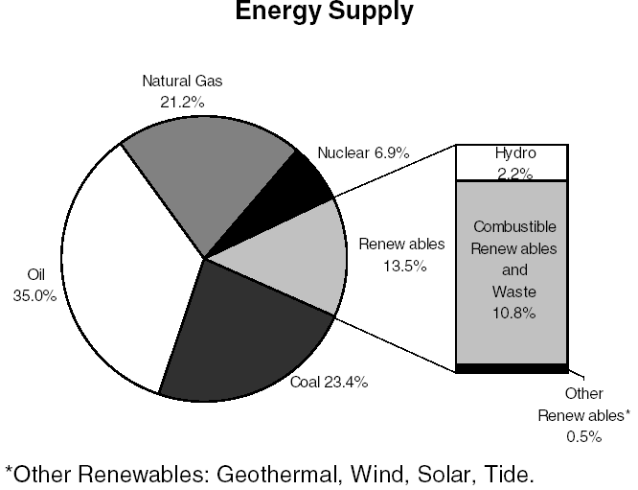

Discuss the likely changes to the worlds energy supplies over the next 50 years. (6)

Fossil fuels will become more difficult to find and extract

Use of fossil fuels is likely to reduce

Fossil fuels release carbon dioxide into the atmosphere

Governments likely to put policies in place to reduce fossil fuel usage

Nuclear fuel power stations are becoming safer, so more are being built which will increase energy from
this resource

Combustible renewables (wood, bio-fuel) and burning waste also increases CO₂ so is likely to reduce

Other renewables are likely to increase to replace some fossil fuel usage

However, energy production from renewables is limited as they often provide only small quantities of
energy
(Credit any reasonable responses) (6)

