A. Cell structure Part 1 – Eukaryotes, prokaryotes and animal and plant cells

1. Describe the similarities and differences between a typical plant and a typical animal cell. (4)
- Typical animal and plant cells contain the following structures: nucleus, cytoplasm, cell membrane, ribosomes, mitochondria (2)
- Plant cells also contain a permanent vacuole, a cell wall and chloroplasts (2)

2. Ribosomes synthesise proteins. Explain what this means. (2)
- Synthesise means to make/produce
- From amino acids
- Ribosomes are the site of protein production/where proteins are made

3. Explain why the mitochondria in cells are important. (3)
- Cells require energy to function
- Mitochondria are the site of respiration
- Energy is released in respiration

4. The table below shows the number of mitochondria in different mammalian cells.
Type of mammalian cell | Number of mitochondria per cell |  |  | Mean number of mitochondria
 | 1 | 2 | 3
Stomach lining | 1720 | 1850 | 1680 | 1750
Liver | 2095 | 2210 | 1995 | 2100
Skin | 290 | 315 | 295 | 300
Large intestine lining | 1295 | 1429 | 1476 | 1400
Muscle | 1853 | 1746 | 1801 | 1800
Kidney | 1450 | 1650 | 1400 | 1500

a. Calculate the mean number of mitochondria in each cell and write these in the table. (6)
- (1 mark for each correct mean)

b. Use graph paper and a suitable method to display the data from the table. (4)
(Remember to add labels).

- Bar chart (1)
- Axis labelled (1)
- Bars plotted correctly (1)
- Gap between bars (1)

5. Extended response question:
The image below shows a type of bacteria called Bacillus cereus. It can cause food poisoning by releasing toxins that can make you vomit.
Bacteria are prokaryotic cells.

Recall the typical structures in a prokaryotic cell and describe the function of each of the structures. (6)
- Level 3 (5-6 marks)

All structures in a bacterial cell named AND the function of each described.
- Level 2 (3-4 marks)

Most structures named AND most functions described.
- Level 1 (1-2 marks)

Some structures named OR some functions described.

Biology content:
Cell part | Function
Cytoplasm | Most chemical processes take place here, controlled by enzymes
Cell membrane | Controls the movement of substances into and out of the cell
Cell wall | Strengthens the cell
Bacterial DNA | Contains DNA that controls the function of the cell and makes/synthesises proteins that the cell needs
Plasmid (DNA) | Small ring of DNA often used as a vector in genetic modification

B. Cell structure Part 2 - Cell specialisation and cell differentiation

1. Extended response question:
Compare and contrast the structure and function of sperm cells and egg cells. (6)
- Level 3 (5-6 marks)

Compare at least three structures AND discuss the function of sperm cells AND nerve cells.
- Level 2 (3-4 marks)
- Compare at least two structures AND discuss the function of sperm cells AND nerve cells.
- Level 1 (1-2 marks)
- Compare at least two structures OR functions for sperm cells AND nerve cells.

Biology content:

Sperm cells:

Function is to fertilise an egg.
- Streamlined with a long tail to swim to the egg
- Acrosome in the head containing enzymes to digest the egg cell membrane
- Large number of mitochondria in the mid-section to release energy for movement

Egg cells:

Function is to fuse with the sperm nucleus to form a fertilised egg.
- Nutrients in cytoplasm
- Haploid nucleus
- Change in cell membrane after fertilisation to prevent further sperm entering

C. Cell structure Part 3 – Microscopy

1. Describe some advantages and disadvantages of the light microscope as compared to an electron microscope. (4)

Advantages:
- small and portable
- (relatively) low cost
- (relatively) easy to use

Disadvantages:
- lower resolution
- lower magnification

2. The diagram below shows sperm cells travelling towards an egg cell.
The real length of the sperm cell labelled A is 42 μm.
Calculate the magnification of the sperm cell. (4)

- Image (I) length of sperm = 21 mm
- Real (A) length of sperm = 42 μm

Convert to mm = 0.042 mm
A

Magnification = size of image (I) / real size of the object (A)
- M = 21/0.042 = 500

3. The diagram shows an image of human cheek cells.
The magnification of the cheek cells is x 100.
Calculate the real length of the cheek cell labelled B. (3)
B

- Image (I) length of cell = 6 mm

Magnification = x 100

Magnification (M) = size of image (I) / real size of the object (A)
- Rearrange to give

Real size of the object (A) = size of image (I)/ magnification (M)

A = 6/100 = 0.06mm

4. Extended response question:
A student has been asked to observe onion cells under a microscope.
State the equipment they would need and describe the procedure they would use. (6)

You do not need to discuss the risks.
- Level 3 (5-6 marks)
A logical plan that INCLUDES most equipment that will allow cells to be viewed under the microscope AND describes how to use the microscope correctly
- Level 2 (3-4 marks)
A plan that INCLUDES some equipment that will allow cells to be viewed under the microscope AND describes how to use the microscope with most of the steps in the correct order

Level 1 (1-2 marks)
Simple plan that lists some equipment OR describes how to use the microscope with most of the steps in the correct order

Equipment: Microscope, glass slides, coverslip, scalpel (sharp knife), iodine or stain, microscope

Procedure:
  - Cut a section of onion and peel off the epidermis (thin inner layer)
  - Place the specimen onto slide.
  - Stain the specimen using iodine.
  - Gently lower cover slip onto the specimen without trapping air bubbles.
  - Soak up any excess liquid with a paper towel.
  - Switch on the light source or move the mirror and place your slide on the stage.
  - Use the lowest objective lens and turn the focusing wheel to move the lens close to the slide.
  - Slowly adjust the focusing wheel until you can see a clear image.
  - Increase the magnification by changing the objective lens and re-focus.

D. Enzymes

1. Explain why enzymes are needed in digestion. (4)
- Biological catalysts
- Breakdown large insoluble molecules (in food)
- Into small soluble molecules
- That can be absorbed into the blood

2. Explain how the release of bile into the small intestines increases the rate of fat breakdown. (3)
- Neutralise acid
- Maintain optimum pH
- For lipase enzyme
- Emulsifies fats to reduce surface area

3. Different enzymes work best at different temperatures.
The graph shows the effect of temperature on different enzymes.
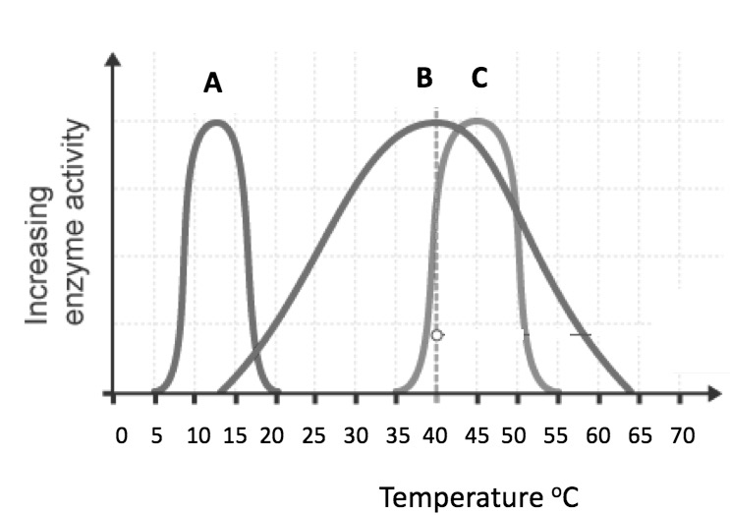

a. Describe and explain the shape of the graph for enzyme A. (4)

Description:
- Rate is (initially) slow
- Rate increases as temperature increases up to 40ºC
- Rate declines to return to 0
- Use of data

Explanation:
- Low (kinetic) energy initially
- Fewer/lower energy collisions
- Optimum rate reached when there is the maximum number of (successful) collisions and all active sites are being used
- Rate falls due to enzymes denaturing

b. Enzyme B is protease and is produced in the stomach, pancreas and small intestine.
Explain why protease works more effectively in the stomach. (3)
- Stomach contains acid
- Acid is low pH (pH2)
- pH provides optimum conditions for protease enzyme

E. Transport in cells

1. The image below shows beetroot in different temperatures of water. The beetroot pieces are all the same size and shape and this is the result after 20 minutes.
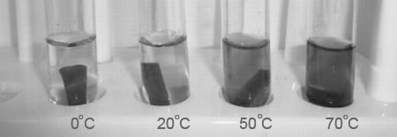

Explain the results of this experiment. (4)
Any four from:
- Dye in the beetroot
- Moves from an area of low concentration to high concentration
- There is a large/steep concentration gradient between the cells and the water
- At higher temperatures, the particles have more energy
- Particles move faster

2. Plants and animals have adaptations that allow for efficient transport of substances in and out of cells. One of these adaptations is maintaining the concentration gradient.
Explain the importance of maintaining the concentration gradient in diffusion. (2)
- The greater the difference between the concentrations (next to each other)
the faster the rate of diffusion occurs
- If the concentrations are the same there is no net diffusion

3. Extended response question:
A student has been given the following equipment and has been asked to investigate the rate of osmosis in potato tissue at different salt concentrations.

Describe how you would use this equipment to investigate the rate of osmosis in potato tissue at different salt concentrations. How will you make it a fair test? (6)

Not all the equipment you will need is shown here. You will not need to write a risk assessment.
- Level 3 (5-6 marks)
A logical plan that INCLUDES sensible volumes and concentrations that would enable valid results to be obtained AND discusses control variables.
- Level 2 (3-4 marks)
A plan that INCLUDES some volumes or concentrations that would enable valid results to be obtained AND discusses at least one control variable.
- Level 1 (1-2 marks)
- Simple plan that lists some volumes or concentrations that would enable results to be obtained.

Biology content: allow any sensible volumes and concentrations
- Use a cork borer to cut potato cylinders of the same diameter.
- Trim the cylinders so that they are all the same length.
- Accurately measure and record the length and mass of each potato cylinder.
- Measure 10 cm³ of the 0.5 M salt solution and put into the first boiling tube. Label boiling tube as: 0.5 M salt.
- Measure 10 cm³ of 0.25 M salt solution and put into the second boiling tube. Label boiling tube as: 0.25 M salt.
- Measure 10 cm³ of the distilled water and put into the third boiling tube. Label boiling tube as water.
- Add one potato cylinder to each boiling tube. Make sure you know the length and mass of each potato cylinder in each boiling tube.
- Leave the potato cylinders in the boiling tubes for an hour/ overnight in the test tube rack.
- Remove the cylinders from the boiling tubes and carefully blot them dry with the paper towels.
- Re-measure the length and mass of each cylinder.

Fair test: Same volume of salt solution/Same length and diameter of potato cylinders/Temperature of the salt solution/Length of time in the solution

F. Using chemical reagents to identify starch, reducing sugars, protein and fats.

1. Write a risk assessment for the experiment required to investigate whether a new type of food, “Chefapie”, contains reducing sugars. (4)
- You test for reducing sugars using Benedict’s solution, it contains copper sulfate and is an irritant that can cause eye damage
- Wear safety goggles
- Avoid skin contact (wash any solution from skin at once),
- Clear up any spills at once
- Heat in a water bath to avoid the solution drying out and spitting

